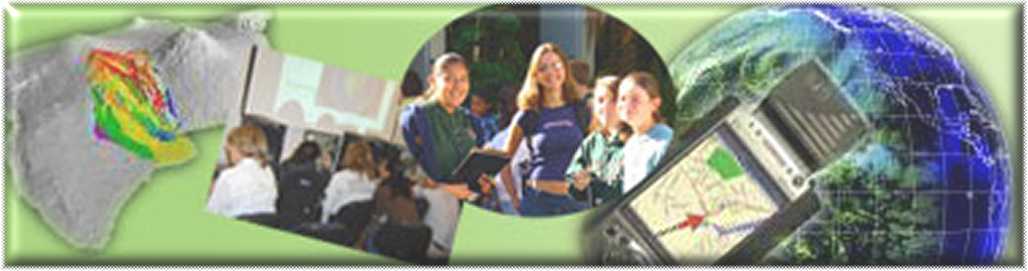

GIS Career Awareness Learning Module # 3
Version 2 - Revision 1 - 4 APR 2007

The Cutting Edge and Future of GIS

- Estimated Time: 90 minutes
- Learning Goal: This module will introduce various GIS applications which involve the cutting edge of current technological innovations currently in use or being developed for the near future. Research applications that will be introduced include Mobile GIS (Computerized Navigation and Habitat monitoring of Mission Trails Regional Park, San Diego), Multimedia GIS Visualization (2003 San Diego County Wildfires), and Participatory (Collaborative) GIS applications (Mapping Where You Want to Visit in the World in Web-Based Community Maps). The module is designed to acquaint students with some advanced and applied uses of GIS that will be prevalent in society, government, and industry in the near future..
- Platforms: PC, Mac, or UNIX.
- Software Tools Required: Web browser with high-speed Internet access. A multimedia video player is required to playback digital movies. (Formats available: .QT (Apple Quicktime), .WMV (Microsoft Windows Media), .MPG (MPEG Video)

Note: This Web-based GIS learning module was developed with support from a National Science Foundation – Advanced Technological Education Program Research Grant (NSF-ATE DUE # 0401990): “A Scalable Skills Certification Program in Geographic Information Systems (GIS).” ( http://geoinfo.sdsu.edu/hightech )

ANSWER ALL QUESTIONS ON THE SEPARATE ANSWER SHEET

Section 1 – Mobile GIS - Small and Portable GIS

Part 1 – Mobile GIS – Application Scenario: Computerized Navigation

Mobile GIS technology is basically taking a smaller version of powerful GIS mapping tools into the “field.” It usually consists of a few different components:
- A small and portable computer like a PDA (personal digital assistant) or laptop which runs the software application and stores information about places in computer memory (Figure 1).
- GIS software that manages and maps the information about places (Figure 2).
- A GPS Receiver (Global Positioning System) (Figure 3) that helps the GIS software figure out where you are located.
- A computer database (computer data) (Figure 4) that holds all of information about places. This database part can be in the computer’s PDA or on a network like the Internet.

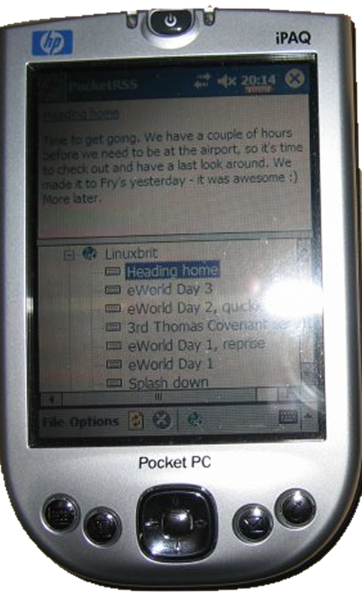
Figure 1: A Pocket PC Personal Digital Assistant (PDA)

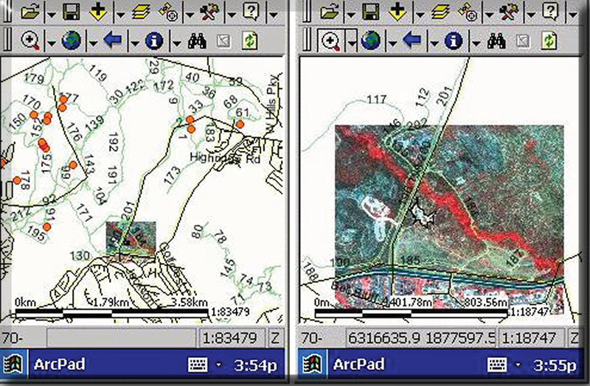
Figure 2: Mobile GIS Software Screenshots

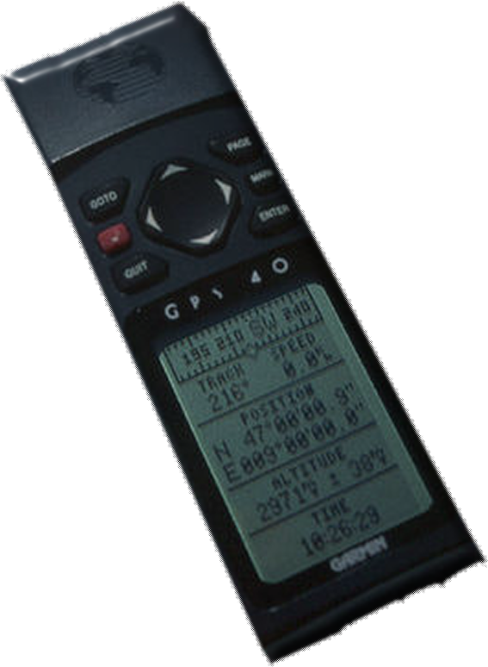
Figure 3: A Portable GPS Receiver

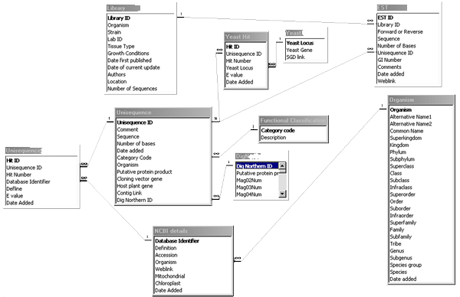
Figure 4: A Computer Database

You can also think of Mobile GIS as a very powerful map that knows where you are and has information stored in it about many places---all without having to bring your home computer with you (Figure 5).


Figure 5: A Desktop Computer – Not very Portable

Well, it’s still difficult to understand this so let’s talk about an example of when it might be useful to use Mobile GIS. Let’s say you are running really low on gas and you are trying to find a gas station in a place that you are unfamiliar with (Figure 6). You would probably need a telephone book and a map of the area to find the nearest gas station, right?

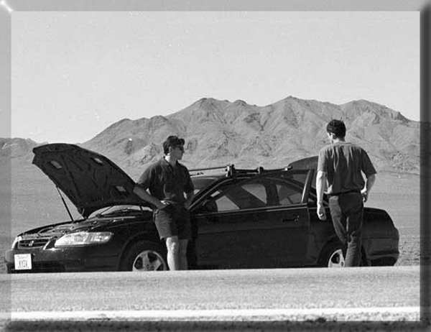
Figure 6: Lost in the Desert with No Gas

The telephone book would have information about many places, including gas stations. The telephone book, in this case, can be thought of as a computer database except that it’s a list of information on paper. It has information about specific places on earth. Most GIS databases, at a minimum, store information about the type of place, the name of the place, and the location of the place. The telephone book has all three of these for our example:
- The type of place is gas station.
- The name of the place is the name of the individual gas station (example: “Mojave Desert Shell Gas.”)
- The location of the place is the gas station’s street address.

So, now that we have our “database,” how is this going to help us find gas? Well, you need a map to find out where you are, right? You also need the map to find out where the nearest gas station is.

What if you are lost and you can’t even find where you are on the map?! You are in trouble because the telephone book and the map won’t help you then. You need to know where you are before you can find specific places on a map.

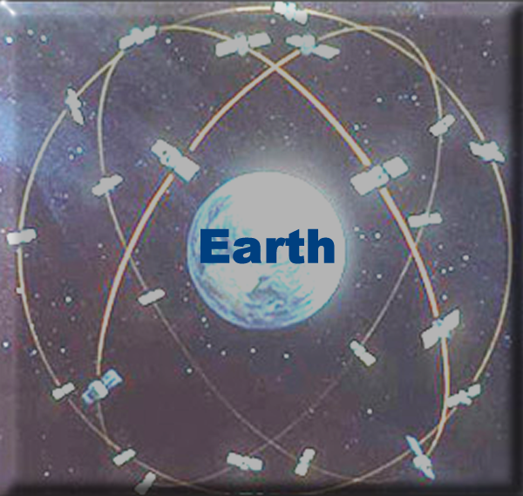
Figure 7: GPS Satellites Orbiting the Earth

Well, this is where the magic of Mobile GIS is. See, Mobile GIS not only stores information about places; it also knows your current location using the radio signals from GPS satellites in space. These GPS satellites (Figure 7) help the Mobile GIS determine very accurately where you are exactly located on earth. If your mobile GIS knows where you are then, it also knows how far you are from everything else! Mobile GIS software is very sophisticated and is able to map your location and everything else stored in its database---so, it will help you find the nearest gas station!

Now, you have no problem finding a gas station nearby even though you are completely lost and you are running low on gas! The question is, did you remember to bring your mobile GIS?

Maker sure you have an Internet connection; open your Web browser; and navigate to http://geoinfo.sdsu.edu/hightech/LearningModules/NavVideos. At the Web page, please watch one of the quick video demonstrations of some car navigation technology based on Mobile GIS. (Please note: Viewing videos over the Internet can be painfully slow. Please be patient. You may have noticed that all of the videos show the same stuff but in different video formats. Depending on the software that is installed on your computer, you may have to choose a specific video format. Ask your teacher for assistance if you have trouble opening up a video.)

After you watch one of the videos, please answer the following questions:

A-1: Name one significant difference between using “Mobile GIS” versus using a “paper map” and a “list of data?” (In the example above, the list of data---the database---was a phone book.)

A-2: What other kinds of information did the mobile GIS-based navigation application demonstrated in the video show?

Part 2 - Application Scenario: Plant Species Monitoring the Fragile Habitat of Mission Trails Regional Park, San Diego

Now, you have some kind of ideas on what Mobile GIS is (remember: it is a portable computer with GIS software, information about locations, and a GPS to track your current location).

Let’s quickly look at another application of Mobile GIS. This time, we are using it to record the growth of “invasive” plant species. What are invasive plants?

Invasive plants, as they are known, grow into the territory of native plants and can harm the native plants by taking up precious and limited nutrients and the water from the native plants. These native plants may not grow as fast and may be less hearty than the invasive plants. Additionally, native plants may be rare or endangered, and may only exist in a limited number of places. Because of this, it is often important to protect these plants.

Another threat to fragile habitats is the human kind. Humans can crush, kill, or destroy rare or endangered plant species or the areas where animals need to survive.

The following is a screen shot of an actual Mobile GIS application running on a Pocket PC (Figure 8).

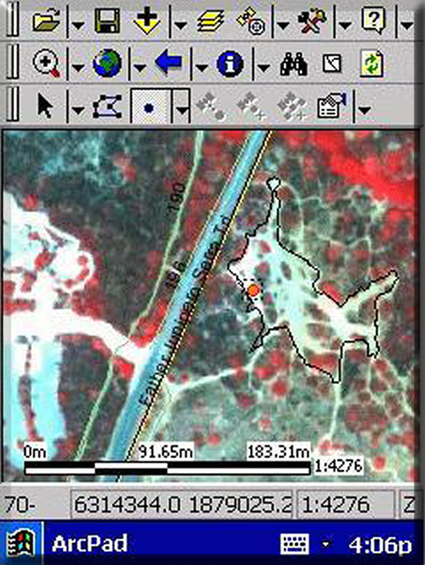
Figure 8: Mobile GIS Software Displaying Locations and Types of Ground Cover

The image that is displayed on the mobile GIS screen was taken with a GIS-related technology called “Remote Sensing.” Remote Sensing cameras can record images from airplanes or from satellites in space. They can be set to automatically detect different kinds of ground cover (whether the ground is covered by road, concrete, building, plants, water, etc.). In the case of Figure 8, the red dots represent vegetation. The white lines represent destructive BMX bike trails.

The park rangers at Mission Trails Regional Park can track the growth, movement, and types of vegetation within the park. This way, they make decisions about the habitat and what to do if an invasive plant species is taking over or if the BMX riders are destroying any of the precious vegetation within the park.

In this next video clip, a mobile GIS application involving the mapping and tracking of invasive plant specifies in the fragile environment of Mission Trails Regional Park is demonstrated.

Maker sure you have an Internet connection; open your Web browser; and navigate to http://geoinfo.sdsu.edu/hightech/LearningModules/MTRP . At the Web page, please watch one of the quick video demonstrations of Mobile GIS for habitat monitoring. (Please note Downloading may take some time. Please be patient. Depending on the software that is installed on your computer, you may have to choose a specific video format. Ask your teacher for assistance if you have trouble opening up a video.)

You will notice the small PDA computer, the connected GPS, the wireless connection to a database, and the specialized mobile GIS software running on the unit. You will notice that Dr. Tsou is demonstrating using the Mobile GIS software to “Mark” specific areas. Remember, since it is mobile, a user can work in the field and do things such as make not of an observation such as a new bike path, the boundaries of a certain type of plant, or how far a wildfire burned (which will be discussed in the next section).

Now, please take a few moments to answer the following questions on the separate answer sheet:

A-3: What else do you think Mobile GIS can be used for and why would it be useful? Be specific and think about how a portable computer, mapping software, database, and GPS (displaying a user’s live location) might help
Section 2 – GIS Visualization with Multimedia – Application Scenario: Fire Progression Visualization of the 2003 San Diego County Wildfires

In this next section, we are going to demonstrate visualizing GIS data with multimedia. In this case, the exact scenario was an enormous wildfire that occurred in San Diego during the late summer/early fall of 2003. The wildfires received a lot of media attention from around the world and you may have heard about---it may have even affected you, your family, or friends(Figure 9) (Figure 10).

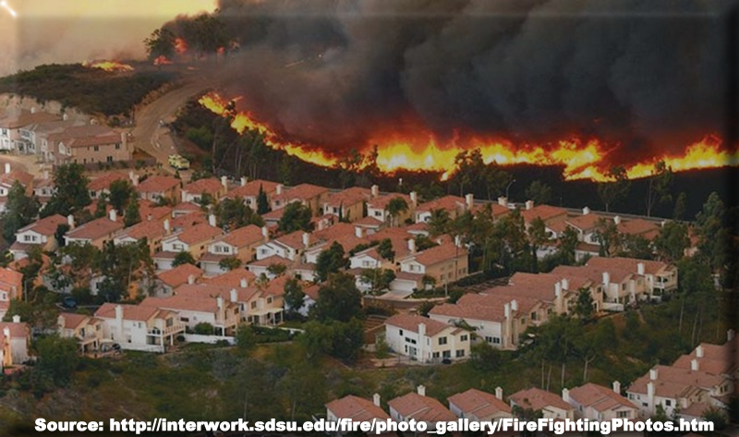
Figure 9: 2003 San Diego County Wildfires – Scripps Ranch

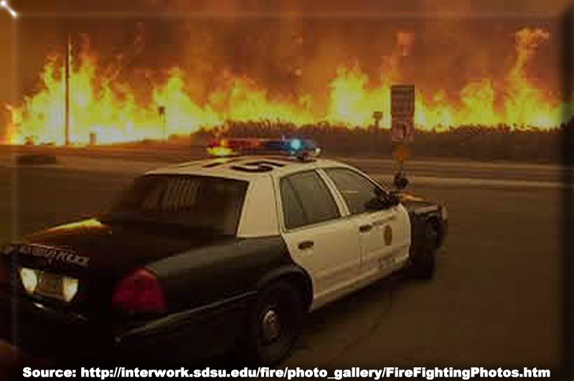
Figure 10: 2003 San Diego County Wildfires – Freeway and Road Closures

The boundaries, direction, and speed of a wildfire can be invaluable information to emergency workers, evacuees, and government disaster assistance personnel. It can help all of these people and agencies assess the situation, evacuate people, and create a treatment or recovery plan. If this kind of information is up-to-date and available, it can save buildings, save money, save resources, and SAVE LIVES!
Now, GIS-related technologies can enable the collection, storage, mapping, and visualization of such information. The mapping and visualization of this critical place-based information is what we’re going to explore now. Again, this kind of information would be invaluable to decision makers, emergency personnel, and other people such as business and home owners.

In this real-world example, the massive wildfires of San Diego County in 2003 are mapped in a GIS application and made into an animated multimedia movie (Figure 11).

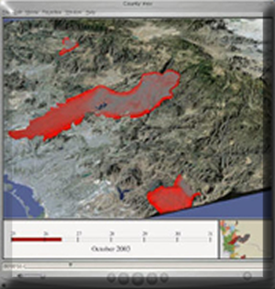
Figure 11: 2003 San Diego County Fire Progression Visualization

Maker sure you have an Internet connection; open your Web browser; and navigate to http://geoinfo.sdsu.edu/hightech/LearningModules/Fire . At the Web page, please watch one of the quick video demonstrations of GIS Visualization to Aid in Decision Making. (Please note Downloading may take some time. Please be patient. Depending on the software that is installed on your computer, you may have to choose a specific video format. Ask your teacher for assistance if you have trouble opening up a video.)

In this example, data gathered with a GPS (and possibly Mobile GIS) from front-line field personnel such as firefighters, police, and aircraft are inserted entered into a GIS database. Since the time and locations of the fire boundaries are accurately recorded, the information can be mapped and displayed over time in a multimedia visualization.

The imagery that was used as the background images are aerial images taken from airplanes or satellites. Realistic background images provide a good backdrop in order to visualize the place, region, terrain, etc. The images are imported into a GIS and made into 3-D based on the actual height of the terrain.

The red line on the bottom displays the date and time progression. You may also notice that it is light during the daylight hours and dark during the evening hours.

All of this was done in GIS and multimedia authoring software. You can easily see that the visualization power of this application is significant. You can also see how huge the fire was!
B-1: What other types of natural or manmade location-based phenomena would be useful to visualize using multimedia GIS visualization? Who would this visualization be useful to and why?

Section 3 – Participatory (Collaborative) GIS – Application Scenario: Web-Based Community Mapping of Where You Want to Visit in the World

STEP 1: VIEW CURRENT COLLABORATIVE MAP

A Collaborative GIS Map

In this section you will create a feature and add it to a Web-based collaborative GIS map. Collaborative or Participatory GIS is a GIS specialty field which can involve the creation of a GIS map based on the input of multiple people. It can be used to aid in making decisions, sharing ideas, and combining knowledge. In this exercise, your feature will be one of many that will become a permanent part of an online GIS map that anybody on the Internet will have access to. Before we begin, let’s define some terms.

Map Features

A map feature is a natural or man-made object or place of interest. It is something that exists at a specific place in a specific time. We are going to assume that the feature you will create currently exists. An example of a feature can be a single school, a single business, a creek, a city, a landmark, or even a country. A feature class is the entire set of grouped features on the map. A GIS map may have a feature class of schools, a feature class of creeks, streams, and rivers, a feature class of landmarks, a feature class of countries, etc.

In the map you will be contributing to, the feature that you will be mapping can be any natural or manmade place or object in the world which you would like to visit. Examples include “The Eiffel Tower in Paris,” “The Great Wall in China,” “Disneyland in Anaheim, California,” “The City of Moscow, Russia,” or “The State of Hawaii.” Notice that the examples included unique places (cities, states, etc.) as well as unique “objects” (The Great Wall, Disneyland, etc.) around the world. Please carefully think about the following question and write down your response. You will create a feature on the Collaborative GIS map based on this response.

It will be very helpful to examine the map you will be creating a feature for. We will also describe some of the map controls at the same time.

1. Go ahead and start your Web browser. Make sure you are connected to the Internet.

2. Navigate to the following URL:
http://geoinfo.sdsu.edu/hightech/LM3

3. Click on the link called, “STEP 1: VIEW CURRENT COLLABORATIVE MAP” (See Figure 12.)

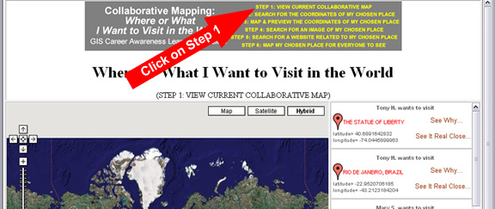
Figure 12: Clicking on STEP 1: VIEW CURRENT COLLABORATIVE MAP

3. The actual Collaborative Web map should eventually appear along with all of the mapped features (the places or things people want to visit).

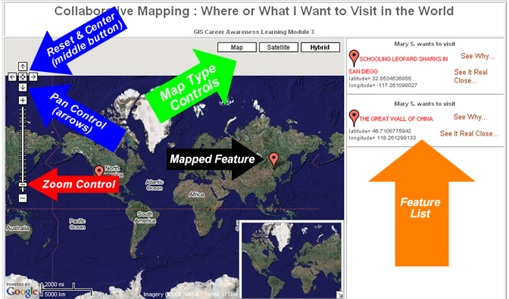
Figure 12: The Collaborative Web Map

Map Navigation

There are many ways to move the map around:
- Try moving the map around by clicking on it and dragging it with your mouse from one side to the other (while holding the mouse button down).
- Try moving the map by clicking on and dragging the little overview map in the inset at the bottom-right corner.
- Try panning the map by clicking on the pan controls on the top-left of the map window.
- Okay, now reset and center the map by pressing the button in the middle of the pan control’s arrows

Zooming In and Out

There are also many ways two zoom in and out so you can see more or less detail:
- Double-click on any place on the map and the map will zoom in and center on that location.
- You can also zoom in by using the zoom control on the left. You can either press the plus and minus buttons on the zoom control or drag the slider control up or down.

Be sure to allow your Web browser to load an updated image. Depending on the speed of your Internet connection, it might take a little time.

You might notice that “zoomed in” high-resolution imagery is not available for the entire planet. Extremely high resolution is, generally, only available for the larger cities and notable places of interest. If you get a message on the map that indicates that no imagery is available for that zoom level, simply zoom out until some imagery is loaded.

Investigating Existing Mapped Features

Now, you are going to view a couple of features that have been mapped by other students. You can look at the details and attributes of a feature by clicking on its name in the feature list (see Figure 12) or by clicking on its red feature marker. The feature list on the right quickly lists all of the mapped places. Use the scroll bar next to the feature list to see them all.

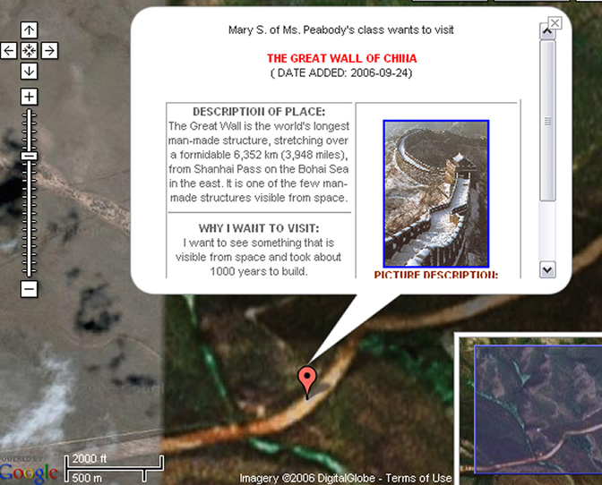
Figure 13: Mapped Feature Details

When you clicked on the feature, the map zoomed into the location and displayed information about the feature. The creator of the feature provided most of the information (attribute data) associated with the feature. They provided the location in latitude and longitude so it could be precisely mapped, named it, described it, and explained why they want to go there. They also selected a Website with more information about the feature and selected an image from the Web to be displayed with the feature. You will be doing the same thing for the place or object YOU want to visit. Everyone using the Web will be able to see it since it will become a permanent part of the collaborative GIS map

If you can’t see the entire mapped feature, move the map around or use the scroll bar. After you are finished studying the mapped feature, you can close it by clicking on the “X” on the top-right side of the pop-up “bubble.”

Okay, after a couple of minutes of exploring the map you will be creating a feature for, decide on a unique place or object to visit in the world and answer the following question:

C-1 (“Name Your Chosen Place”): If you can visit anywhere or anything in the world, where or what would YOU visit? Name it in 10 words or less.

example: The Eiffel Tower in Paris, France.

Notice the question number above (C-1). You will use the answers to these questions to map your selected place based on these question numbers.

Map Feature Attributes

Feature attribute data consist of any information related to the associated feature. Think of it as specific information about individual features. There are many examples of attribute data. If a group of features are streets, the attribute data for each street feature can include the name of the street, the number of lanes, whether the street is a one-way street, the length of the street, etc. Another example can include the attributes of a group of countries. The attributes of each country can include the country name, the population of the country, the type of government (examples: democracy, dictatorship, constitutional monarchy, etc.), the date the country was founded, etc..

In this collaborative GIS map, the features will consist of “places or objects that people want to visit.” Your feature will be one of many on a single Web map. Some people may even describe or name the same feature as you! Now, you are going to include some attribute data with your feature. Carefully think about the following questions and try to keep the answers very short. Notice that, in the example response given below, the source of the information was included because the words and ideas were borrowed from someone else---they weren’t my original words. (As long as you include your source, you can “borrow” words and ideas from other people.)

In the mapped features that you have explored in the actual collaborative GIS map, the “attributes” were the specific info associated with each mapped feature. They include, a name to describe your chosen place (which you have already decided on in C-1 above), a description of your chosen place, the feature location, etc.

We will now create some attributes for your feature.

C-2 (“Description of Your Chosen Place”): Briefly (in three sentences or less) describe the place or object that you specified in Question C-1 above?

example: The Eiffel Tower is an iron tower built on the Champ de Mars beside the River Seine in Paris. It is the tallest structure in Paris and among the most recognized symbols in the world. It is named after its designer, engineer Gustave Eiffel. (from the Wikipedia Website)

C-3 (“Why Do You Want to Visit This Place or Object?”): Why do you want to visit the place or object that you specified in Question C-1 above? Please limit your response to a maximum of two sentences.

example: It is a very famous landmark which I have seen in many movies.

Your responses to questions C-1, C-2, and C-3 above are some attributes that are associated with your chosen place. Other attributes include you, the author of the feature; the date it was created; and the location of your chosen place. The location is probably the most important attribute of any feature in a GIS map. Without the location, the feature can’t be mapped!

The Location Attribute

In order to map your chosen place which you described in Question C-1 above, you need to know its approximate location. Suppose that you don’t know where it is located. This is probably the case for most people---How many people know the latitude and longitude coordinates of their own home?! Well, there are a couple of options for determining the location with very good accuracy. Let’s first talk about how you can describe the location in this collaborative GIS map.

In this collaborative GIS map, you will specify the location by latitude and longitude coordinates. The collaborative mapping application has been set up so you can quickly and easily obtain your latitude and longitude coordinates by simply entering the name of the place.

There are other options for obtaining latitude and longitude coordinates for more advanced user. The advanced options are listed here and are explained in more detail in the Appendix of this document:

Advanced Options for Obtaining Latitude and Longitude Coordinates (Detailed instructions are in the Appendix)

1. Finding and using latitude and longitude coordinates from a Web search and converting coordinates, if necessary (from Degrees Minutes Seconds format to Decimal Degrees format)
2. Obtaining the latitude and longitude coordinates (in Decimal Degrees format) by using the U.S. Street Address of your chosen place (This is only an option if your chosen place is located in the U.S.).
3. Obtaining the latitude and longitude coordinates (in Decimal Degrees format) by zooming in and clicking on your chosen place directly on a Web map. (You will have to know its approximate location on a map in advance.)

If you really need to refresh your memory on latitude and longitude coordinates or wish to read about advanced methods for obtaining latitude and longitude coordinates, read and review the Appendix; otherwise, we are now going to obtain latitude and longitude coordinates for your chosen place by place name.

STEP 2: SEARCH FOR THE COORDINATES OF MY CHOSEN PLACE

1. If you are not already at the collaborative mapping Website, navigate to the following URL:
http://geoinfo.sdsu.edu/hightech/LM3

2. Click on the link called, “STEP 2: SEARCH FOR THE COORDINATES OF MY CHOSEN PLACE” (See Figure 14.)

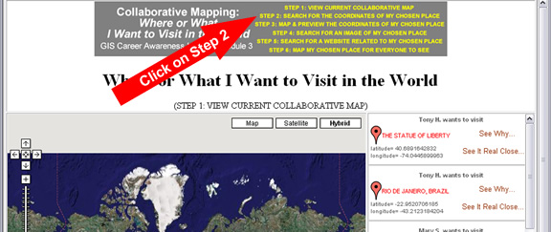
Figure 14: Clicking on STEP 2: SEARCH FOR THE COORDINATES OF MY CHOSEN PLACE

After clicking on the link for STEP 2, you will be directed to a Web page with student instructions in yellow and a single form field (See Figure 15).

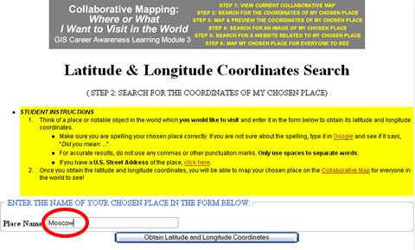
Figure 15: STEP 2: SEARCH FOR THE COORDINATES OF MY CHOSEN PLACE

Think of the general name or location of your chosen place, enter it in the Place Name field, and press the button. Examples of place names can include the names of cities or towns (Moscow, San Diego, Port Au Prince, Tokyo, etc.); countries (Tibet, Liechtenstein, Costa Rica, etc.), and the names of specific features (Disneyland (Amusement Park), Okeechobee (Lake), Everest (Mountain), Yellowstone (National Park), Amazon (Jungle), etc.).

In most cases, you should be able to find something associated with the name your entered. To get the most accurate location, you may have to enter a single word instead of multiple words (example: “Okeechobee” instead of “Lake Okeechobee”).

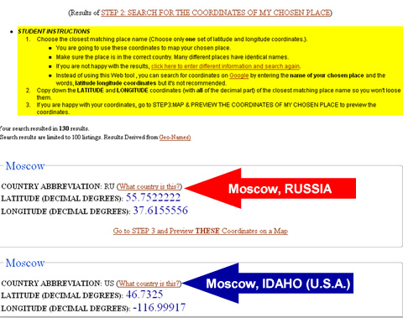
Figure 16: Latitude and Longitude Coordinates Search Results for Moscow

After entering and searching for your chosen place, the collaborative Web mapping application will generate a list of possible locations (Figure 16). It will become your responsibility to scroll through the list and find the closest match, if any. Remember, many places share the same place name. The first thing you should do is read the student instructions in yellow. Following that, you should verify that your place is in the appropriate country. As an example of this, in Figure 16, you will notice that there is a Moscow in Russia AND Idaho.

If you were searching for Moscow, Russia, click on the link, “Go to Step 3 and Preview THESE Coordinates on a Map.” If the tool did not generate appropriate results or no results at all, return to STEP 2: SEARCH FOR THE COORDINATES OF MY CHOSEN PLACE and try a different name or combination of names.

C-4: What word or words did you enter in the text search field in STEP 2: SEARCH FOR THE COORDINATES OF MY CHOSEN PLACE?

example: Moscow

STEP 3: MAP & PREVIEW THE COORDINATES OF MY CHOSEN PLACE

If you were successful in finding a set of possible coordinates in STEP 2 and clicked on the link, “Go to Step 3 and Preview THESE Coordinates on a Map,” your browser will be directed to the STEP 3 Web page where you can preview the coordinates you have selected in STEP 2 (See example in Figure 17.).

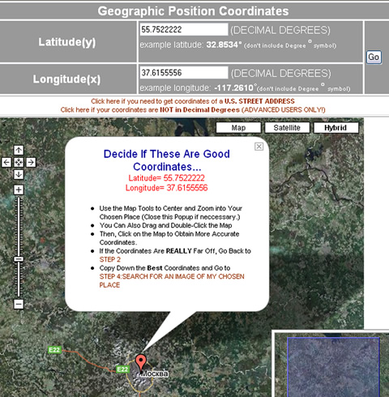
Figure 17: Example of Previewing Coordinates for Moscow in STEP 3: MAP & PREVIEW THE COORDINATES OF MY CHOSEN PLACE

After the preview map draws itself, read the student instructions in yellow. You can then, at your option, use this map tools to zoom in and verify that the mapped location corresponds to your chosen place. In the case of Figure 17, we did, in fact, correctly locate Moscow, Russia however, if your chosen place is the famous Red Square of Moscow, Russia (Figure 18), then we need to zoom in and click on the map to get more accurate coordinates of this “smaller” map feature. Once you single-click on another location on the map, new coordinates will be generated (Figure 19). This way, you can get more precise coordinates for your chosen place!

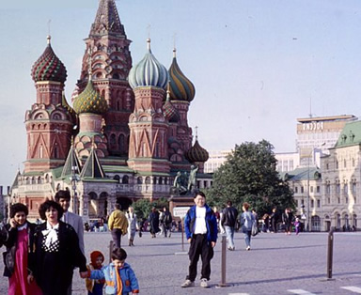
Figure 18: Red Square in Moscow, Russia
(Source: http://www.rahul.net/kenton/fun/red_square.jpg)

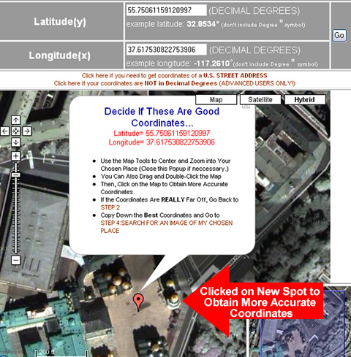
Figure 19: Zoomed in and Clicked on the Center of Red Square (Moscow, Russia) to Obtain More Precise Coordinates

If you do not know what your chosen place looks like or its precise location, you do not need to zoom in that close. You can just obtain for the coordinates for its general location (like the city or town in which it is located). If you REALLY want to be able to generate the precise latitude and longitude coordinates for a location, read the Appendix and learn how to obtain precise coordinates using a Web search engine or U.S. street address.

Now, after you are satisfied with the latitude and longitude coordinates which you generated in STEP 3: MAP & PREVIEW THE COORDINATES OF MY CHOSEN PLACE, copy them down below (Do not forget any negative signs, if any, and, copy down the ENTIRE decimal number for each.).

C-5 (“Latitude Coordinate”): Write down the latitude coordinate of the place or object you want to visit:

LATITUDE (in Decimal Degrees only and don’t forget the negative sign, if any):

example: 55.75061159120997

C-6 (“Longitude Coordinate”): Write down the longitude coordinate of the place or object you want to visit:

LONGITUDE (in Decimal Degrees only and don’t forget the negative sign, if any):

example: 37.617530822753906

STEP 4: SEARCH FOR AN IMAGE OF MY CHOSEN PLACE

Once you are done copying down the coordinates, you will quickly search for and select an image on the Web to associate with your selected place. (You can, alternatively, upload an image however; this is an advanced function and is not recommended if this is your first time using the collaborative mapping system.)

1. If you are not already at the collaborative mapping Website, navigate to the following URL:
http://geoinfo.sdsu.edu/hightech/LM3

2. Click on the link called, “STEP 4: SEARCH FOR AN IMAGE OF MY CHOSEN PLACE” (See Figure 20.)

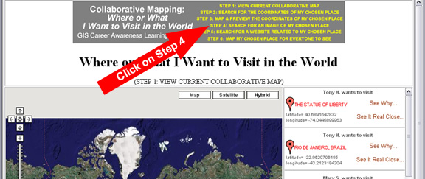
Figure 20: Clicking on STEP 4: SEARCH FOR AN IMAGE OF MY CHOSEN PLACE

After clicking on the link for STEP 4, you will be directed to a Web page with student instructions in yellow and a single form field (See Figure 21).

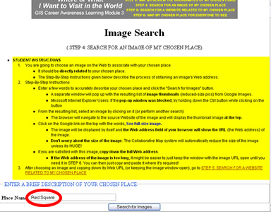
Figure 21: STEP 4: SEARCH FOR AN IMAGE OF MY CHOSEN PLACE

Read the student instructions in yellow then; enter a VERY SPECIFIC name or words to describe your chosen place in the STEP 4 search field. Finally, click the button to search for images.

If you browser allows it, a new window will pop up with a list of image thumbnails (Figure 22). (If you are using Internet Explorer and your browser blocked the pop-up window, be sure to refer to the student instructions in yellow.)
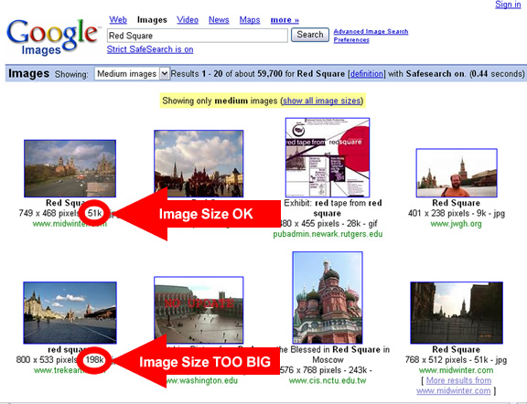
Figure 22: Image Search Results (Images that are larger than 75k are too big)

Browse the thumbnail images and choose one to associate with your chosen place. Be sure to quickly observe the size of the images (Two examples are highlighted in Figure 22). Generally, smaller images load faster and are better. Do not select any images that are over 75k. When you see an image that interests you, click on the image. This will take you to the Website where the image is from (Figure 23). If there are any problems with the Website, click on the “back” button on your browser to return to the image search results and, select another image.

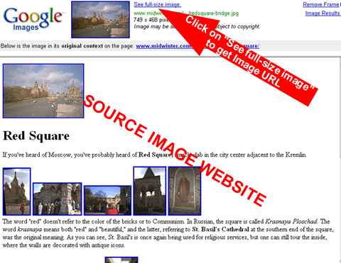
Figure 23: Source Image Website with “See full-size image” URL Link

After selecting a specific image, the browser will navigate to the source image’s Website (Figure 23). Do not worry about how large the image appears in your Web browser. The collaborative mapping system will reduce its size.

Toward the top of the browser window (Figure 23), there will be a link named, “See full-size image.” Click on this link to obtain the image URL (Uniform Resource Locator)---also known as Web address.

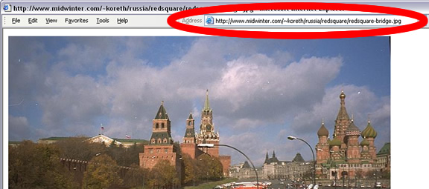
Figure 24: Standalone Image URL (Web Address)

The resulting URL is the Web address of the standalone image. It is not the Web address of the home page of the Website. You will need to copy down this ENTIRE URL. Unfortunately, these Web addresses tend to be very long and difficult to read. Do your best to copy down the entire Web address including the http:// part. As an added “safety measure,” leave this Web browser window (with the standalone image and its URL) open for the rest of this activity so you can copy and paste the Web URL of the image when you need it a little later.

C-7 (“Image of Your Chosen Place”): Write down the full Web URL (Web address including the “http://” part) of the image associated with your chosen place which you selected in STEP 4 on the separate answer sheet. (If you obtained a valid URL, it should end with one of the following, either in all lowercase OR all uppercase letters: “.png”, “.gif”, “.jpeg”, “.jpg.”):

example: http://www.midwinter.com/~koreth/russia/redsquare/redsquare-bridge.jpg

C-8 (“Description of the Image of Your Chosen Place”): Now write down a few words or a VERY short sentence describing the image you selected in Question C-7

example: The Red Square in Moscow, Russia

Remember, KEEP THE WEB PAGE WITH YOU IMAGE OPEN!

STEP 5: SEARCH FOR A WEBSITE RELATED TO MY CHOSEN PLACE

Now, you are going to do something very similar. This time, you are going to select a Website that is related or associated with your chosen place. A Web link will be created with your mapped feature that will take users to more or related information about your chosen place.

1. If you are not already at the collaborative mapping Website, navigate to the following URL:
http://geoinfo.sdsu.edu/hightech/LM3

2. Click on the link called, “STEP 5: SEARCH FOR A WEBSITE RELATED TO MY CHOSEN PLACE” (See Figure 25.)

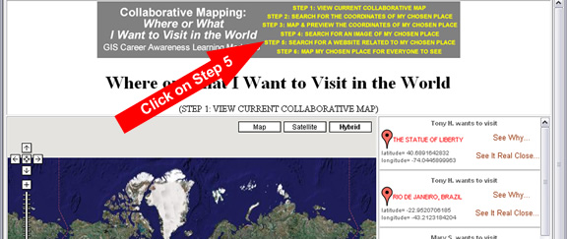
Figure 25: Clicking on STEP 5: SEARCH FOR A WEBSITE RELATED TO MY CHOSEN PLACE

After clicking on the link for STEP 5, you will be directed to a Web page with student instructions in yellow and three form fields (See Figure 26). Choose a search engine to perform your Website search. In this collaborative Web mapping application, we have provided you with Website search options with Yahoo, Ask Jeeves, and Google. If you have another favorite Web search engine, you may use it instead, if you wish.

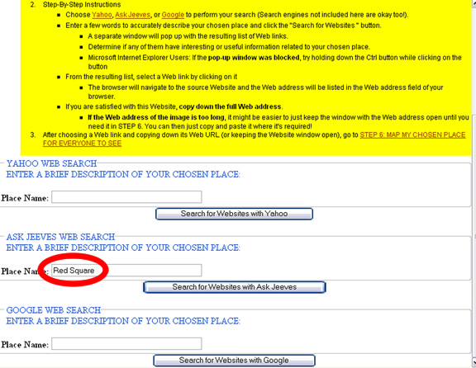
Figure 26: STEP 5: SEARCH FOR A WEBSITE RELATED TO MY CHOSEN PLACE

Read the student instructions in yellow then; enter a VERY SPECIFIC name or words to describe your chosen place in a STEP 5 search field. Finally, click the button associated with that search field to search for Websites related to your chosen place.

If you browser allows it, a new window will pop up with a list of Websites generated by your selected search engine. (If you are using Internet Explorer and your browser blocked the pop-up window, be sure to refer to the student instructions in yellow.) From these results, you will need to select a SINGLE Website to associate with your chosen place. Go ahead and quickly explore any of the Websites that the search engine found. If you like one, copy down the entire URL of the Website. Like before, you may keep this browser window open if the Web address is too long or difficult to copy accurately by hand. You can then, copy and paste the Web URL (Web address) of your chosen Website a little later.

C-9 (“Related Website”): Write down the full Web URL (Web address including the “http://” part) of the Website you wish to link to from your mapped chosen place. Users will be able to click on this link to get more information about your chosen place.

example: http://www.geographia.com/russia/moscow03.htm

C-10 (“Description of the Related Website”): Now write down a few words or a VERY short sentence describing the Website you selected in Question C-9

example: Official Red Square Website of the Russian Tourism Office

After writing down your responses to questions C-9 and C-10, proceed to STEP 6---You’re almost done!

STEP 6: MAP MY CHOSEN PLACE FOR EVERYONE TO SEE

Now, you have all of the information you need to instantly map your chosen place for the entire world to see. Your mapped feature will be on this Web map for everybody to see and will try not to remove it for a very long time so be careful and thoughtful with what you submit.

1. If you are not already at the collaborative mapping Website, navigate to the following URL:
http://geoinfo.sdsu.edu/hightech/LM3

2. Click on the link called, “STEP 6: MAP MY CHOSEN PLACE FOR EVERYONE TO SEE” (See Figure 27.)

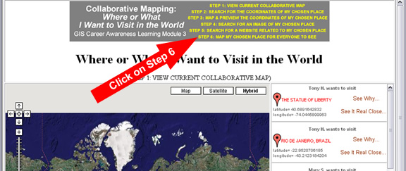
Figure 27: Clicking on STEP 6: MAP MY CHOSEN PLACE FOR EVERYONE TO SEE

After clicking on the link for STEP 6, you will be directed to a Web page with student instructions in yellow and two form fields to log in to the system (See Figure 28).

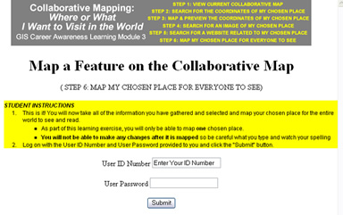
Figure 28: STEP 6 Log In Page

Read the student instructions in yellow then; enter your User ID Number and User Password and, click on the Submit button to log into the collaborative GIS mapping system.

Once you have logged on, a Web page should appear with your name and a bunch of input form fields (Figure 29).

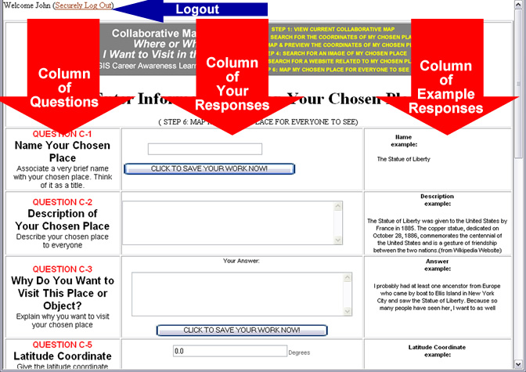
Figure 29: STEP 6 Input Form

Using what your wrote down in Questions C-1, C-2, C-3, C-5, C-6, C-7, C-8, C-9, and C-10, you will fill out the form fields one-by-one and in order.

It is EXTREMELY important that you DO NOT forget to click on the button, “CLICK TO SAVE YOUR WORK NOW” whenever you finish filling in the form fields above it.

We will now describe this process step-by-step:

Question C-1 (Figure 30)
Copy down your response for Question C-1.

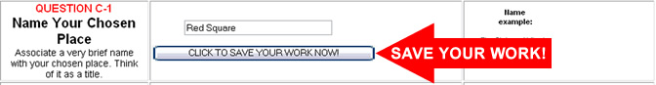
Figure 30: Response for Question C-1

Save your work by clicking on the button.

Question C-2 (Figure 31)
Copy down your response for Question C-2.


Figure 31: Response for Question C-2

Question C-3 (Figure 32)
Copy down your response for Question C-3.

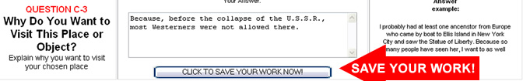
Figure 32: Response for Question C-3

Save your work by clicking on the button.

Question C-5 (Figure 33)
Copy down your response for Question C-5.

Figure 33: Response for Question C-5

Question C-6 (Figure 34)
Copy down your response for Question C-6.


Figure 34: Response for Question C-6

Save your work by clicking on the button.

Question C-7 (Figure 35)
Click on the link, “Use An Image from the Web.”

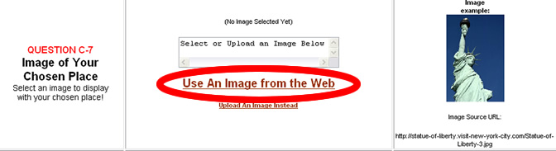
Figure 35: Specifying an Image for Question C-7

After clicking on the link, you will be taken to a Web page where you can specify the Web address of the image you chose for Question C-7 (Figure 36). Read the student instructions in yellow and proceed.

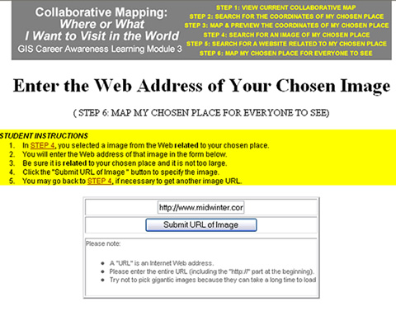
Figure 36: Submitting URL (Web Address) of Image Specified in Question C-7

After entering the ENTIRE URL (including the “http://” part), click on the Submit URL button. If everything is okay, the information in Figure 37 should appear.

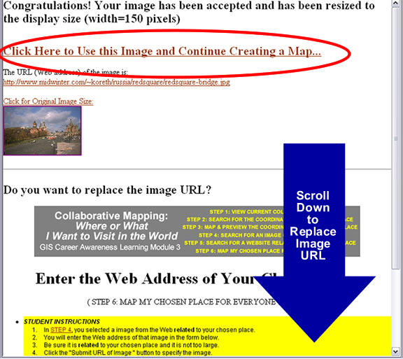
Figure 37: Image URL Accepted (Arrow Indicates Instructions to REPLACE Image URL)

If you are happy with the image you have specified for your chosen place, click on the link, “Click Here to Use this Image and Continue Creating a Map…” and you will be taken back to the form which you were working on previously (Figure 38).

If you need to replace or re-enter the URL, scroll down to the bottom of the image and repeat this step.

If there is any problem with your image URL, follow the instructions that appear on the Web page.

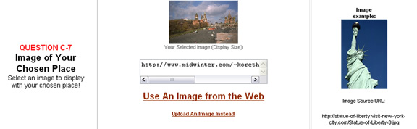
Figure 38: After Successfully Specifying an Image URL for Question C-7

Question C-8 (Figure 39)
Copy down your response for Question C-8.


Figure 34: Response for Question C-8

Question C-9 (Figure 40)
Copy down your response for Question C-9. Be sure to include the “http://” part of the Website URL.

Make sure you erase what is in the form field “box” before you type anything so you won’t include two “http://” parts or any unnecessary spaces. (These error will cause your Web link to not work properly!)

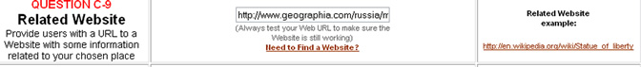
Figure 40: Response for Question C-9

Question C-10 (Figure 41)
Copy down your response for Question C-10.


Figure 41: Response for Question C-10

You’re almost done! Save your work now by clicking on the button.

Now, it’s time to create your feature! Click on the button to permanently map your chosen place (Figure 42).

Figure 42: MAP MY CHOSEN PLACE

If you followed all of the steps correctly, the Web page should return to the collaborative GIS Web map with all of the mapped features visible (Figure 43).

Scroll through the list of mapped features to find your feature and click on any of the links on it. Alternatively, click on the actual “place marker” on the map to bring up the information about your chosen place. Zoom in and examine your mapped chosen place. Be proud that you have carried out all of the steps necessary for the world to see your contribution to this map made by several people.

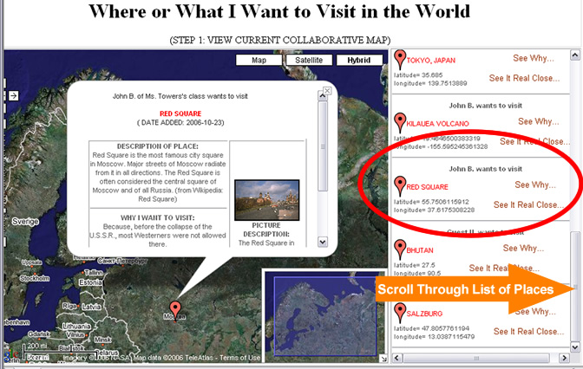
Figure 43: Checking Out the Newly-Mapped Chosen Place!

Now, you are almost done with this learning module. There are just a few more questions left. Please answer the following:

C-11: Briefly write down the steps you took to obtain the latitude and longitude coordinates of the place or object you want to visit on the separate answer sheet.

C-12: Explain why mapping your chosen place can be called “Public Participatory GIS,” “Collaborative GIS,” “Collaborative Mapping,” “Community Mapping,” or “Community GIS.” Why is it useful?

Section 4 – Written Assignment

Now that you have seen several examples of cutting-edge and upcoming GIS technology, it is time to take a few moments to think about and write a summary paragraph about the future of GIS and what might the future technology be useful for. Please spend 30 minutes writing a summary paragraph (600 words) about what you have learned in this section.

D-1: In your paragraph, quickly describe the three cutting-edge GIS applications that were discussed. Recall that they included Mobile GIS, GIS Visualization with Multimedia, and Collaborative Mapping.

D-2: In your paragraph, please give one example use not discussed for one of the three GIS applications described (Mobile GIS, GIS Visualization with Multimedia, and Collaborative Mapping.) Describe how it will help and be useful to people, businesses, or governments.

D-3: In your paragraph, describe what place you mapped with the Participatory GIS map and how could such a technology be useful for mapping other things besides where you want to visit. Could this Web-based technology be useful to other people, businesses, or governments? Why?

Student Survey

This learning module was developed specifically for you---the students---in order to expose you to GIS and related geospatial technologies.

GIS and related geospatial technologies, similar to what you worked with in this learning module, are major components of one of the most important new industries for career growth. Businesses, organizations, and governments are increasingly seeking skilled talent in this industry.

Now, to benefit other students and the authors of this learning module, we would greatly appreciate your input. Please take time to answer these questions as openly and honestly as possible. They will not affect your grade or score. You can either provide your feedback to your teacher/educator along with the learning module answers on the separate answer sheet or you can email your responses using the mail form available at http://geoinfo.sdsu.edu/hightech/contactUs.htm.

Thank you for helping us improve our modules!

S-1: What did you like best about this learning module? Why?

S-2: What did you like least about this learning module? Why?

S-3: Was there anything that was really hard to understand or difficult to complete? What was it? Why?

S-4: Is there anything in this learning module that we can add, exclude, or change to make it better? What is it? Why?

Appendix

The Appendix provides a brief review of latitude and longitude coordinates and provides some alternative and advanced techniques for finding latitude and longitude coordinates of your chosen place.
Latitude and Longitude Coordinates

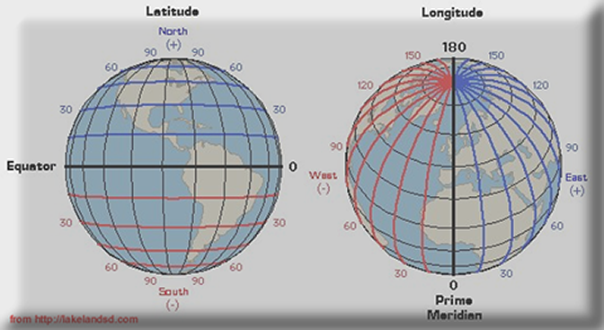
Figure 14: Parallels of Latitude (Left) and Meridians of Longitude (Right)

Latitude and longitude, like x and y coordinates on a Cartesian map, can uniquely specify a location on the spherical globe that we call earth.
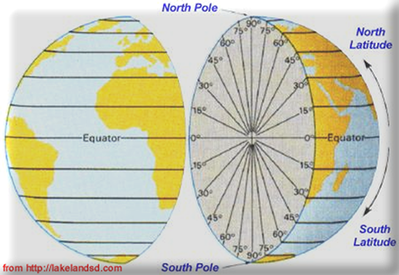
Figure 15: Parallels of Latitude

Latitude lines are imaginary lines on the earth's surface. They run east and west around the globe and tell you your distance north or south of the Equator. As you can see in Figure 15 above, latitude lines encircle the entire globe like a ring. Think of them as belts around the earth. The latitude lines (also known as parallels of latitude) range from 0 to 90 Degrees running north or south of the equator. The equator, which runs exactly between the North and South Poles, is at 0 Degrees latitude. If you move north toward the North Pole, the latitude will increase---in other words, it will become greater (or more positive).

If you go to the very “top” of the planet---where the North Pole is located---you will be at “90 Degrees north latitude.” You can also call this “90 Degrees latitude” since all latitude values north of the equator are considered positive values (See Figure 14).

If you go to the very “bottom” of the planet---where the South Pole is located---you will be at “90 Degrees south latitude.” This is often called “-90 Degrees latitude” since all values south of the equator are considered negative values (See Figure 14). Notice the negative sign is a substitute for the “south” hemisphere designation.

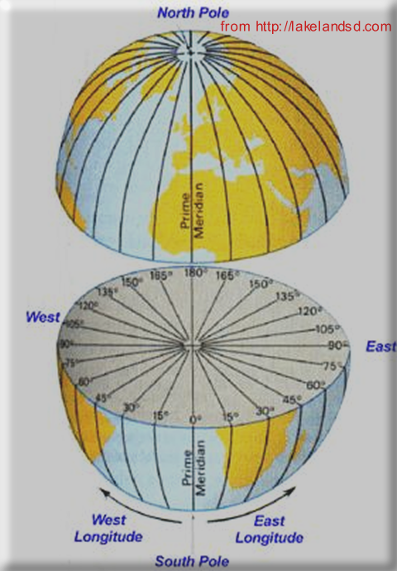
Figure 16: Meridians of Longitude

Longitude lines are imaginary lines on the earth's surface that run from pole to pole around the globe and tell you your distance east or west of the Prime Meridian (Figure 16). Each longitude line does NOT encircle the entire globe like a ring. They only go from pole to pole.

The Prime Meridian is an imaginary line that runs north to south through the Royal Astronomical Observatory in Greenwich, England. The Prime Meridian is designated as 0 Degrees longitude.

If you go west or east of the Prime Meridian, the longitude values will decrease or increase, respectively.

“60 Degrees west longitude,” which lies close to the east coast of the Unites States and is west of England across the Atlantic Ocean, can also be described as “-60 Degrees longitude” (See Figure 14.) because it is west (or to the “left”) of the Prime Meridian. Notice the negative sign is a substitute for the “west” hemisphere designation.

“60 Degrees east longitude,” which lies close to the east coast of Africa and is east of England, can also be described as “60 Degrees longitude” (See Figure 14.). It is a positive value because it is east (or to the “right”) of the Prime Meridian.

“180 Degrees longitude” is the farthest meridian of longitude from the Prime Meridian (See Figure 16). It is also called the International Date Line. It is an imaginary line that runs approximately in the middle of the Pacific Ocean between Asia and North America. It can be described as +180 or -180 Degrees longitude but it is usually just called “180 Degrees longitude” or the International Date Line. The International Date Line is approximately an equal distance away from the Prime Meridian going either east OR west.

This concludes our brief review of latitude and longitude coordinates. Now we will describe how you can obtain latitude and longitude coordinates by using alternative means such as using coordinates from a Web search, using coordinates not in Decimal Degrees format (in Degrees Minutes Seconds format instead), or using latitude and longitude coordinates obtained from a U.S. street address.

Obtaining and Using Coordinates from a Web Search

Latitude and longitude coordinates can be used to specify a unique point on the earth’s surface. One of the best ways of obtaining coordinates is by doing a Web search at a search engine like http://www.google.com . All you really have to do is do a Web search of the name of the place or object you are looking for followed by the two words latitude and longitude If the place is not too obscure, you will probably find some or many Websites with very accurate coordinates for it. You can then use these coordinates to map your feature. We’ll show you how to do this later with another map and other tools specially designed for doing this.

As an example, we did a quick Google Search for the coordinates for the famous Golden Gate Bridge in San Francisco, California (Figure 17).

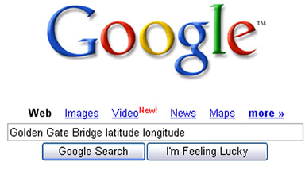
Figure 17: Google Search for Latitude and Longitude Coordinates for the Golden Gate Bridge

On the very first page of search results, we got several sets of accurate coordinates (Figure 18).

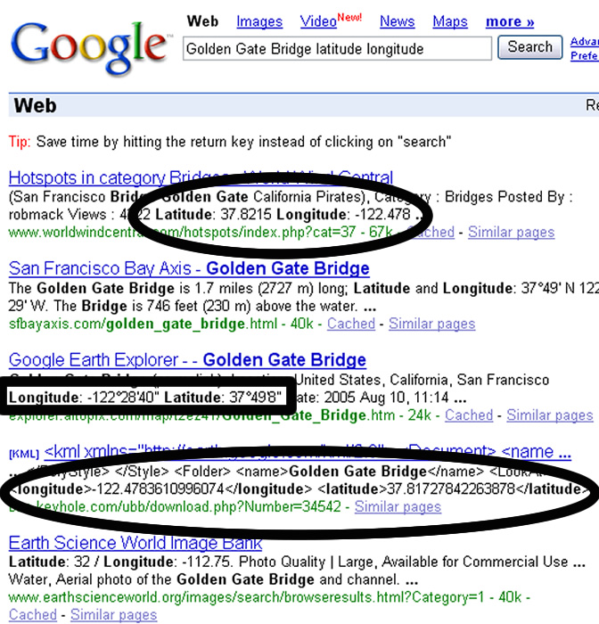
Figure 18: Latitude and Longitude Coordinates for the Golden Gate Bridge Found with Google (Note the 2 Sets of “Decimal Degree” Coordinates Circled in Black and the Single Set of “Degrees Minutes Seconds” Coordinates Boxed in Black)

So, by checking out the first set of coordinates form Figure 18 in our special map tool, which you can use later, you can see that the latitude and longitude coordinates that were found on Google for the Golden Gate Bridge were really accurate (see Figure 19). Please note that the negative sign, if any, is EXTREMELY important. If you don’t copy the negative sign, you feature could be mapped to the “opposite side” of the earth by mistake (See Figure 14 again if you forgot why).

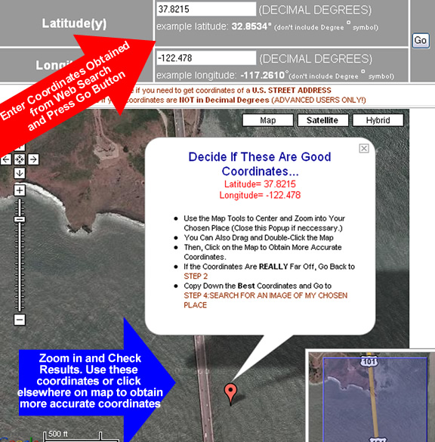
Figure 19: Checking Coordinates Found with Google for the Golden Gate Bridge

Using Coordinates in Degrees Minutes Seconds Format

Now, this is an excellent opportunity to talk about that strange set of coordinates which we found with our Google search. While we prefer that you find “Decimal Degrees” coordinates, you will often encounter latitude and longitude in “Degrees Minutes Seconds” format. As an example, the boxed coordinates in Figure 18 are the following:

Longitude: -122°28'40" Latitude: 37°49'8"

Believe it or not, that is the equivalent of -122.47777778 Degrees Longitude and 37.81888889 Degrees Latitude in “Decimal Degrees” format---our preferred format. If we used those coordinates in “Degrees Minutes Seconds” format, they first, have to be converted to “Decimal Degrees” format. We can do this with another tool that you will have a chance to use.

The coordinate conversion tool is specifically made for converting “Degrees Minutes Seconds” format to “Decimal Degrees” format. To access the coordinate conversion tool, be sure you click on STEP 3: MAP AND PREVIEW THE COORDINATES OF MY CHOSEN PLACE and click on the link, “Click here if your coordinates are NOT in Decimal Degrees (ADVANCED USERS ONLY!)” (See Figure 20).

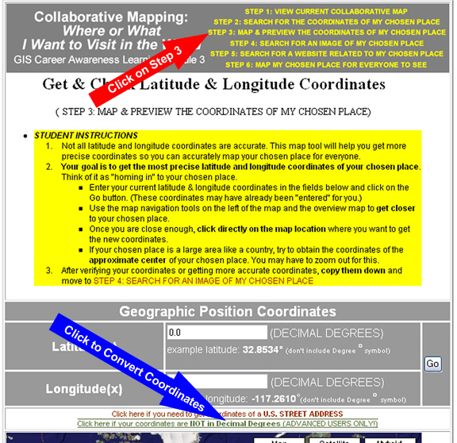
Figure 20: Accessing the Coordinate Conversion Tool

Once you click access the coordinate conversion tool, you will be able to convert latitude and longitude given in Degrees Minutes Seconds format to latitude and longitude given in Decimal Degrees format---the format acceptable to the collaborative mapping application (See Figure 21). Note in the figure that, since the “Degree Minutes Seconds” longitude value from the Google search has a negative sign in the front, we have to follow some special instructions on the coordinate conversion tool (See Figure 21 text circled on the right side.). The instructions state to leave out the negative sign and, instead change the hemisphere to “West,” if it isn’t already west. Remember, the Western Hemisphere is in the “negative longitude” direction; and the Southern Hemisphere is in the “negative latitude” direction. Fortunately, you don’t have to remember this because the tools remind you. Anyway, the end result of the coordinate conversion tool is nearly the same as the coordinates that were in “Decimal Degrees” to begin with.

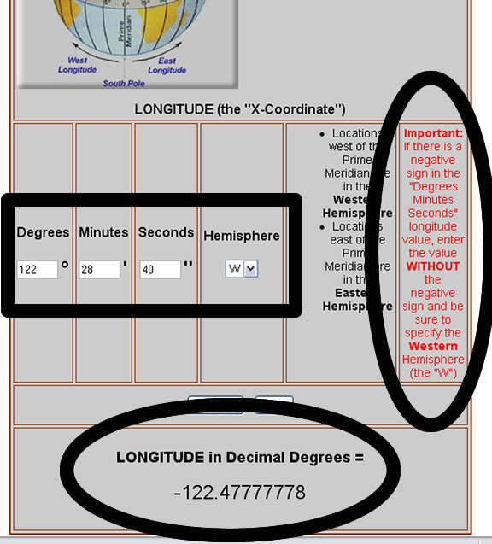
Figure 21: Conversion of “Degrees Minutes Seconds” Format Longitude to “Decimal Degrees” Longitude (The Input is Boxed in Black. The Warning Circled at the Center-Right Applied Because the “Degrees Minutes Seconds” Longitude Had a Negative Sign. The Result is Circled at the Bottom.

Obtaining Latitude and Longitude Coordinates by U.S. Street Address

If the location you specify is in the U.S. and you know its address, you can specify the location by street address and the mapping application will automatically generate the approximate latitude and longitude coordinates of that street address for you.

As an example, suppose we wanted to visit the White House in Washington, D.C. and map it as a place or object that we want to visit. Well, we did a Google Search with the words White House Address and eventually came up with the following:

1600 Pennsylvania Avenue NW
Washington, DC 20500
With the special map tool, we found the White House and zoomed in even closer (Figure 22). From this, we can zoom in more and directly obtain more accurate “Decimal Degrees” coordinates by clicking directly on the White House.

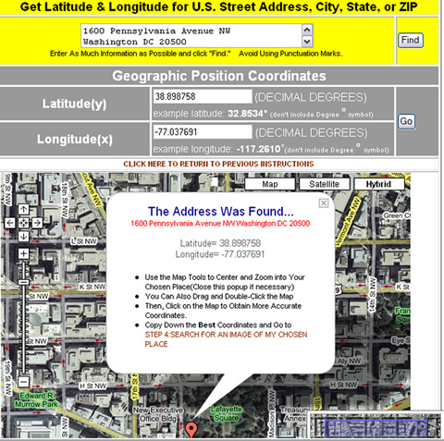
Figure 22: Using the Address Search Tool to Zoom In and Obtain Latitude and Longitude Coordinates

Access the U.S. address coordinate search tool by clicking on STEP 3: MAP & PREVIEW THE COORDINATES OF MY CHOSEN PLACE and then click on the link, “Click here if you need to get coordinates of a U.S. STREET ADDRESS” (Figure 23).

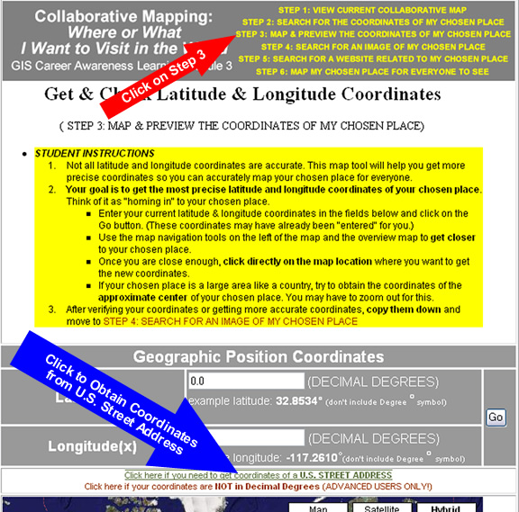
Figure 23: Accessing the Tool to Obtain Latitude and Longitude from a U.S. Street Address
The address search tool could be very picky and, sometimes, it will refuse to work. If that is the case, try another address or leave out additional information such as suite number, apartment number, etc. Try not to put punctuation marks such as periods and commas in the address.

Obtaining Latitude and Longitude Coordinates by Knowing the Approximate Location on a Map

If you can find the place or object you want to visit directly on a world map, you can obtain latitude and longitude coordinates this way. First, be sure to go to the map by clicking on STEP 3: MAP & PREVIEW THE COORDINATES OF MY CHOSEN PLACE.

Remember, you can zoom in really close to many places and objects on the map. This special map has been set up so when you click on any location on this special map, the latitude and longitude coordinates will automatically be displayed for whatever location you clicked on.

As an example, if you know the general location of something like the Statue of Liberty in New York City. You can zoom into New York City until you find it; get as close as possible by zooming in more, and then obtain very accurate latitude and longitude coordinates by clicking right on it. This technique (Location by Selecting a Point on the Map) generally works if you know where something is on a map. The Statue of Liberty is in New York Harbor so we zoomed all the way into New York Harbor until we found it. Then, we zoomed in as close as we could. When we were happy how close we were, we mouse-clicked directly on top of the Statue of Liberty and copied down its coordinates in “Decimal Degrees” (See Figure 24 below). The coordinates were the following:

Latitude: 40.68915614801549 Degrees
Longitude: -74.04459536075592 Degrees

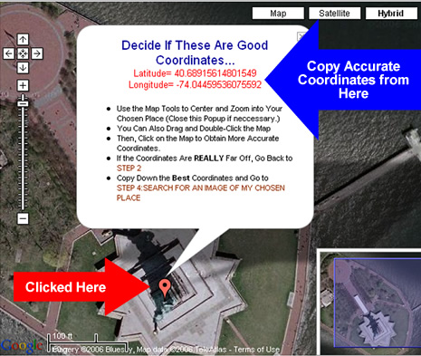
Figure 24: Obtaining Latitude and Longitude Coordinates by Clicking on the Map

So with this special map tool and some general knowledge of a place or object’s location on a world map, you can determine the latitude and longitude coordinates of your chosen place.

