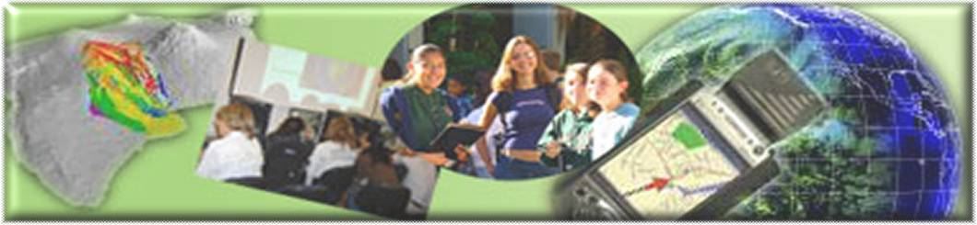

GIS Career Awareness Learning Module Additional Component

April 8, 2011 by Nihal Baloglu Ugurlu

(Version 1)

An alternate approach towards learning about the U.S. population with the 2010 census
- Estimated Time: 2.5 hours
- Learning Goal: This module will introduce GIS applications related to the U.S. population subject. Students will learn what is the distribution of U. S. population density and percent of races in each state, will identify locations of states and information about these state populations, will use this information and will interrelate state’s locations and population features, will also learn about the map scale and measurement with GIS.
- Platforms: PC.
- Software Tools Required: ArcGIS 10.
- Data Resources:
Borderof States shapefile: www.esri.com
Population data: www.census.gov
Climate data: www.usgs.gov
Corn data: www.nass.usda.gov
- Allied to California Content standards: GIS Learning module additional component can be allied to the following California Content standards:
- History-Social Science Content Standards
4.1.5. Use maps, charts, and pictures to describe how communities in California vary in land use, vegetation, wildlife, climate, population density, architecture, services, and transportation.
.
Objectives
After completing this lesson, students will be able to do the following:
• Locate states on a U.S. map
• Identify population of states.
• Know distribution of population and population density of the U.S.
• Analyze percent of population by race in each state.
• Compare population density and distribution of races in each state.
• Explain reasons of population density and distribution according to states.

GIS Tools and Functionality
- Identify a selected feature on the map
- Zoom in to a desired section of the map or to the center of the map
- Zoom to the full extent of the map
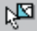Select Features on the map
- Clear selected features
- Zoom out to a desired section of the map or to the center of the map
- Move the map to bring a different portion of it into view
- Select a graphic
- Measure distances between points on the map
- View a hyperlink to an image
Find latitude and longitude of a place on the map
Activate a data frame
Turn layers on and off
Turn feature labels on and off
Turn layers on attribute table
Display a graph
Determine latitude and longitude of map features
Measure distance between two places

Teaching the lesson
Introducing the lesson
Begin by helping students understand what GIS is and explain basic properties of GIS. Then the teacher will learn students’ opinions of topics related to U.S. population.

Student activity
Teacher should complete the activity before presenting the lesson in class. Doing so will allow the teacher to modify the activity to accommodate the specific needs of students. If they will not be working on individual computers, be sure to explain any necessary modifications.
Students will analyze population density and distribution of population on the each state according to races. They will identify states according to population properties. In addition, they will introduce states’ locations (latitude and longitude); they will measure distance between two states; and they will evaluate this data together with population density.
The following are things to look for when the students are working on this activity:
- Are the students answering the questions?
- Are students thinking spatially?
- Are students using a variety of menus, buttons, and tools to answer the questions?
- Are the students referring to their original maps and notes from class discussion?

Concluding the lesson
When the class has finished the activity, teacher will lead a discussion that summarizes the conclusions the students reached. Be sure to address states locations, geographical features as factors that influence population density and distribution. After students have had an opportunity to share their conclusions, discuss the similarities and differences among the ideas presented. Allow students to question each other and clarify confusing or contradictory statements. Develop a consensus about how each factor influences population.

LESSON ACTIVITIES
1.Opening ArcMap:
Begin by downloading the zipped exercise data from Learning Module Additional Component at http://geoinfo.sdsu.edu/hightech/GISCareerLearningModules_top.htm. Unzip the data.
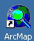
Start ArcMap™ by double-clicking the ArcMap shortcut icon on your desktop or by clicking Start > All Programs > ArcGIS > ArcMap 10.
In the ArcMap Getting Started dialog box, under Existing maps, click "Browse for more." Browse to the folder where you saved the course exercise data. The default download location is Local Disk(C:)\GIS-module\US\map.
In the this folder, double-click map.mxd to open the map document (see figure 1).

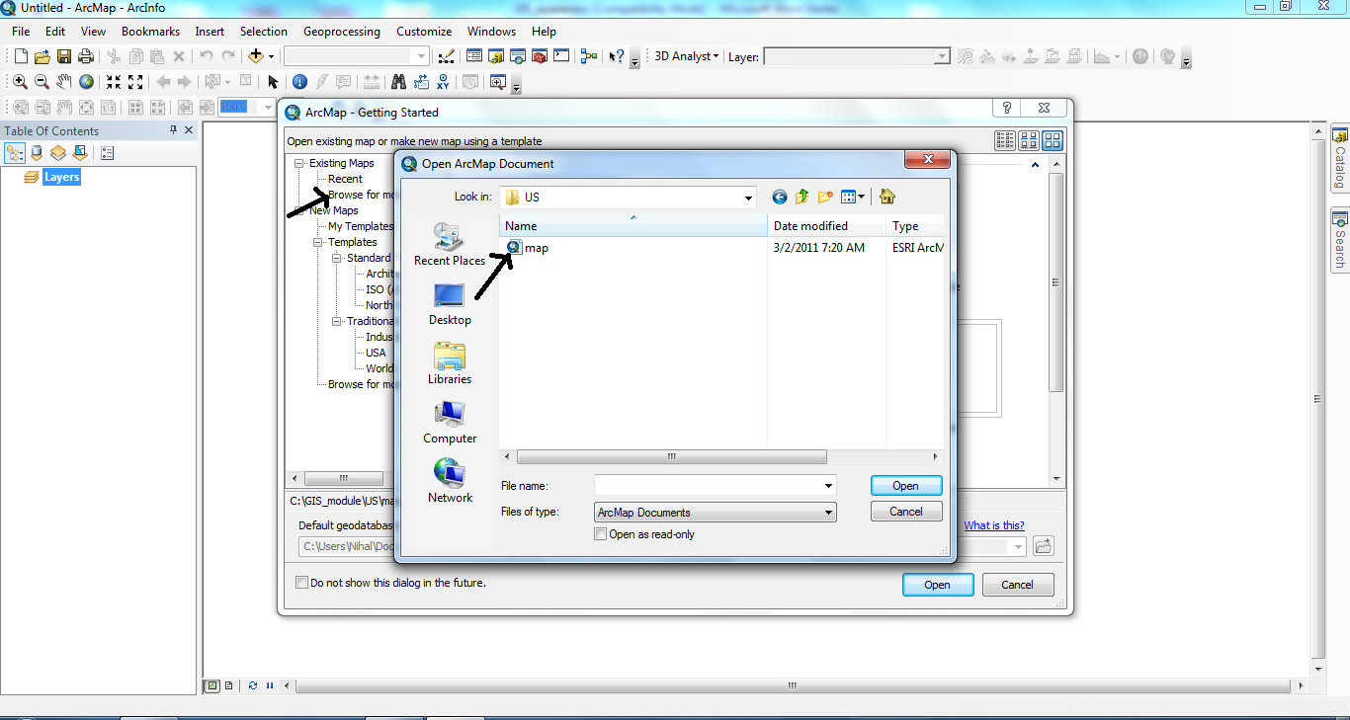
Figure 1. Screenshot of opening the map exercise file

2.Using the activate property:
In ArcMap, there are two major windows: the table of contents and map area. The exercise data provides a few map layers that include different geographical properties found in the table of contents on the left side of the screen. For any map layer to appear on the map area screen, it has to be activated. To activate the desired layer, right click on the desired layer and click activate (see figure 2)
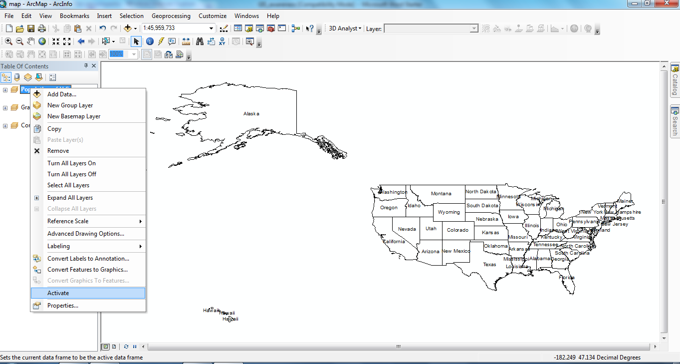
Figure 2. Screenshot of activating a map layer

When you activate the group layer “Castles”, what do you see? Does the original map change to reveal something new?

3. Opening both group and map layers:
There are different map layers in the group layer. A group layer is similar to a folder on your computer which contains any number of files, or in this case, map layers. To reveal the contents of a group layer, click the plus sign located next to the group layer name (see figure 3)
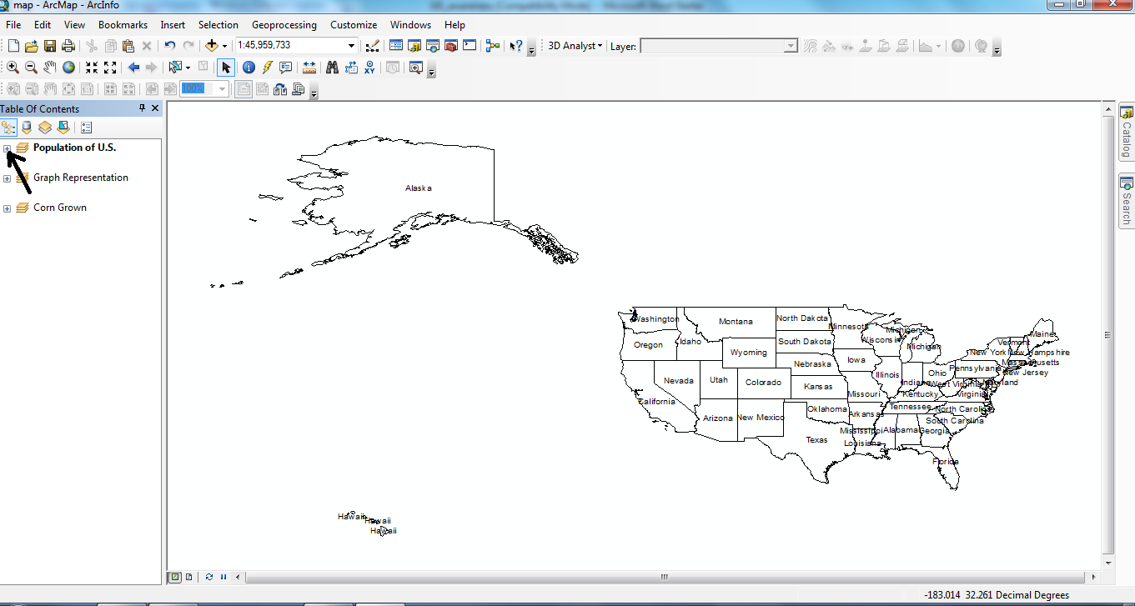
Figure 3. Screenshot of revealing the contents of a group layer

Display the contents of the group layer “population of states”. How many map layers are in the group layer? Provide the name of three of these map layers?

In order to view a map layer, click any empty box to the left of the name to remove any layer from the map display, uncheck the box (see figure 4).

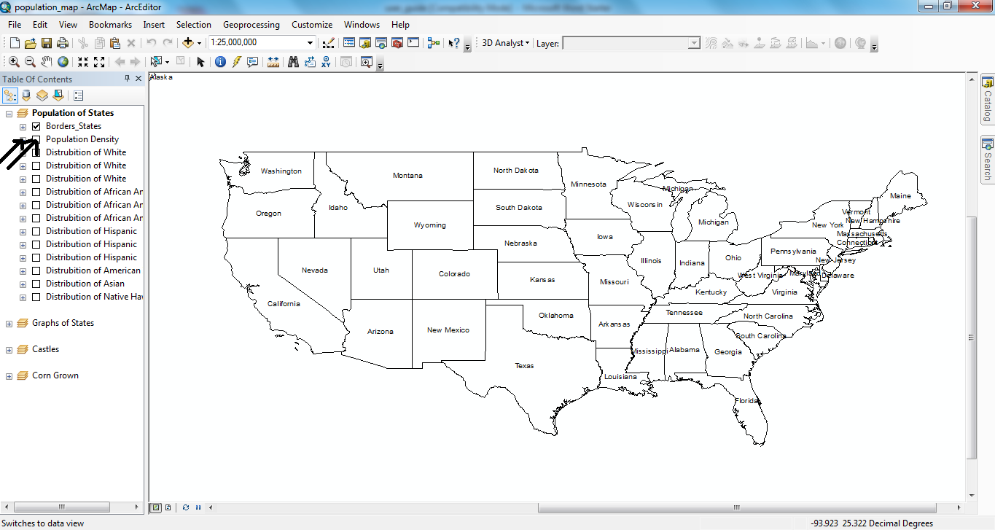
Figure 4. Screenshot of displaying a map layer in the map window

What do you see when you open the “population density” map layer? What states have the highest population density?

4. Symbolization:
To change the symbolization of any map layer, be sure to check the hollow box to the left of the name next, click the plus sign to the left of the hollow box to reveal the symbols belonging to this map layer (see figure 5).
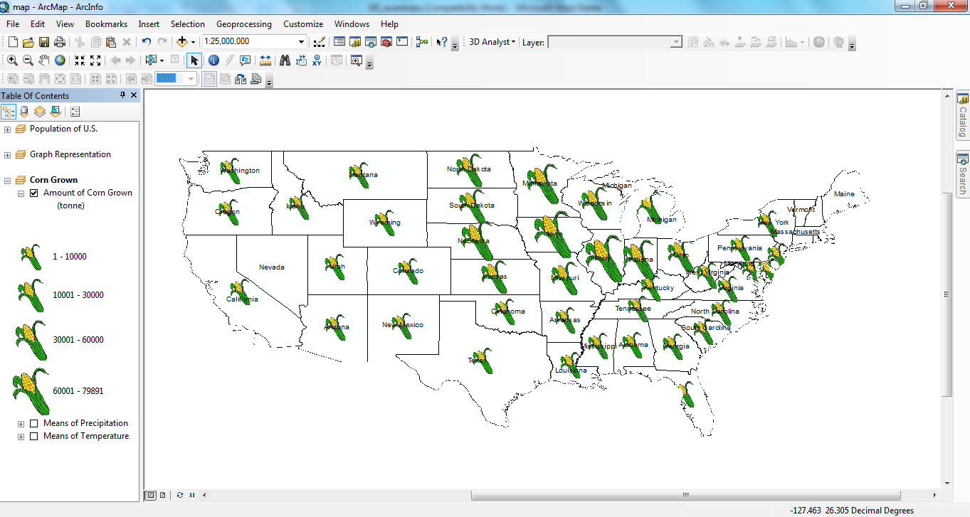
Figure 5. Opening symbols of map layer

What do you see when you view the symbols for the “distribution of corn grown” map layer found within the “Corn Grown” group layer? What range of corn distribution is represented by the large corn symbol?

5.Viewing two layers at the same time:
Viewing two map layers at the same time provides an opportunity for more spatial analysis. But, if you open two colored map layers at the same time you can not look at the underlying map layer because the upper map layer closes it. In that case you should use a different kind of map layer such as a colored map and a symbol map at the same time (see figure 6).
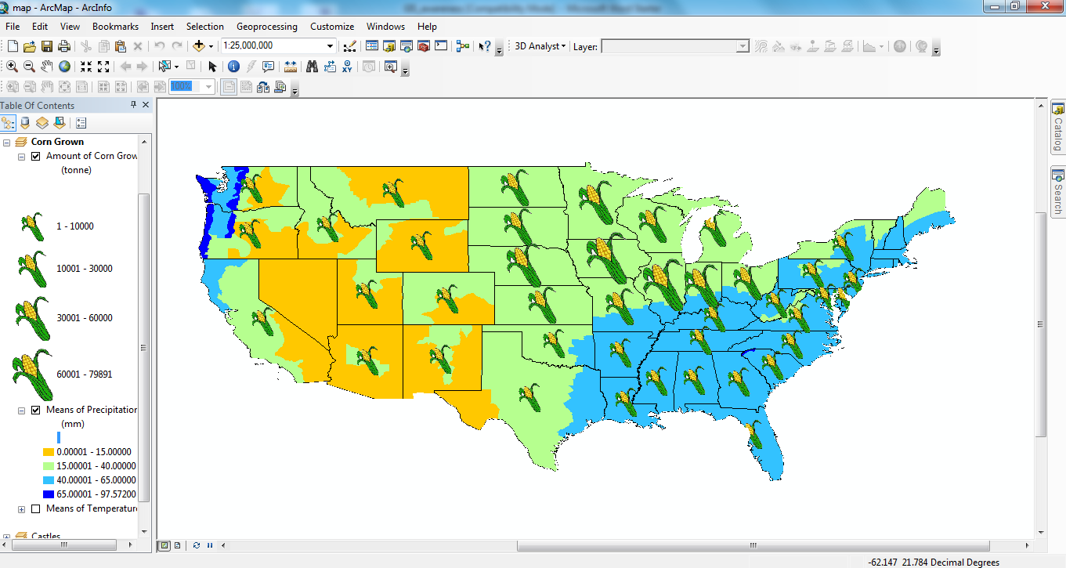
Figure 6: Making spatial analysis with two map layers

What do you see when you view both the “distribution of corn grown” map layer and the “means of precipitation” map layer? Can you explain what you are seeing? How do climate properties in an area effect the growth of corn? You can also compare “means of temparature” map layer.

Hint: Is a higher precipitation related to the growth of corn? Is a colder climate the related to the growth of corn?

6. Labeling layers:
The label features property allows users to visualize the names of geographic elements on the map. To use these properties, right click on the desired map layer and select label features (see figure 7).
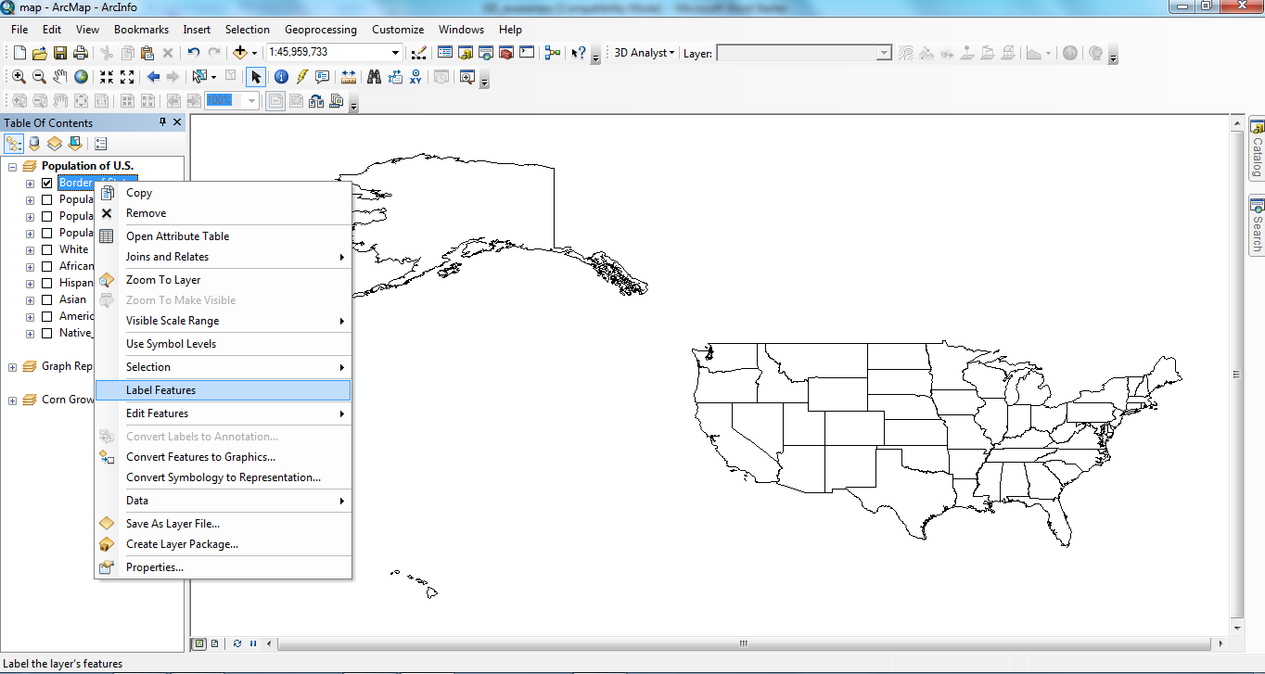
Figure 7. Screenshot of the “label features” location

After you label the “border states” map layer, can you identify states which border Canada?

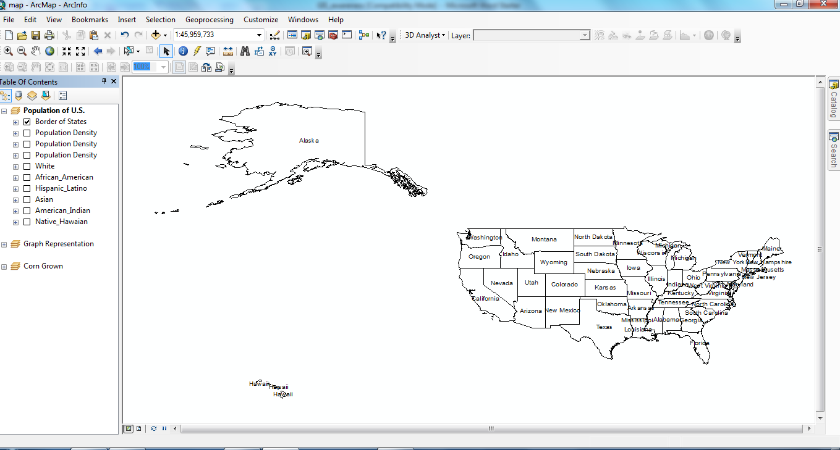
Figure 8. Screenshot of labeled states

7. Zoom in tool:
By clicking the “zoom in” button is found in the tools menu, the cursor becomes a tool that allows you to zoom into areas clicked on the map (see figure 9).
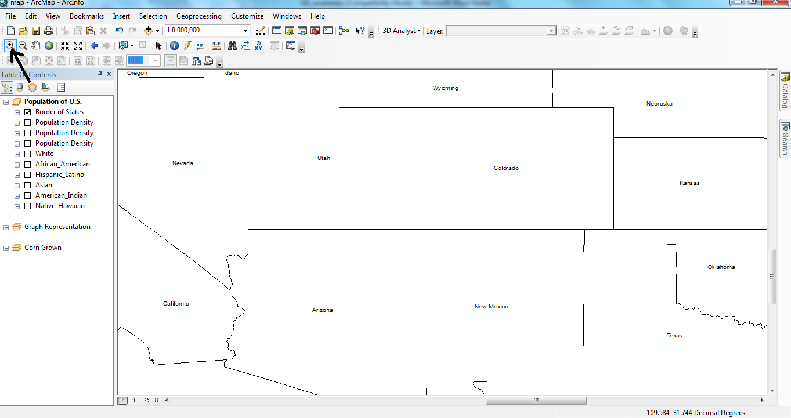
Figure 9. Screenshot of zoom in example

What do you see when you use the “zoom in” button? Does it increase or decrease the map detaiIs?

8.Zoom out tool:
By clicking the “zoom out” button is found in the tools menu, the cursor becomes a tool that allows you to zoom out of areas clicked on the map (see figure 10).
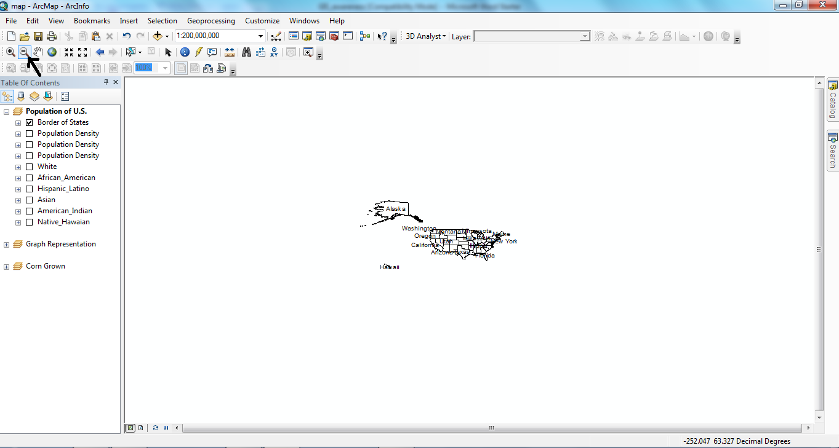
Figure 10. Screenshot of zoom out example

What do you see when you use the “zoom out” button? When do you need this button?
9. Moving the map:
By clicking the the pan button which is found in the tools menu, the cursor becomes a tool that allows you to drag the map into a different location on the display (see figure 11).
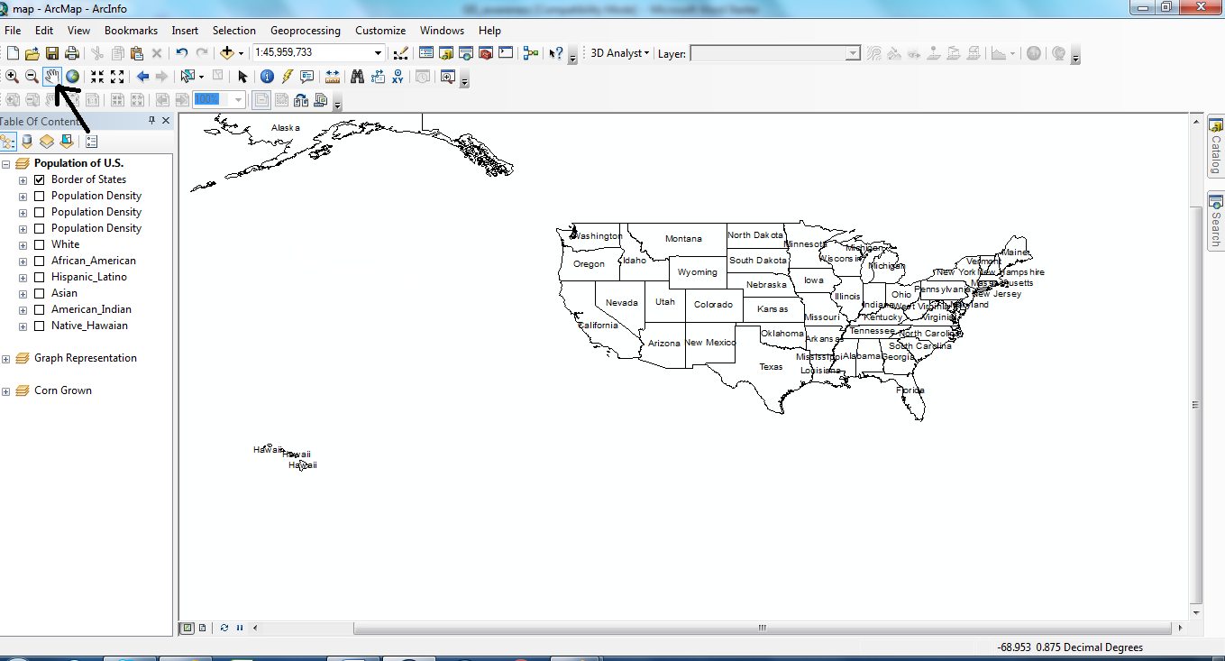
Figure 11. Screenshot of example for moving the map
Please drag the map to the lower right corner. Do you see Alaska?
10. Enanging the map to reveal the full extent:
As you have seen the map can be zoomed in, zoomed out or moved to another place. To view the full extent of the map layer, click the full extent button (see figure 12).
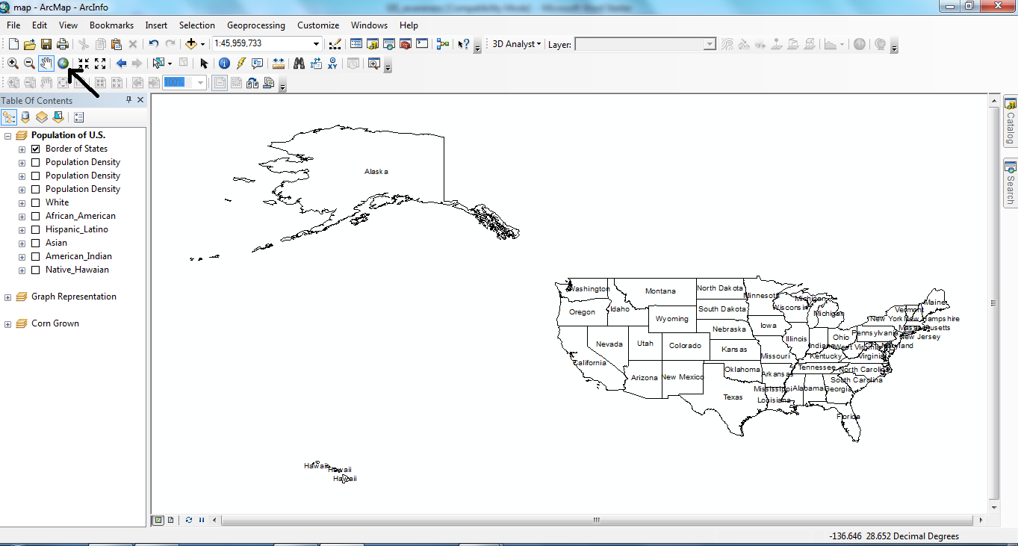
Figure 12. Screenshot of the full extent of the map layer
What can you see when you click the full extent?

11.Creating a graph:
In order to use the graph feature, the database of the map layer must support graphic creation. To create a graph, click on View→Graphs→Graph of Each State (see figure 13).
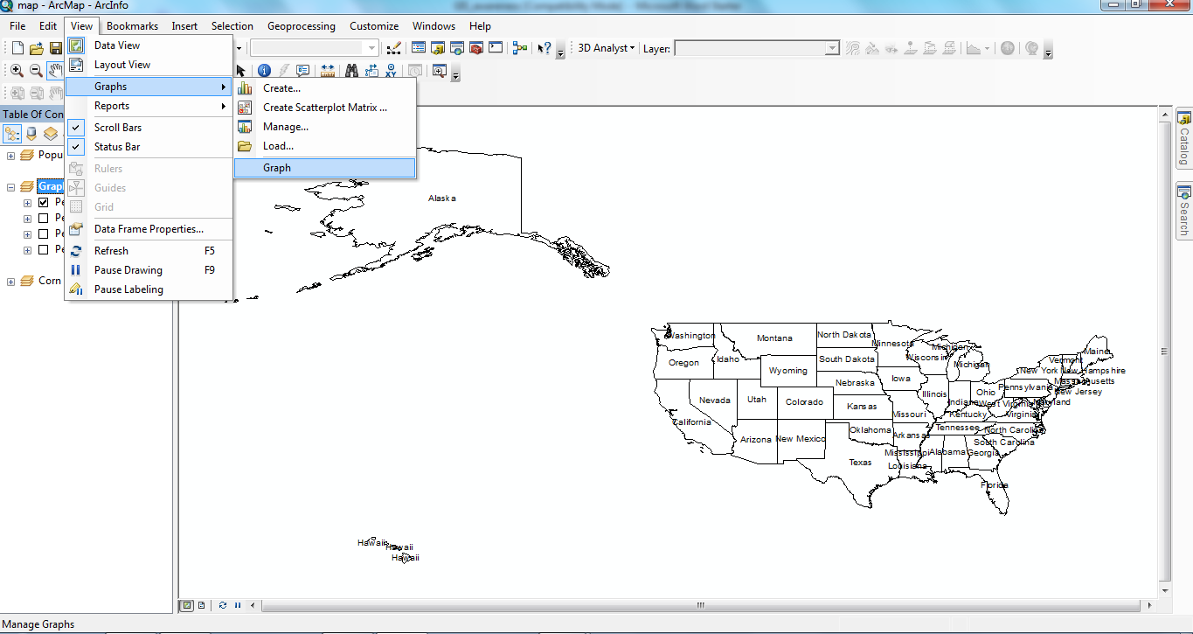
Figure 13. Screenshot of the graph feature

Choose the select feature button found in the tools menu and click on any state on the map. The graph on the opened window will display the related information for that state (see figure 14).

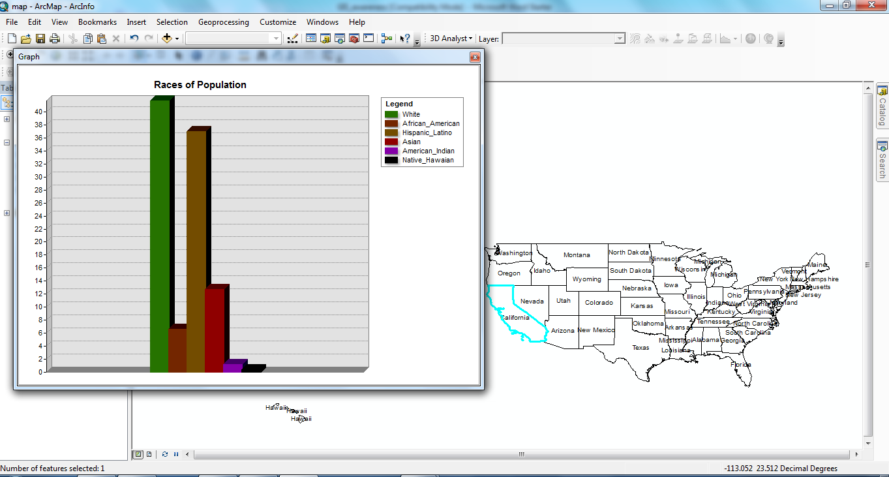
Figure 14. Screenshot of the graph property for a selected map feature

What is the distribution of race in Ohio, as found on the graph?
Hint: Select the state of Ohio first.

12.Looking at the attribute data for any state:
Choosing the identify button found in the tools menu changes the cursor to allow you to find out more attribute information on any map feature when clicked (see figure 15).

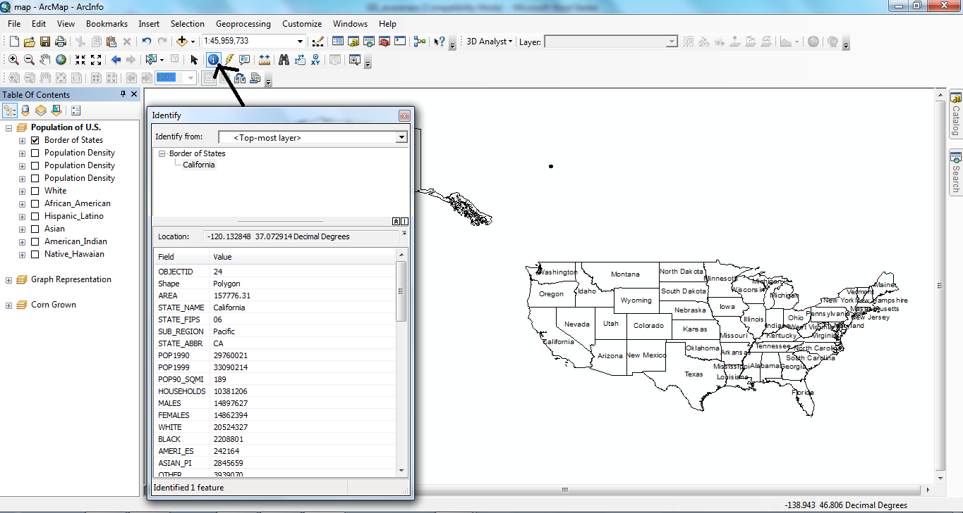
Figure 15. Screenshot of the identify feature

To view the attribute data for the states, right click on the desired map layer and click “open attribute table”. The attribute table will pop up on the display and reveal all related data for each state (see figure 16-17).
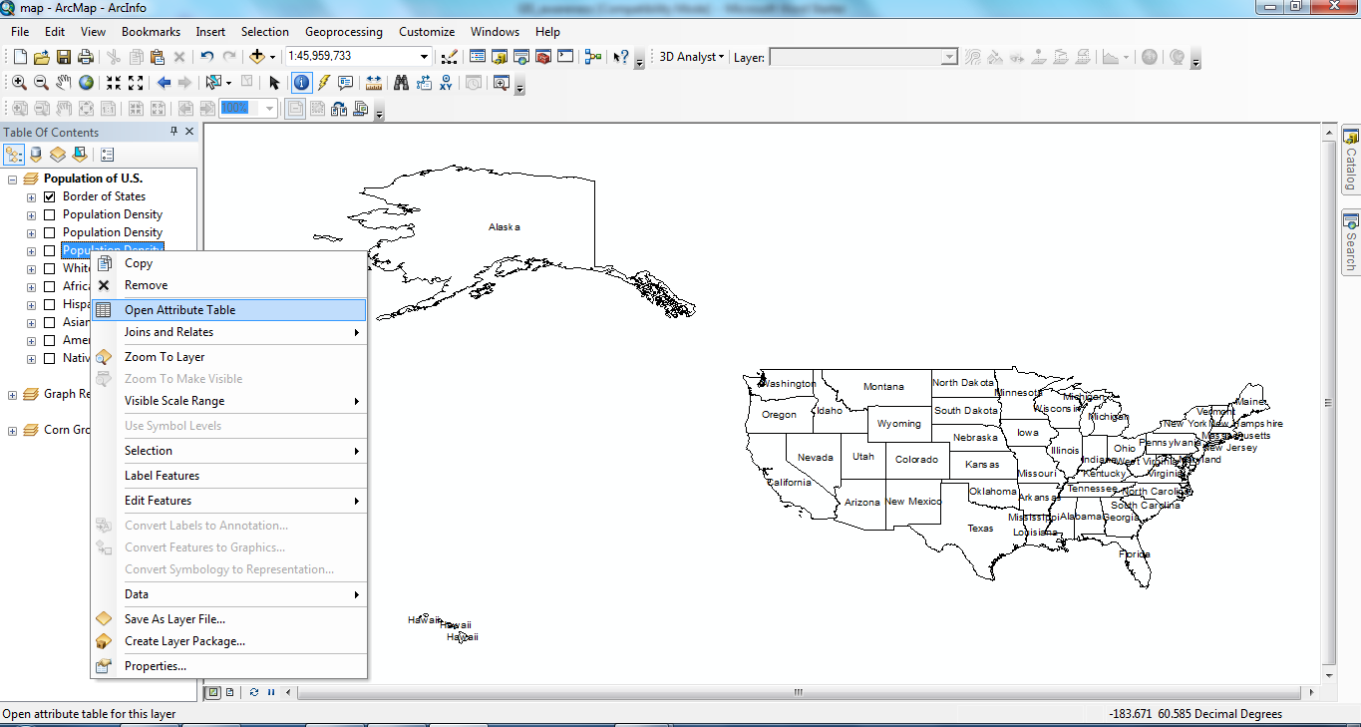
Figure 16: Screenshot of opening the Attribute Table

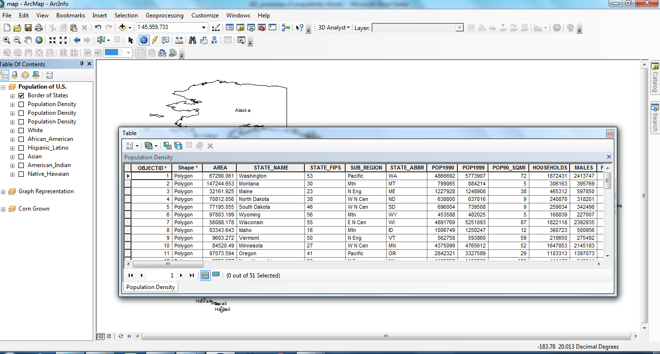
Figure 17: Screenshot of the attribute table

If you only want to look at the population information for Colorado, which feature (identify or the attribute table) is more useful for you?

13.Finding the geographic coordinates for any location on the map
By using the “go to XY” button found in the tools menu, you can find any coordinate on your map. Click the “go to XY” button, type in a latitude and longitude coordinate and click “add point” on the opened window.The location of this coordinate will appear as a symbol on the map (see figure 18).
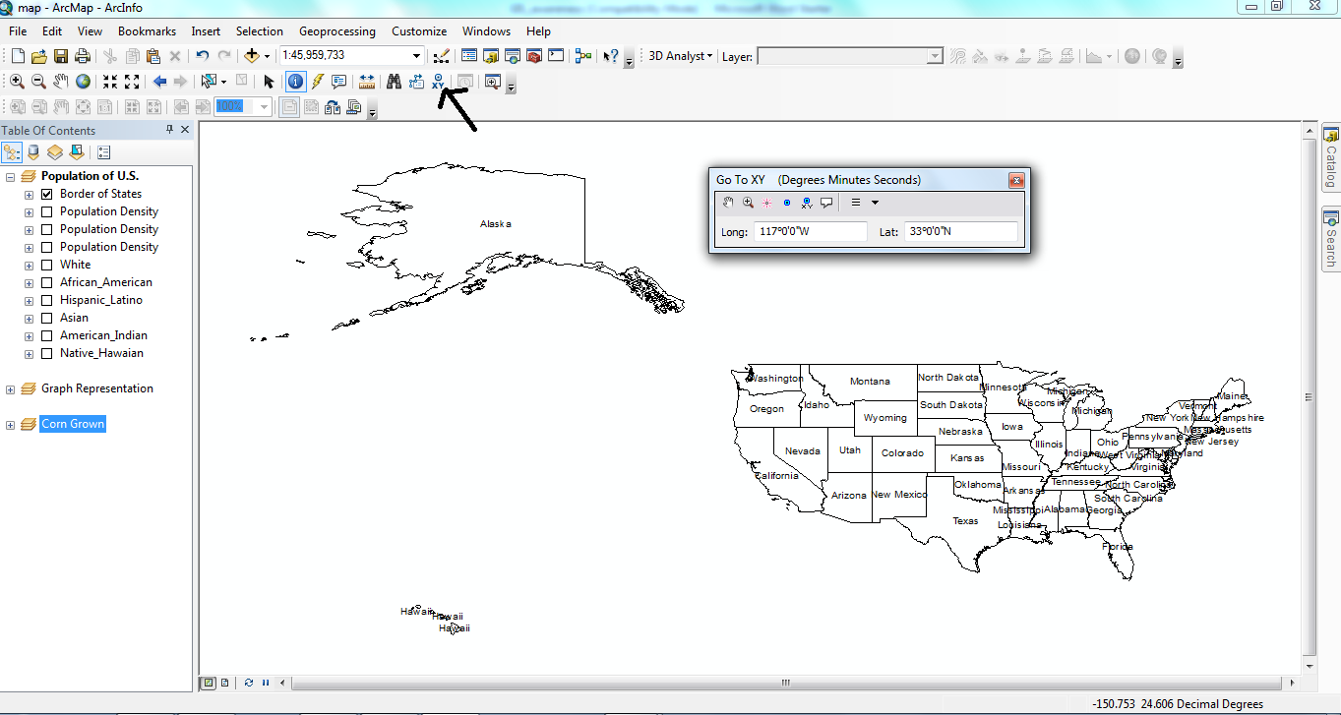
Figure 18. Screenshot of mapping a coordinate location

Enter the coordinates 77° 10' 33'' W and 38° 47' 20'' N using the “go to X Y” button. In what state is the coordinate located?

14.Removing a previous xy coordinate from the map:
To remove a plotted xy coordinate, click the select elements button found in the tools menu Right-click the plotted point and click delete(see figure 19).
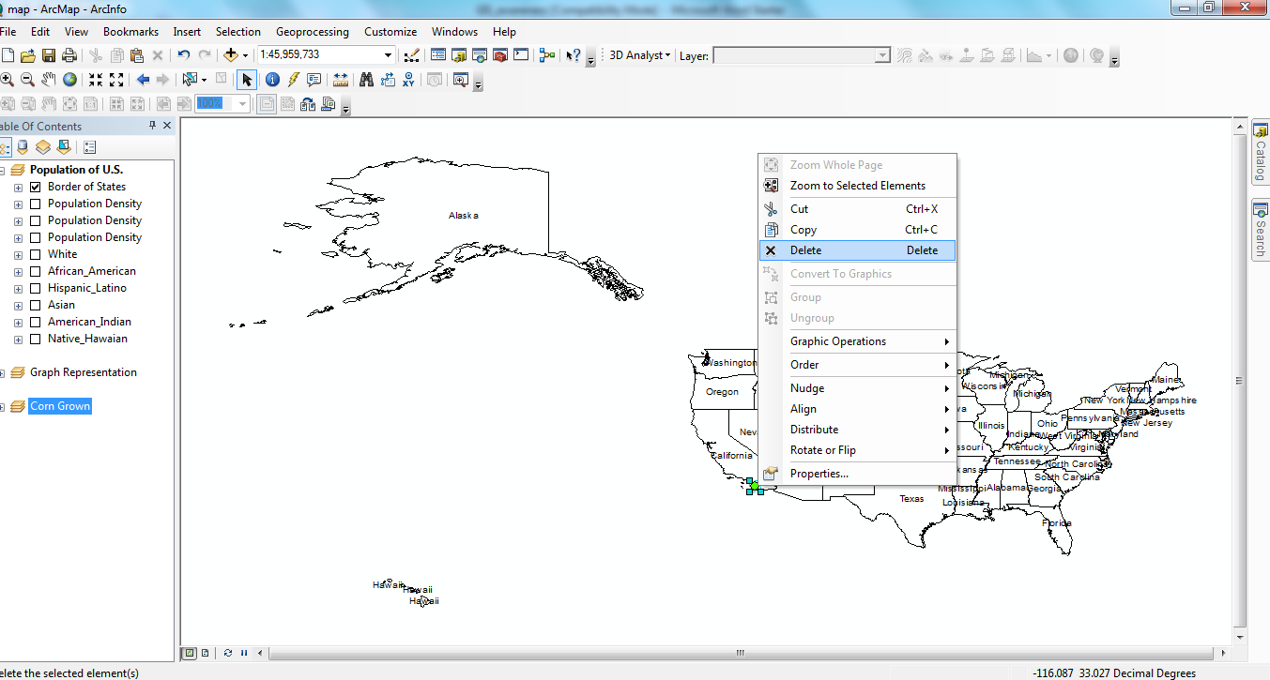
Figure 19. Screenshot of removing a plotted coordinate point.

15.Measuring distance between two points:
To measure the distance between any two points, click the measure button found in the tools menu. Click the first location, and while continuing to hold down the mouse button, drag the line to desired final locations. The distance will appear in the openedn window (see figure 20).
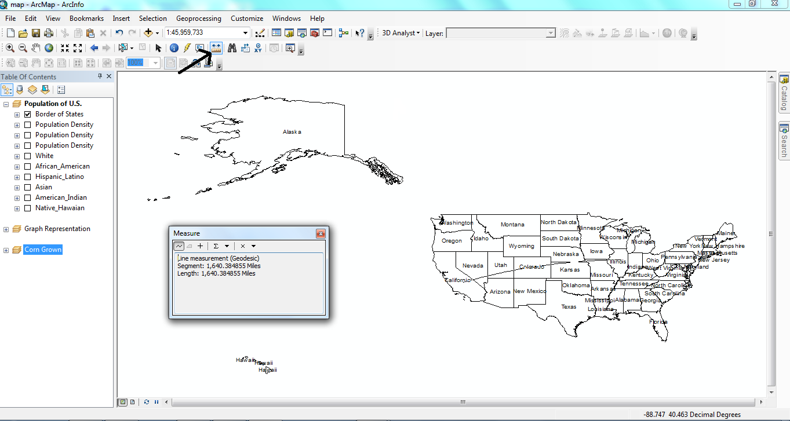
Figure 20. Measuring distance between two points on the map

For the first time, you will visit a friend who is living in Utah. You want to take a bus trip; however, you do not have any idea about the distance between California and Utah. What property will help you in ArcMap?

16.Using hyperlink feature:
If any media object (such as a picture or video) is found within the database of any layer it can be displayed on the map screen. To do so, click the hyperlink button found in the tools menu and click on any state (see figure 21).
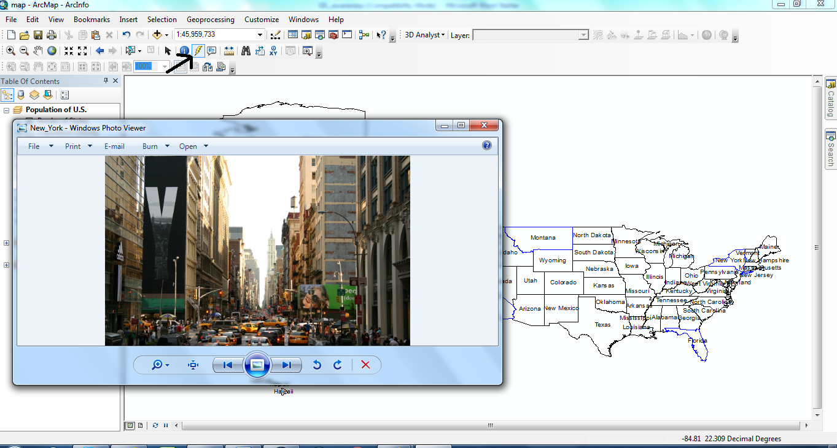
Figure 21. Screenshot of an example of the hyperlink feature
What do you see when you click on the state of California with the hyperlink feature?

17. Printing your map:
If you need to print a map you have prepared, you can do so by using the “layout view”.
Click the “layout view” button found along the bottom of the display screen (see figure 22).
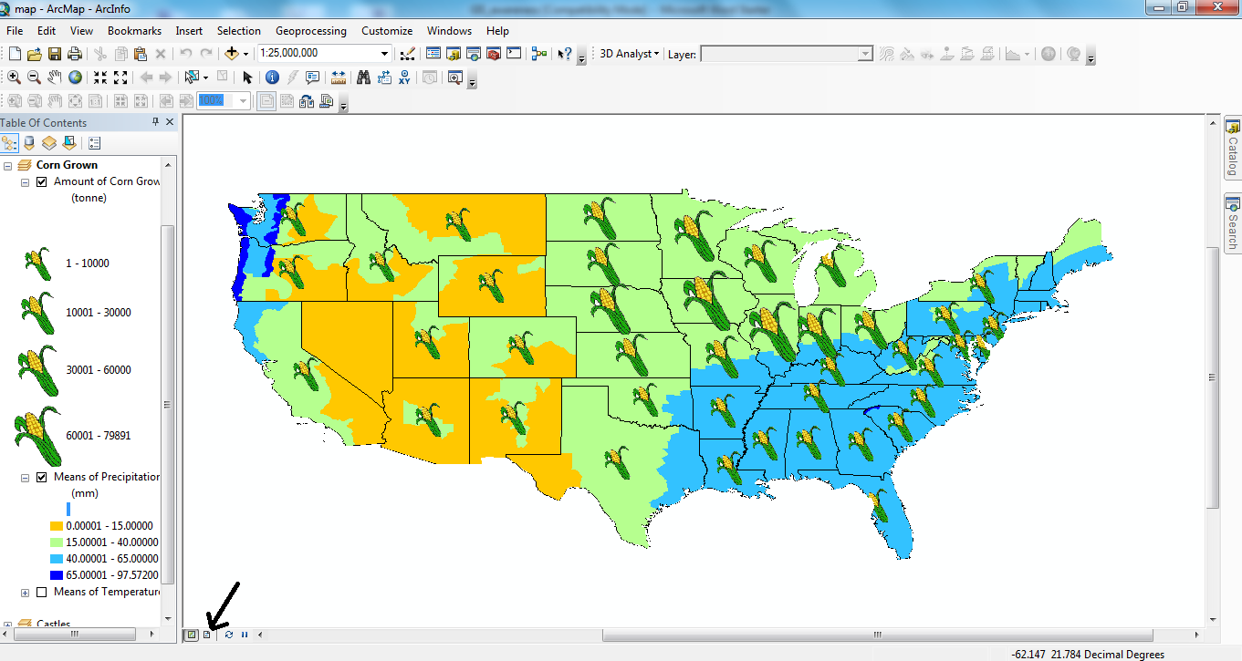

Figure 22. Screenshot of the location of the layout button.

On the “layout view” button opened the layout screen. You could click the insert button and you could choose options such as title, legend, north arrow and scale bar or text. These properties would be added on the map (see figure 23).

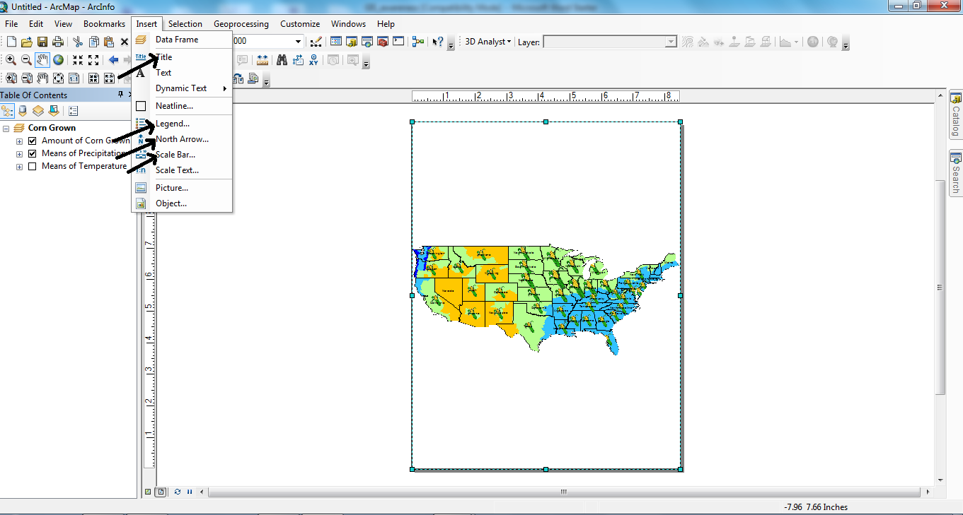
Figure 23. Screenshot of the location to insert features for enhancing your map.

Your map is ready to print now!

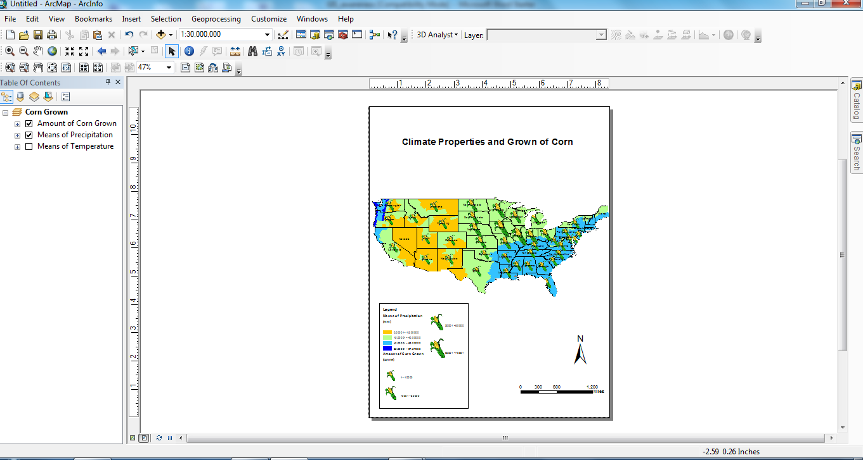
Figure 24. Screenshot of a final map readye to print from layout view.

