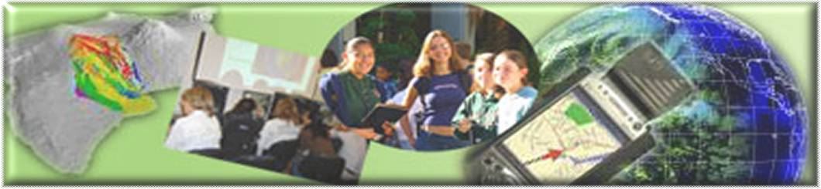

GIS Career Awareness Learning Module # 1

Version 4.0 July 28, 2008

The Digital Earth --- Virtual Globes and Computerized Maps

- Estimated Time: 2.5 hours
- Learning Goal: This module will introduce the concept of the Digital Earth. The intended goal of all of the module’s learning activities is to demonstrate to students how useful it would be to spatially represent data and imagery on virtual globes and computerized maps (computer/digital cartography). In the course of the learning activities, students will have the opportunity to learn and use engaging software such as Google Earth.
- Platforms: PC, Mac, or UNIX.
- Software Tools Required: Google Earth, Web browser with high-speed Internet Access. Installation instructors for educators and users are available in the Appendix at the end of this learning module.
- INSTALLATION: Educators or Lab Administrators may view step-by-step installation instructions in the Appendix of this learning module.
- Allied to California Content standards nine through twelve: GIS Learning module #1 can be allied to the following California Content standards:
- History-Social Science Content Standards
11.2.2 Describe the changing landscape, including the growth of cities linked by industry and trade, and the development of cities divided according to race, ethnicity, and class.
- Science Content Standards
6.b (Ecology) Students know how to analyze changes in an ecosystem resulting from changes in climate, human activity, introduction of nonnative species, or changes in population size.
- English-Language Arts Content Standards
1.1 (Writing) Establish a controlling impression or coherent thesis that conveys a clear and distinctive perspective on the subject and maintain a consistent tone and focus throughout the piece of writing.

Note: This Web-based GIS learning module was developed with support from a National Science Foundation – Advanced Technological Education Program Research Grant (NSF-ATE DUE # 0401990): “A Scalable Skills Certification Program in Geographic Information Systems (GIS).” ( http://geoinfo.sdsu.edu/hightech )

ANSWER ALL QUESTIONS ON THE SEPARATE ANSWER SHEET

Section 1 – Google Earth

Part I – Google Earth and its Basic User Controls

Google Earth is a friendly 3D, Internet-based Geographic Information System (GIS) application. This application was originally developed by the Keyhole Inc. located in Silicon Valley. In 2004, Keyhole Inc. was acquired by Google. Google re-packaged Keyhole’s 3D Virtual globe software and release the new version, call “Google Earth” in June, 2005. The concept of the Digital Earth was unveiled to the general public by Google Earth; many researchers or governments agencies started to utilize Google Earth for their works. The software enables you to virtually fly over any place in the world from your computer.

The following exercises will give you hands on experience with using these software applications as learning and research tools.

Begin by starting the Google Earth application.
Start Google Earth, you have two ways:
  - Click on the Google Earth icon 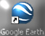 on your desktop.
  - Use the “Start” button (Start > All Programs > Google Earth > Google Earth).

Learn about Google Earth’s basic features and controls. Please spend no more than 10 minutes completing the following steps.

[1] Toggle on some Points of Interest such as “Roads,” “Terrain,” and “Borders” by clicking on the check boxes next to them (Scroll through and expand the folders in the Layers list of the bottom-left side of Figure 1-1 below). This will enable you to view these features on the virtual globe when you are zoomed in sufficiently close.
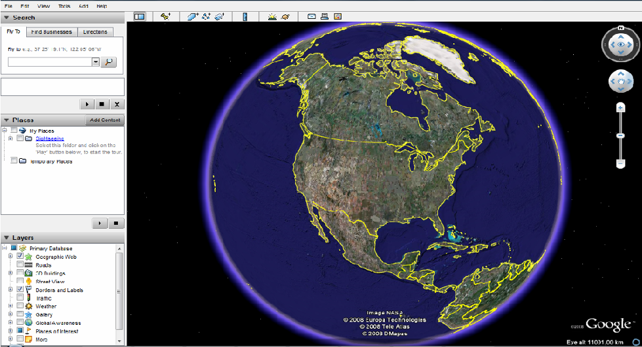

Figure 1-1: Google Earth Primary Map Controls and Functions
Go to the “View” pull-down menu and toggle on the “Overview Map” by clicking on the option from the pop-down list. If it is already selected, leave it alone.

[2] Here is a list of some of the basic controls and their functions:
  - The “Look Joystick” control  : Use the Look joystick to look around as if you were turning your head. Click an arrow to look in that direction or continue to press down on the mouse button to change your view. After clicking an arrow, move the mouse around on the joystick to change the direction of motion.
  - The “Move Joystick” control: Use the Move joystick to move your position from one place to another. Click an arrow to look in that direction or continue to press down on the mouse button to change your view. After clicking an arrow, move the mouse around on the joystick to change the direction of motion.
  - The Zoom Slider: To get closer to the ground to see more detail but in a smaller geographic area. Try to clicking and dragging the slider toward the plus/minus sign; try double-clicking on any part of the image.

  - The Hider/Show Sidebar  : To conceal or the display the side bar (Search, Places and Layers panels).
  - The “Add Placemark” control  : To add a placemark for a location.

  - The “Measure” control  : To measure a distance or area size.

  - The “Add Overlay” controls  : To create and add your own overlay features onto Google Earth. You can draw a polygon, a line, or add a graphic image to the map which Google Earth will “drape” over the terrain.

  - Email : To send the current view to a user with Google Earth or send an image of the current view to an email recipient.

  - : To show the current view in Google Maps in your web browser.
  - : A switch press between sky and earth. Click it to view stars, constellations, galaxies, planets and the Earth's moon.
Let’s quickly try some of the steps you learned above. Spend about four minutes.

[1] Be sure that Google Earth is running.

[2] Type “San Diego” in the “Fly To” address field and then press the enter key.

[3] Now we are going to introduce an important concept in GIS called, “Map layers.” Map layers are layers of map features, data, or imagery that can be overlaid or stacked together like layers on a cake or toppings on a burger.

Now turn on the “Geographic Web,” “Terrain,” “Roads,” and “3D Buildings” features in the “List of Layers” (Figure 1-2); answer the following questions A-1 and A-2 on the separate answer sheet:

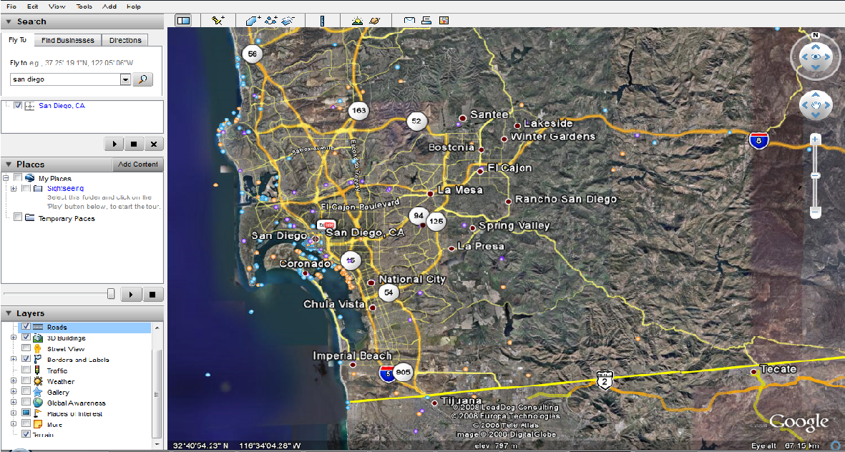
List of Layers

Figure 1-2: List of Layers

A-1: Click the points (blue, purple, and orange) shown on the map, what websites provide these information?

Try some examples of 3D View.

a) The Grand Canyon in Arizona (dramatic terrain):

- Fly to the Grand Canyon by Entering “Grand Canyon” in the “Fly To” Address Field, choose terrain, and press enter. (See Figure 1-3)

- Click on the “Look Joystick” control until you see the terrain (See Figure 1-4).

- Exploring the local area by moving around (panning) and zooming in and out.
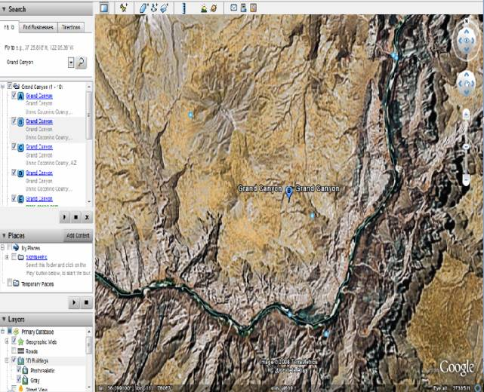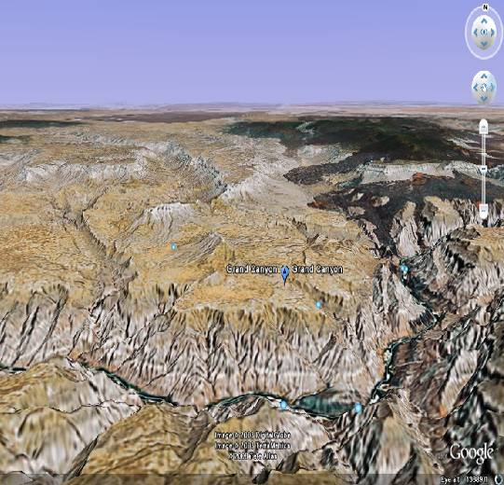
Fly to Address Field

Figure 1-3 the Grand Canyon Figure 1-4 a 3D perspective of
in Arizona Grand Canyon in Arizona

b) Downtown San Diego:

- Try the same way as above. Choose Roads, 3D buildings, borders, and free to zoom in, zoom out and tilt (Figure 1-5).

You just need to enter “San Diego, CA” in the “Fly to” Address Field. The focus of Google Earth is the downtown San Diego area.

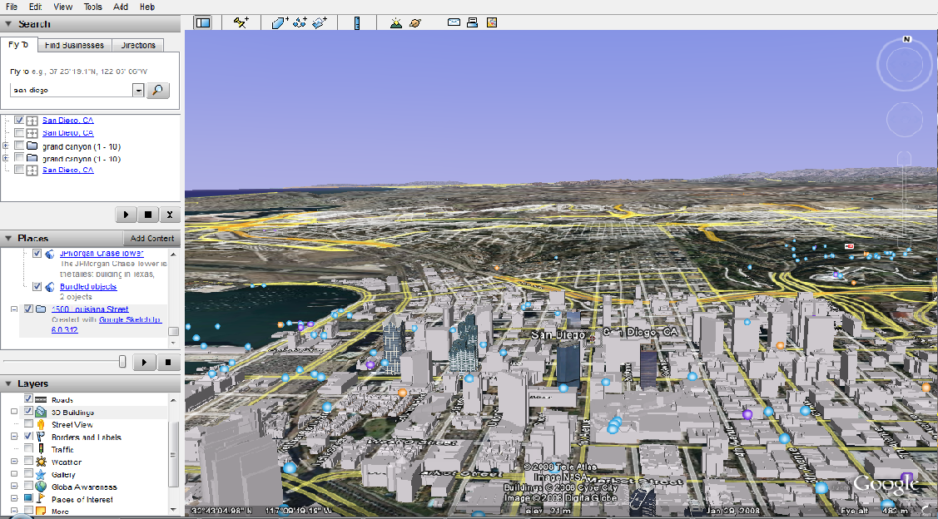

Figure 1-5 Downtown San Diego

A-2: After touring the Grand Canyon and downtown San Diego, write down your opinions regarding the usefulness of different function like “terrain” and “3D Buildings”.
[4] Now add more feature layers to Google Earth. You may want to select “Borders,” “Transportation,” “Geographic Features,” etc., and their associated features may not be visible until you sufficiently Zoom In or go to the geographic areas where they occur. This is called “scale-dependent features.”

[5] Now you are free to use the Google Earth navigation tools like “Zoom In,” “Zoom Out,” “Tilt,” etc. to explore the entire globe.

Part II – Please complete the following exercises and answer the following questions. You should try to spend no more than 30 minutes doing these exercises:

To locate a unique point on the earth, a coordinate system must be used. Google Earth and many other applications use the geographic coordinate system of latitude and longitude.

[1] Latitude: Latitude describes an imaginary survey line which runs east to west. You can think of these parallels of latitude as forming the rungs on an imaginary ladder. Latitude, when used in a coordinate, is expressed as an angle from 0 to 90 Degrees either north or south of the equator (See Figure 1-6).

The most important parallel of latitude is the equator. It surrounds the middle of the earth like a belt and can be described as 0 Degrees latitude.

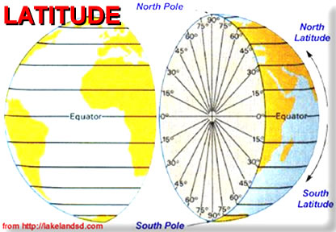
Figure 1-6: Latitude

In the “Decimal Degrees” system, it is important to note that when you are going north of the equator the values range from 0 to 90 Degrees and you are going in the “positive” direction. Think of this as going “up” on the imaginary ladder starting from the equator. You go south of the equator; the values range from 0 to -90 Degrees. Think of this as going “down” the imaginary ladder from the equator.
As an example, Sydney, Australia, which is in the Southern Hemisphere, lies at approximately -33.87 Degrees Latitude (note the negative sign).
Anchorage, Alaska which lies in the Northern Hemisphere lies at approximately 61.22 Degrees Latitude (note that it’s a positive value).

When used on a map, a single latitude value is sort of like the equivalent of a y-coordinate in the Cartesian coordinate system.

[2] Longitude: Longitude describes an imaginary survey line running south to north. There are 360 Degrees of longitude and they all converge at the North and South Poles. Longitude, when used in a coordinate, is expressed as an angle from 0 to 180 Degrees either west or east of the Prime Meridian (See Figure 1-7).

The most important meridian of longitude is the Prime Meridian. This imaginary line extends from the South Pole to the North Pole and passes through Greenwich, England. It can be described as 0 Degrees longitude.

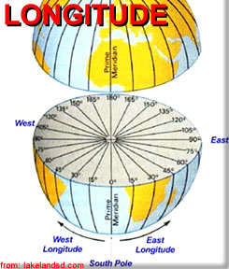

Figure 1-7: Longitude

In the “Decimal Degrees” system, it is important to note that when you are going west of the Prime Meridian, the values range from 0 to -180 Degrees and you are going in the “negative” direction. You go east of the Prime Meridian; the values range from 0 to 180 Degrees. At positive OR negative 180 Degrees longitude, you reach the International Date Line. This imaginary line runs from the South Pole to the North Pole in the middle of the Pacific Ocean and is on the opposite side of the earth from the Prime Meridian.

As an example, Sydney, Australia, which is in the Eastern Hemisphere, lies at approximately 151.21 Degrees Longitude (note that it’s a positive value).
Anchorage, Alaska, which is in the Western Hemisphere, lies at approximately -149.89 Degrees Longitude (note the negative sign).

When used on a map, a single longitude value is sort of like the equivalent of an x-coordinate in the Cartesian coordinate system.

[3] Decimal Degrees: Latitude and longitude are most commonly expressed in “Degrees, Minutes, and Seconds” or “Decimal Degrees.” Both are equivalent. However, for the sake of simplicity, you are going to use “Decimal Degrees.”
In order to view map coordinates in decimal degrees, you will have to make a change. First, select the “Tools” pull-down menu and click on “Options…”

The Google Earth Options menu should appear (Figure 1-8). In the Google Earth Options menu, be sure the “3D View” tab is selected and change the “Show Lat/Lon” option to “Degrees” (Figure 1-8). In this case, the latitude (y-coordinate) and longitude (x-coordinate) will be represented in decimal degrees. This is how most GIS and related software applications represent latitude and longitude. Save the settings by clicking on the “OK” button.

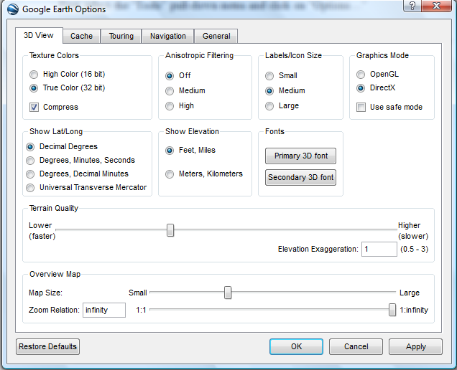
Figure 1-8: Google Earth Options Menu with Degrees Selected for Latitude and Longitude in the 3D View Tab

Now you are going to determine what the Latitude and Longitude coordinates of your school are?

Hint:
- Be sure the “borders” and “roads” features are selected in the List of Layers.
- Locate your school.
- Find out the latitude and longitude coordinate values by moving your mouse cursor over the center of your school in the view window.
Coordinates will appear in the bottom-left corner (See Figure 1-9 below).

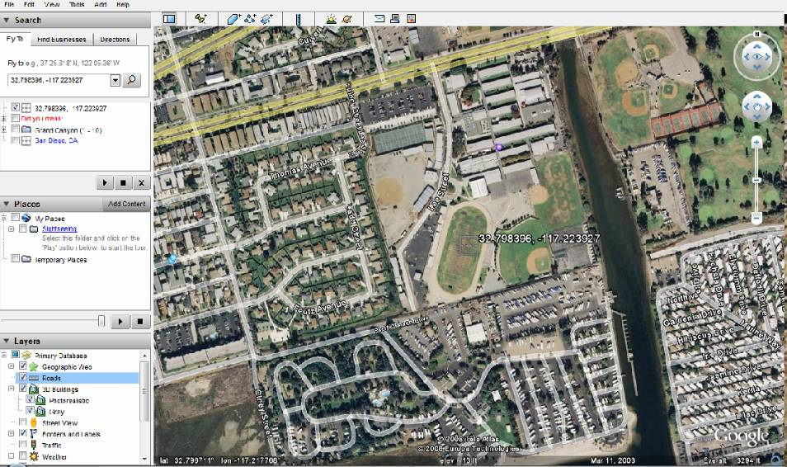
Figure 1-9: Latitude & Longitude Coordinates of Mission Bay High School
Latitude & Longitude Displayed at the Bottom Left-side Comer of Scene
(San Diego, CA)

Alternatively, you can enter the full address of your school in the “Fly To” address field.

[4] After you determine where your school is located, create a Placemark that marks it. To do this you need to follow a few easy steps and spend no more than 8 minutes:
- Make sure your school is displayed near the center of your screen.
- Click the “Add Placemark” control. It looks like a pushpin and is located near the top of your Google Earth window.

A New Placemark control panel should pop-up and a Placemark will appear near the center of the screen (Indicated by the black arrow in Figure 1-10 below).

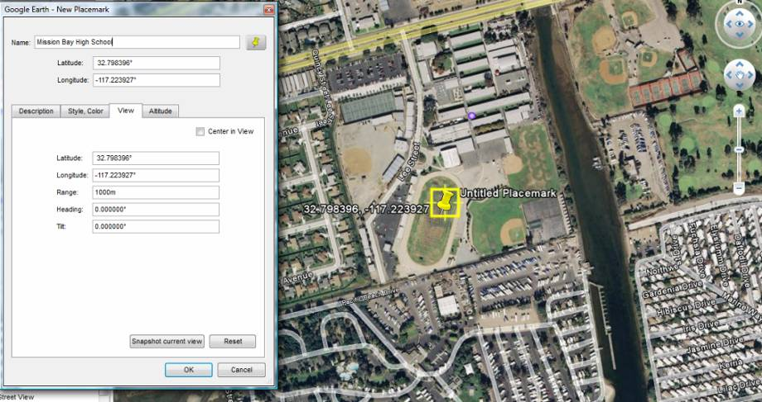
Name Field
New Placemark

Figure 1-10: Creating a Placemark in Google Earth
(Mission Bay High School, San Diego, CA)
- Click and drag the Placemark on the map to the center of you school campus.

- Type in the name of your school in the Name field of the New Placemark control panel (Figure 1-10).The Placemark will then, automatically display your school’s name.

Before you press the OK button to finish creating the Placemark, fill in the following information from the New Placemark control panel on the separate answer sheet:

A-3: Name Which You Entered for the School:

- Click on the “View” tab in the New Placemark control panel. You will see the Latitude and Longitude that is associated with your Placemark.

Based on the information that you read from the New Placemark menu, fill in the following on the separate answer sheet:

A-4: Latitude as Shown in the New Placemark control panel:

A-5: Longitude as Shown in the New Placemark control panel:

- Click on the OK button to save the new Placemark of your school on the map. When you Zoom Out, the new Placemark of your school will remain visible.

Now you will determine what is the direct straight line distance between your school and San Diego State University (SDSU)?

- Type the address of SDSU in the “Fly To” address field. The address is near 5398 Campanile Dr., San Diego, CA.

- Create a new Placemark for SDSU.

- Zoom out enough so you can see both Placemarkers (your school and SDSU). You should be able to do this even if your school is located in another country!

- Open the Measure Tool control, which is located in the Tools pull-down menu. It might also be called Ruler depending on which version of Google Earth you are using. Use Miles as your measuring unit and click on your school and then click on SDSU while the Measure Tool is open. (Figure 1-11)

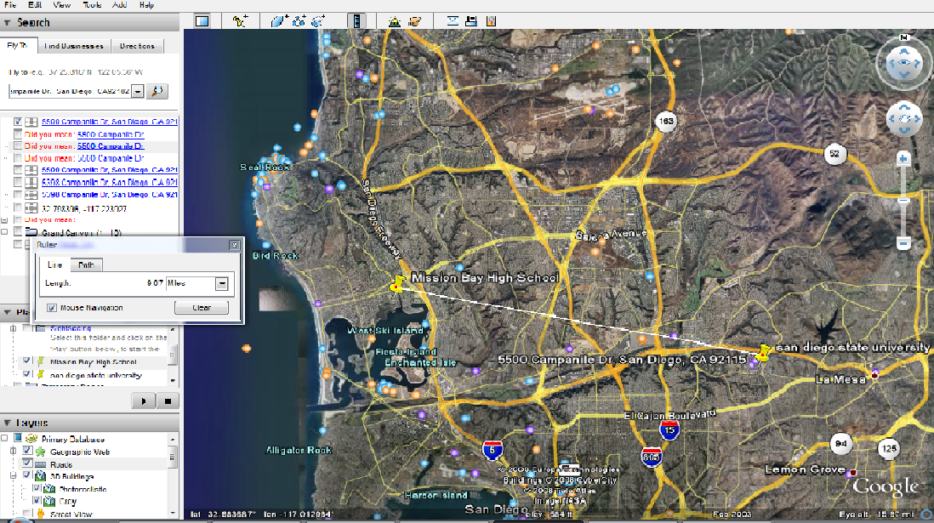
Distance

Figure 1-11: Determining the Distance between Two Places

Answer the following question on the separate answer sheet:

A-6: Distance between Your School and SDSU (miles):

Now close the Measure Tool by clicking on the X on the top right-hand corner of the Measure Tool menu.

In this next step, you will create street map directions between your school and SDSU.

- The “From”: Click right mouse (or Mac users, hold down the Control button and mouse Click) on your newly-created high school Placemark. A pop-up menu should appear. Select the “Direction from here” option.

- The “To”: Right mouse click (or Mac users, hold down the Control button and mouse click) on the SDSU Placemark which you created. Select the “Direction to here” option.

Now, Google Earth should automatically create the street navigation direction between your school and SDSU (Figure 1-12)!

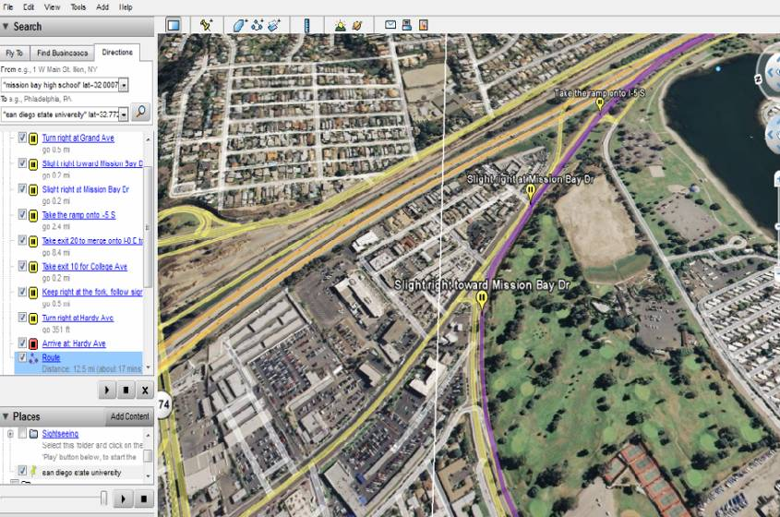
Generated Turn-by-turn Instructions
Fly Over Route

Figure 1-12: Generating Turn-by-Turn Navigation Instructions

If you zoom into your school, you will see street by street instructions all the way to SDSU!

A-7: Copy down the first driving instruction that Google Earth lists FROM your school (Just copy down the first one!) on the separate answer sheet:

Now, let’s try something really cool.

- Press the “play” button under your list (Figure 1-12) and watch the route fly over animation. (Some versions of Google Earth may not have this feature enabled.)

[5] Other questions with Google Earth.

- “Area 51” is a Top Secret U.S. Military site in the Nevada desert that many in the government claim does NOT exist! The coordinates are 37.249361,-115.812339.

Now briefly answer the following question based on what you find. What is Area 51? (Hint: Copy these coordinates into the “Fly To” address field. Be sure the “Fly To” address field tab is selected!)

A-8: Briefly describe “Area 51” on the separate answer sheet:

- What is the name of the nearest Pizza restaurant to your school? (Hint: Make sure your school is near the center of the screen then; Select the “Find Businesses” tab located next to the “Fly To” tab (Figure 1-13) and enter Pizza in the “What” field then press enter.)

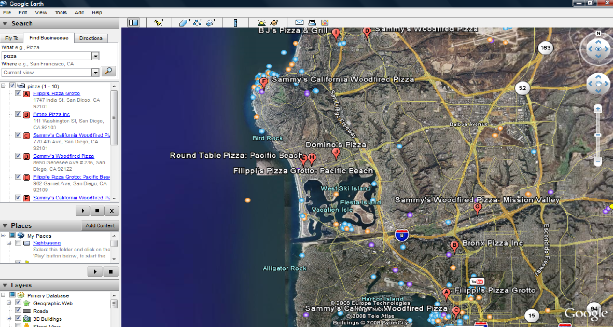
Figure 1-13: A Local Search of Pizza Restaurants

A-9: What is the name of the nearest Pizza Restaurant to your school? (Answer on the separate answer sheet.):

Measure how far it is from your school with the Measure Tool.

A-10: How far is the Pizza Restaurant from your school? (Give the distance in feet.) (Answer on the separate answer sheet.):

- Alcatraz Island, near San Francisco, California, used to be used as an “inescapable” high-security prison where the worst and most notorious criminals were kept. The island known as “The Rock” is surrounded by dangerous currents and freezing-cold water. It was supposed to be nearly impossible to escape!

- Determine which direction the city of San Francisco is from Alcatraz Island and how far apart they are. (Hint: Use the Fly To field and type Alcatraz.)

- The idea is to determine how far someone needs to swim in the ice-cold water to escape the prison island (If you need to know the city names on the viewer, simply toggle on the layer called, “Populated Places” in the “List of Layers.”)

- Determine what direction the Golden Gate Bridge is from Alcatraz Island.

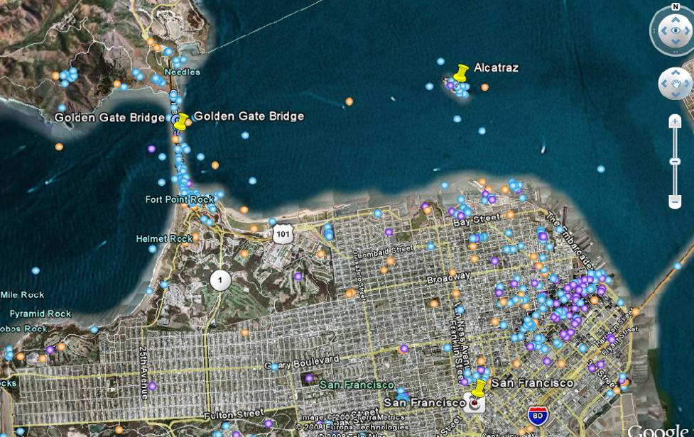

Figure 1-14: Placemark of Alcatraz Island, San Francisco and the Golden Gate Bridge shown on Google Earth Map

A-11: Which direction must you go (North, South, East, West) from Alcatraz Island to the shores of the city of San Francisco? (Answer on the separate answer sheet.):

A-12: How far apart is Alcatraz Island from the nearest point along the shoreline of the city of San Francisco (in feet)? (Answer on the separate answer sheet.):

A-13: Which direction (North, South, East, West) is the Golden Gate Bridge from Alcatraz Island? (Answer on the separate answer sheet. (Make sure the 3D Buildings layer is toggled on.)

Part III – Google Earth Applications

[1] The Bird Flu Example. You should spend no more than 10 minutes to finish this part.

Bird flu is a contagious viral infection that can affect all species of birds. The contagious virus lives primarily in the respiratory system in the infected birds, and human infection occurs when people come into contact with infected birds or contaminated surfaces. There are thought to be millions of migratory ducks and wildfowl which carry the disease. Worldwide, according to the World Health Organization, more than 135 humans’ infections of the virus have been recorded.

On November 16, 2005, Nature Magazine's Senior Reporter Declan Butler has thoroughly researched the Avian Flu outbreak information and has published the confirmed cases of Avian Flu in a Google Earth file. His avian outbreak map includes Human cases, and a time series of placemarks showing the progression of the flu over the last 18 months.

- Click the link http://www.nature.com/nature/googleearth/avianflu1.kml to open the KML file. Then Google Earth will be automatically launched (Figure 1-15). If you see alert message window, click “continue”.

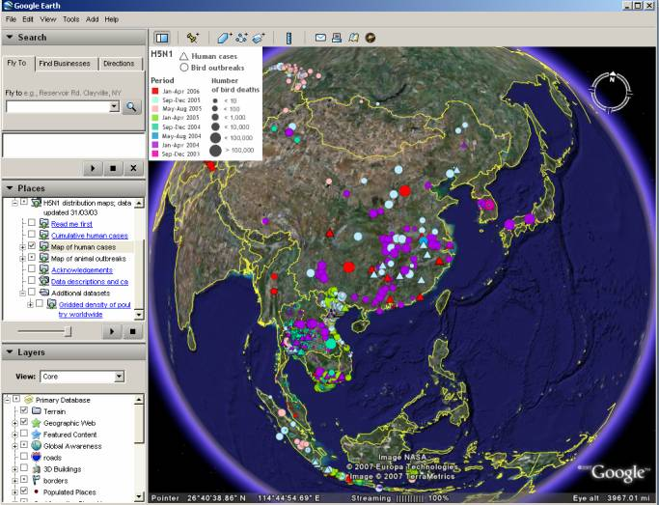

Figure 1-15: Bird Flu Outbreak map of Google Earth

- In the “Place Panel”, select the layer of “Additional datasets.” If you see the alert message window such as “Unsupported image format, go_Russia.png”, click “ok” and remove the Russia layer (“Additional Datasets -> Gridded density of poultry worldwide->Russia”)

This way you can view the poultry density for any continent you are interested in. You can focus on the human cases or animal breaks by selecting the respective layers.

For example, you may notice that there were quite a few human cases happened in the first several months of 2006 in the Middle East (Figure 1-16). For each case, you can make an inquiry to learn more information by directly clicking on the symbol. Please keep track of the spread of the flu virus based on the maps.

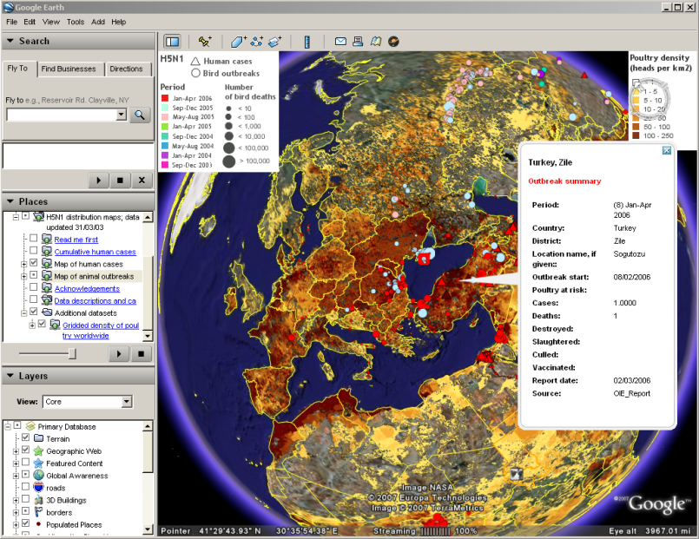

Figure 1-16: Bird Flu Outbreak map of Google Earth Focused in the Middle East

A-14: Describe the geographic and seasonal patterns of the bird flu for both bird and human cases in the Middle East by viewing the bird flu maps.

A-15: Try to identify how many human cases happened in Turkey and report their Latitudes and Longitudes (Hint: in the place panel, only select the “Map of human cases”).

A-16: According to the maps, what region could be the most popular areas that are impacted by the bird flu (Hint: Use poultry density map and if possible try to search for bird migration information)?

[2] The Google 3D Warehouse Example. You should spend no more than 10 minutes to finish this part.

Computer-aided design (CAD) is the use of computer technology to aid in the design of 3D models and/or 2D drawings of physical components. CAD has become an especially important technology within the scope of computer-aided technologies. Google has developed its own CAD software “Google Sketchup”. You can use it to create, modify and share 3D models. It's easier to learn than other 3D modeling programs, which is why so many people are already using it.

The Google 3D Warehouse is an online repository of 3D models. Anyone can search for and download models, but to publish your own, you'll need to sign in using your Google account. If you model 3D buildings and would like to share them with the world, you can do so through the "Best of the 3D Warehouse" layer in Google Earth. Only the very best models are selected for inclusion in this layer.

- Navigate to the website http://sketchup.google.com/3dwarehouse and click the link “Featured Google Earth Modelers” under the catalog of “3D Building Collection” (Figure 1-17).

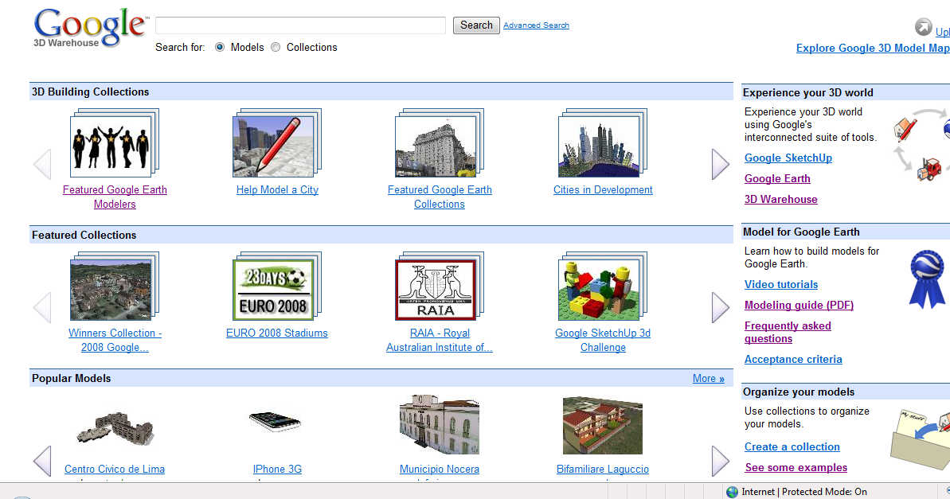

Figure 1-17: Google 3D Warehouse

- Choose any collection you interest in and click on it.

A-17: Please write down the name of the collection you choose and the people who share this collection. How many models are included in this module? (Answer on the separate answer sheet.)

- Click on “View in Google Earth”

- Click any model you interested in and see the 3D module in Google Earth (Figure 1-18). (Note: not all 3D models are available to see in Google Earth.)

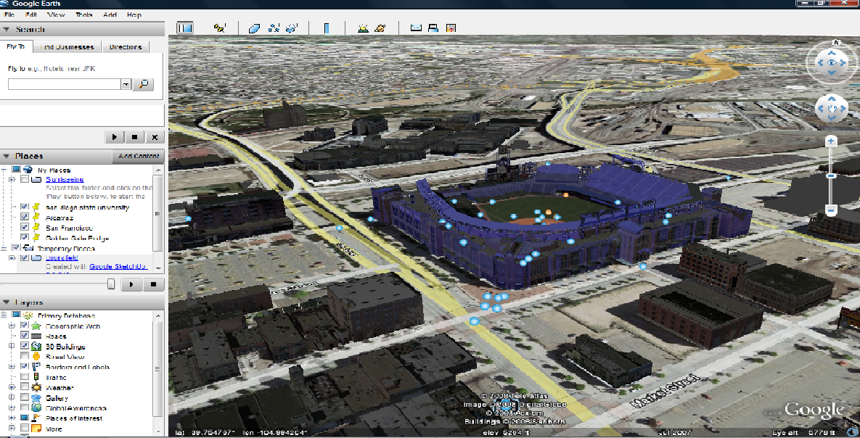

Figure 1-18: an Example of 3D Buildings in Google Earth

A-18: Please write down the name of the model you choose and describe this 3D model simply. (Answer on the separate answer sheet.):

Section 2 – Written Assignment

Now that you have seen and worked with examples of digital globes and computerized maps, we would like you to answer some questions about them. We want you to combine all of your answers into a 250-word paragraph (approximately one typed page) by including the following information on the separate answer sheet:

B-1: In your paragraph, quickly describe (in two sentences or less) the GIS applications that you used (Google Earth).

B-2: In your paragraph, also answer if you think that the GIS applications (Google Earth) can help people? It what ways can they help people? In what kinds of occupations/industries would they be useful?

B-3: In your paragraph, based on your experience with GIS applications (Google Earth), please discuss which application you liked the best and tell us WHY? Please also discuss what the best or “coolest” feature of your favorite application was.

Student Survey

This learning module was developed specifically for you---the students---in order to expose you to GIS and related geospatial technologies.

GIS and related geospatial technologies, similar to what you worked with in this learning module, are major components of one of the most important new industries for career growth. Businesses, organizations, and governments are increasingly seeking skilled talent in this industry.

Now, to benefit other students and the authors of this learning module, you are required to finish this Student Survey and please send it back to the San Diego State University NSF-ATE team. We would greatly appreciate your input. Please take time to answer these questions as openly and honestly as possible. They will not affect your grade or score. You can provide your feedback to your teacher/educator along with the learning module answers on the separate answer sheet.

Thank you for helping us improves our modules!

S-1: What did you like best about the learning module one? Why?

S-2: What did you like least about the learning module one? Why?

S-3: Was there anything that was really hard to understand or difficult to complete in the module one? What was it? Why?

S-4: Is there anything in this learning module one that we can add, exclude, or change to make it better? What is it?

STUDENTS MAY STOP HERE!
------------------------------------------------------------------------

Appendix: Installation Instructions for Google Earth

These simple instructions have been written using screen shots and instructions for the Windows Operating System. Installation instructions for the Mac and Linux Operating Systems are similar.

Be sure to have “administrative” privileges on the computer you are installing the software on. Accounts on computers in a lab setting usually limit installation to users with administrative privileges only.

1. Open your Web browser and navigate to URL:
http://earth.google.com/download-earth.html and click “agree and download”
2. On the next Web page, click on the “Download Google Earth” button.

After you have clicked on the “Download Google Earth” button, specify where you want to save the installation file on your computer and keep the original file name.

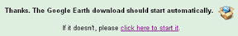
Figure A: Part of What is Displayed on the Web Page after Pressing the “Download Google Earth” Button

NOTE: Web browsers with pop-up or download blocking may get an error message. If this is the case, click on the “click here to start it” link displayed on the download page to manually initiate a download (Figure A).

3. After saving the installation file to your computer, close your Web browser and run the installation file by clicking on it.

4. Follow the Google Earth installation instructions that follow and accept the licensing agreement and any other installation messages that appear. The default “Complete” installation is sufficient for the learning module.

WINDOWS USERS NOTE: If you are given an option to “switch to ‘DirectX’mode,” we recommend that you respond by clicking “No” and keep Google Earth in ‘OpenGL Software Emulation’ mode since it is compatible with a greater number of computer graphics cards.

Answers to some of the most popular Google Earth-related installation questions are also available at http://earth.google.com/faq.html.

