High School GIS Awareness

Learning Module 1: Mapping Earthquake Magnitude & Plate Boundaries with ArcExplorer Java Edition for Education

A Scalable Skills Certification Program in GIS
National Science Foundation-Advanced Technological Education
Division of Undergraduate Education (NSF-ATE DUE) Research Grant #0401990



http://geoinfo.sdsu.edu/hightech

This GIS learning module is developed through a National Science Foundation – Advanced Technological Education Program Division of Undergraduate Education Research Grant (NSF-ATE DUE # 0401990): “A Scalable Skills Certification Program in Geographic Information Systems (GIS)”. This project is a collaborative research partnership between San Diego Mesa College, San Diego State University, San Diego City Schools, and members of the local community. Please explore our research Website to learn more about our research and programs.
http://geoinfo.sdsu.edu/hightech

Outline of this Document

1. GIS Learning Module Summary

2. Introduction to this GIS Learning Module

3. GIS Learning Module Audience

4. Software Installation

5. Data Preparation

6. Description of GIS

7. Description of the Research Project

8. Comments, Suggestions, and Inquiries

9. Disclaimer

10. Contacts

11. GIS Learning Module 1: Earthquake Chasers
GIS Learning Module Summary

Education Category
High School Earth Science Education

Grade Level
9th to 12th Grades

Learning Module Objective

The intention of this learning module is to introduce some GIS technology and features to high school-age students through the use of an earth science/physical science learning module on earthquakes/seismology/plate tectonics.

In this module, the student will make a map showing earthquake locations, color classify them based on earthquake magnitude, and identify plate boundaries. In these activities, the student will develop an understanding of the relationships between earthquakes and plate tectonic boundaries.

A major portion of this learning module is completed with the free ESRI, Inc. GIS software package, “ArcExplorer Java Edition for Education” and associated learning module data. Instructions for obtaining the requisite software and data are given below.

Learning Level

- Earth Science: Introductory
- GIS: Introductory

Required Materials-Computer Hardware

- Compatible Platforms:
  - Windows 98
  - Windows 98SE
  - Windows 2000
  - Windows NT
  - Windows XP
  - Macintosh OS-X (or newer)

- Minimum Recommended Configuration:
  - 250 MB Hard Drive Space Available
  - 16MB RAM
  - 2MB Video Memory
  - Color VGA Monitor
  - Keyboard
  - Mouse
  - Connection to the Internet (for initial software download, data download, and certain learning activities only)

Required Materials-Computer Software

Free Software:
ESRI ArcExplorer Java Edition for Education (AEJEE)
(Instructions for obtaining AEJEE are given below.)

Compatible Platforms:
WIN: Windows 98, Windows 98SE, Windows 2000, Windows NT, Windows XP
MAC: Apple Macintosh OS-X or newer

Required Materials-Learning Module Data

“seismic.zip” from ESRI K-12 Educational ArcLessons (author: Bob Coulter)

Files used in the “seismic.zip” ZIP archive file include the following:
- “country.shp”
- “plate_in.shp”
- “quak2000.txt”

Bob Coulter <bob.coulter@mobot.org> of the Missouri Botanical Gardens is the author of the original data files and lesson from which this GIS learning module was derived.

(Note: Actual file names do not include quotation marks.)

Optional Materials-Reference Reading

Earthquake Intensity (Richter Magnitude Scale) Information from the Ministry of Energy and Mines in the Province of British Columbia, Canada

http://www.em.gov.bc.ca/Mining/Geolsury/Surficial/quake/eq2.htm

Education Content Standards

This GIS learning module follows content standards specified by the California State Board of Education (http://www.cde.ca.gov/be/st/ss/scearth.asp).

The following topical areas are specifically covered in this learning module:

Grades Nine through Twelve - Earth Science

Dynamic Earth Processes

3. Plate tectonics operating over geologic time has changed the patterns of land, sea, and mountains on Earth's surface. As the basis for understanding this concept:
a. Students know features of the ocean floor (magnetic patterns, age, and sea-floor topography) provide evidence of plate tectonics.

d. Students know why and how earthquakes occur and the scales used to measure their intensity and magnitude.

California Geology

- The geology of California underlines the state’s wealth of natural resources as well as its natural hazards. As a basis for understanding the concept:
b. Students know the principle natural hazards in different California regions and the geologic basis of those hazards.

Learning Objectives

Upon completion of this activity, students will learn about the following concepts:

    - Earthquake/Seismology Concepts:
      - Be able to identify world earthquake locations.
      - Be able to comprehend the Richter Magnitude Scale.
      - Be able to explain the relationship between earthquakes and plate tectonic boundaries.

    - ArcExplorer Java Edition for Education GIS Skills/Concepts:
      - Be able to add data and change layer properties.
      - Be able to change the layers of view.
      - Be able to add themes and change theme properties.
      - Be able to construct a map query with a query builder.
      - Be able to overlay maps and identify spatial relationships.

Estimated time for Learning Module Completion

The learning module may be broken up into 3 sections. Each section will likely require 15~30 minutes of activity time with a total of 60 minutes. These sections are readily identifiable.

Note to Educator, Instructor, or Learning Module Participant

To participate in this activity, you will first need to have the requisite hardware, software, and data as given by this document. Instructions for obtaining and setting up the software and data are given in this document.

Depending on the comfort level of the learning module participant, they may need assistance in setting up and participating in some or all of this learning activity. In general, the intended audience should be able to complete this module with minimal guidance.

Introduction to this GIS Learning Module

This document, combined with the specified free software and data is an educational product of the NSF-ATE project, “A Scalable Skills Certification Program in GIS.”

The intention of this learning module is to introduce some GIS technology and features to high school-age students through the use of an earth science/physical science learning module on earthquakes/seismology.

A standard desktop computer, including mouse, monitor, and keyboard is required for this learning module. To download the application software and data for this learning module, an Internet connection will also be required. Once the relevant software and data are obtained, the user will no longer be required to be connected to the Internet unless he/she would like to participate in some optional learning activities.

GIS Learning Module Audience

This learning module is intended for high school level students (9th through 12th grades). Generally, this learning module is presented with guidance from an educator, parent, or community member.

Besides offering an introduction to Geographic Information Systems (GIS), this learning module addresses certain educational content standards provided by the California State Board of Education. This information was provided in Education Content Standards in the GIS Learning Module Summary above.

Software Installation

The GIS data is viewed, manipulated, and analyzed in the learning module with a freely available GIS application from ESRI, Inc. called ArcExplorer Java Edition for Education. The software (and the GIS data used in the learning module) are compatible with most desktop computer platforms.

Compatible Platforms:
WIN: Windows 98, Windows 98SE, Windows 2000, Windows NT, Windows XP
MAC: Apple Macintosh OS-X or newer
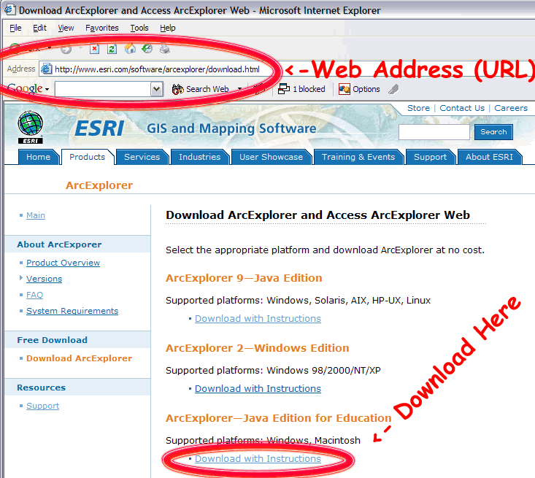
FIGURE A: Download of ESRI ArcExplorer Java Edition for Education (AEJEE)

The user will need to obtain this software application in order to complete the GIS learning module. It is recommended that the educator, computer system administrator, or an adult complete this step for younger or less-experienced participants. Here is the download location with Installation Instructions:

http://www.esri.com/software/arcexplorer/download.html
(Note: ArcExplorer Java Edition for Education must be downloaded and installed before the learning module may be begun.)

While connected to the Internet, copy and paste the Web address to access the download page; then click on the “Download with Instructions” link for ArcExplorer-Java Edition for Education (FIGURE A).
Follow the instructions to install the application for your platform.

Data Preparation

The user will need to obtain data in order to complete the GIS learning module. It is recommended that the educator, computer system administrator, or an adult complete this step for younger or less- experienced participants.

This section is separated into two different sets of instruction. The first set of instructions is for users of a Windows-based platform. The second set of instructions is for users of a Mac-based platform. Follow the appropriate set of instructions in order to prepare the data for use in the learning module.

This GIS learning module cannot be completed without completing this step.

Windows Users Instructions
You will be downloading a single ZIP (compressed “archive” file) containing the necessary data files for this GIS learning module.
- While connected the Internet, open your Web browser and navigate to the following Website: http://gis.esri.com/industries/education/arclessons/search_results.cfm?topicSearch=Physical%2FEarth%20Sciences
It is best to copy and paste this entire Web address (URL) into the Web address field of your browser (FIGURE B).
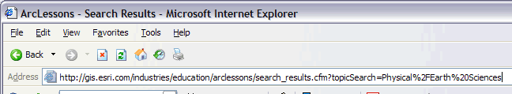 FIGURE B: NAVIGATING TO THE WEBSITE WITH THE MODULE DATA
- Once the ArcLessons Website has loaded, scroll down (use the “down arrow” on your keyboard) to almost the end of the Web page and locate the “seismic.zip” file name (FIGURE C).
- Once you have located the file name, click on the clipboard icon on the left to begin the download (FIGURE C). The icon is labeled, “Mapping Seismic Activity With ArcView GIS 3.x.”
- Read and accept the ESRI License agreement and the download of the seismic.zip file should commence. Be sure to save the download and note its location on your computer.
You will need to know where this file has been saved on your computer. On some computers, there is a default “Downloads” or “My Documents” or “My Downloads” folder where downloaded files are saved. If you are given an option on the location where the download will occur, choose your “Desktop” where it will be easy to find. Consult with your operating system’s documentation if you have any questions.
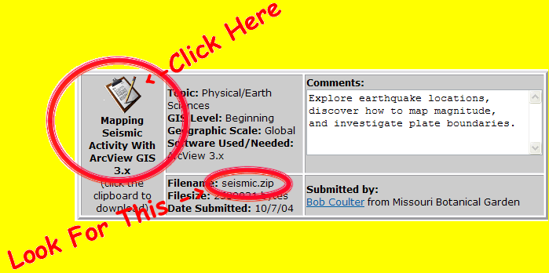 FIGURE C: LOCATING & DOWNLOADING THE REQUIRED DATA FILE
- After download is complete, you should be able to find the file seismic.zip. As stated before, it is a compressed ZIP archive containing all of the data files that you will require for this learning module.
- Double click the seismic.zip file. If you are lucky, this will launch your ZIP-compatible decompression utility automatically. If this is not the case, you will need to separately download a ZIP utility.
There are many compatible ZIP utility applications available. If you don’t have one, you can download a functional free trial version of WinZip at this Web address: http://www.winzip.com/downwzeval.htm. (We are sorry but we do not support the installation and use of a ZIP utility however, we believe that these instructions are sufficient for success. If you need additional help on decompressing ZIP archives, please consult the help menu of your ZIP utility application)
- "Extract" the compressed files from the seismic.zip archive using the “extract” function with your ZIP utility. This will usually open an extract dialog box showing you the compressed files and providing you options on the location of these files after they are decompressed.
- Extract these files to a location where you can find them later. Again, your “Desktop” is a place where they would be easy to find.
- If necessary, after decompressing and verifying the presence of the files, you may close your ZIP utility by choosing the “File” pull-down followed by “Exit.”

Macintosh Users Instructions
You will be downloading a single ZIP (compressed “archive” file) containing the necessary data files for this GIS learning module.
- While connected the Internet, open your Web browser and navigate to the following Website: http://gis.esri.com/industries/education/arclessons/search_results.cfm?topicSearch=Physical%2FEarth%20Sciences
It is best to copy and paste this entire Web address (URL) into the Web address field of your browser (FIGURE D).
FIGURE B: NAVIGATING TO THE WEBSITE WITH THE MODULE DATA
- Once the ArcLessons Website has loaded, scroll down (use the “down arrow” on your keyboard) to almost the end of the Web page and locate the “seismic.zip” file name (FIGURE E).
- Once you have located the file name, click on the clipboard icon on the left to begin the download (FIGURE E). The icon is labeled, “Mapping Seismic Activity With ArcView GIS 3.x.”
- Read and accept the ESRI License agreement and the download of the seismic.zip file should commence. Be sure to save the download and note its location on your computer.
You will need to know where this file has been saved on your computer. On some computers, there is a default “Downloads” or “My Documents” or “My Downloads” folder where downloaded files are saved. If you are given an option on the location where the download will occur, choose your “Desktop” where it will be easy to find. Consult with your operating system’s documentation if you have any questions.
FIGURE E: LOCATING & DOWNLOADING THE REQUIRED DATA FILE
- After download is complete, you should be able to find the file seismic.zip. As stated before, it is a compressed ZIP archive containing all of the data files that you will require for this learning module.
- Start “Stuffit Expander.” If you do not have this application, you will need to separately download a ZIP utility.
There are many compatible ZIP utility applications available. A functional limited use version of “Stuffit Expander” is available as a free download at the following Web address: http://www.stuffit.com/mac/expander/index.html. (We are sorry but we do not support the installation and use of a ZIP utility however, we believe that these instructions are sufficient for success. If you need additional help on decompressing ZIP archives, please consult the help menu of your ZIP utility application)
- "Expand" the compressed files from the seismic.zip archive using the “Expand” function with your ZIP utility. The function is usually available in the “File” menu. This will usually open a dialog box. Locate and select the seismic.zip archive and click the “Expand” button. This will expand the compressed files to the same directory/location as the original seismic.zip archive.
- If necessary, after decompressing and verifying the presence of the files, you may close your ZIP utility by choosing the “File” pull-down followed by “Exit.”

Description of GIS
Geographic Information Systems or GIS are the technological tools to store, query, analyze, and visualize spatially-associated data.
It is an area of phenomenal growth. Applications of GIS exist in almost every level of industry and government. Some applications include resource management, fleet asset tracking, mapping and maintenance of networks and grids, sales and market analysis, and environmental monitoring. New uses for GIS are always being developed and its usage is becoming increasingly widespread. In fact, if you have used a computer-based, Internet-based, or GPS-based map, you have probably used a simple GIS tool!
With the expansion of GIS's utilization, there is and will continue to be a significant shortage of trained and talented people to envision, implement, and operate the future applications of GIS.
With the cooperation and support of the National Science Foundation's Advanced Technological Education program, San Diego Mesa College, San Diego State University, the San Diego City School District, GIS industry leaders, and community members this project and program was proposed to address this great need by preparing motivated individuals for a rewarding career in GIS with the fundamental knowledge and skills to succeed.
Read more about GIS at our project Website: http://geoinfo.sdsu.edu/hightech.

Description of the Research Project

A major goal of this new project includes facilitating and articulating a comprehensive program of GIS education for students in the high school, junior college, and 4-year college levels.

This project is one of many initiatives to foster a technologically-literate 21st Century labor force. GIS usage continues to expand at a significant pace in all sectors of industry and government. Correspondingly, there is a current and growing need for GIS technicians and GIS education/training. Ultimately, this program was funded to address these needs.

To learn more about the project and research-related activities, please visit our Research page on the project Website. To learn more about the anticipated and significant labor shortfall of skilled-and-trained GIS technicians, please visit our What is GIS? page and click on “Why is GIS Valuable?” on the project Website. The project Website is accessible at http://geoinfo.sdsu.edu/hightech.

Comments, Suggestions, and Inquiries

If you have any comments or suggestions for this learning module module, our project Website, or our research, please contact any of the individuals at the end of this guide or at our Contacts page on the project Website. We greatly appreciate your input!

Additionally, please let us know if you are interested in participating in our research in any way. We are especially interested in collaborating with high school students and educators.

Disclaimer

The project research team, our sponsoring organizations and institutions, and our affiliates are not responsible for any errors, omissions, or misrepresentations on the learning module modules or project Website. If you come across anything that you have questions or concerns about, please let us know through your comments or suggestions so we can promptly address the matter. Thank you for your assistance.

Contacts

Ming-Hsiang (Ming) Tsou, Ph.D.
Co-PI: A Scalable Skills Certification Program in GIS
Associate Professor
Geography Department, San Diego State University
San Diego, CA 92182
TELEPHONE: 1 619 594 0205
EMAIL : mstou@mail.sdsu.edu

(Page Intentionally Left Blank)

GIS Learning Module 1 – Earthquake Chasers

Dear Student,

Please help us! We are the “Traveling around the Earth” TV Production Company and we are based in California. We need a producer to make a new show for the KNSI-9 television network. The show is called “Earthquake Chasers.”

We want your help and we need someone with knowledge and skills in these areas:
1. Earth Science and Geography
2. Geographical Information Systems (GIS).

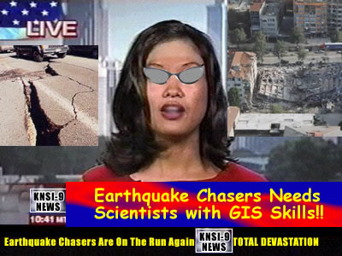
BUT IT IS WAY TOO HIGH TECH FOR US.

NO ONE AT KNSI-9 KNOWS ANYTHING ABOUT GIS!!

WE WANT TO BE ABLE TO SHOW OUR VIEWERS THE NEWEST STUFF. WE’RE NOT AN OLD SCHOOL CHANNEL! BY THE WAY, MY GLASSES ARE COOL AREN’T THEY?

CAN YOU HELP US????

Thank you for accepting the challenge!

Your first task is to explain what earthquakes are by using a computer software tool called Geographic Information Systems (GIS).

Before we create the stuff for the show, you need to know what the following icons are and what they mean:

- Adds themes to the view window

Zooms to full extent of the view

Zooms in on the view

Zooms out of the view

Query Builder

And, let’s get a few definitions out of the way:

- Layer = Theme
Some people call a GIS layer a theme.
- List of Layers = Table of Contents
Some people call a list of GIS layers a table of contents.

I am telling you these things because you will probably see both meanings used.

Don’t worry about the specific meaning of anything on this page right now. I will go over that stuff a little later.


Introducing Dr. GIS
Hi! I’m Doctor GIS. Occasionally, I will appear in the following exercises to tell you about a few important GIS concepts. I look forward to sharing with you information about this powerful technology which happens to be my favorite subject! See you soon.

Section 1

Part 1- What’s an earthquake?

An earthquake is the shaking of the earth caused by movements in the position of the pieces of the crust. When the energy that is stored within the earth is suddenly released, the energy is transmitted to the surface of the Earth by earthquake seismic waves.

Think of snapping a very long rope or garden hose very hard at one end. If you do it right and are strong enough, you can watch the wave that you created go all the way to the other end. You have transmitted energy from one end to the other through this “wave” of energy. The interior of the earth can do something very similar to this when huge pieces of the earth’s crust shift suddenly.

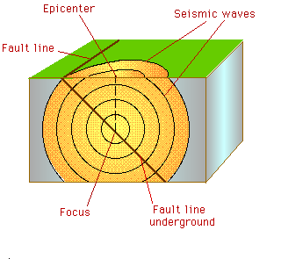
Cutaway View of a Fault and Epicenter
Source: http://cse.ssl.berkeley.edu/img/earthquakes/Epicenter.gif

The Earthquake Focus is the location within the earth where underground rock and earth shifts and sends out the earthquake seismic waves.

The earthquake focus can occur at many depths.

- shallow (0-70 km)
- intermediate (70-300 km)
- deep (300-700 km).

A Fault is the line that is created between two sections of rock or earth that move in different directions and/or speeds.
Seismic waves are the rock and earth movements which transmits the vibration energy outward in all directions from the earthquake focus.
The Epicenter is the point at ground level directly above the focus.

Now you know what an earthquake is.

Next, I will show you how to use a popular GIS software package called ArcExplorer Java Edition for Education. I will use this to indicate where the most earthquakes are located in the world.

Before I continue, can you guess where?
Write some places down here for fun:

___________________________________
___________________________________
___________________________________
___________________________________

Part 2 - Where are earthquakes located?

Building a base map:
Before you can plot the earthquake data, you need a world map to show their locations.

GIS APPLICATIONS AND BASE MAPS
The base map is your “building blocks” for a GIS map. Because GIS’s are run on computers, they allow you to use a lot of different maps and images for the base map. On a paper map, you only have one choice—whatever is already printed on the paper!

- Start the ESRI ArcExplorer Java Edition for Education (AEJEE) software application by doubling clicking the AEJEE icon  on your desktop. If you cannot find it, you may have to ask for help or figure out where else you can start the program on your computer.

- After you get a window on your screen like the one below, click on the Add Data icon to open a new view:

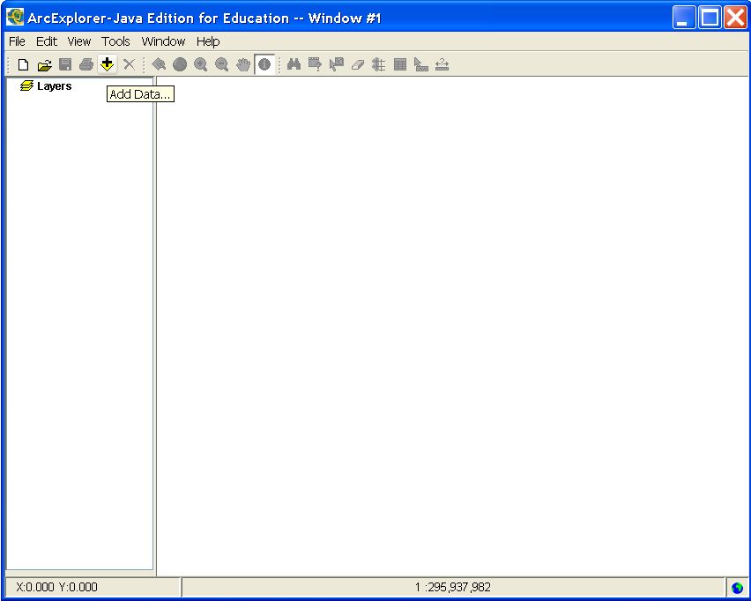
Add Data Button on Arc Explorer Java Edition for Education

- Now we are going to load a map of the world.

You are going to need to know where the data files are on your computer’s hard drive. If you didn’t prepare the data with the instructions at the beginning of the learning module yourself and you don’t know where they are, ask for help.

  - Browser on your local hard drive to the location of the data files. They will probably be located in a folder called “seismic.”
  - After you found the folder, double click on the folder to open it then click on “country.shp” file and choose .

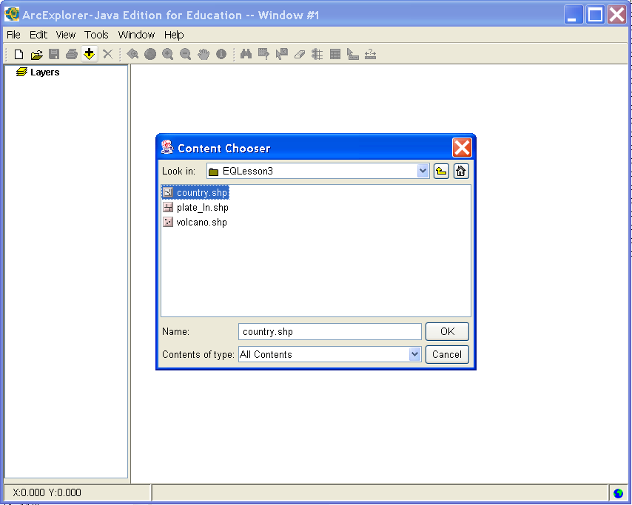
Opening the country.shp Data File

  - Now, “country” should appear under “Layers” on the left column. No click on the check box next to “country” to turn on the world countries layer.

Your screen should now show a world map like the picture below. Don’t worry if it is a different color. ArcExplorer likes to use different colors automatically.

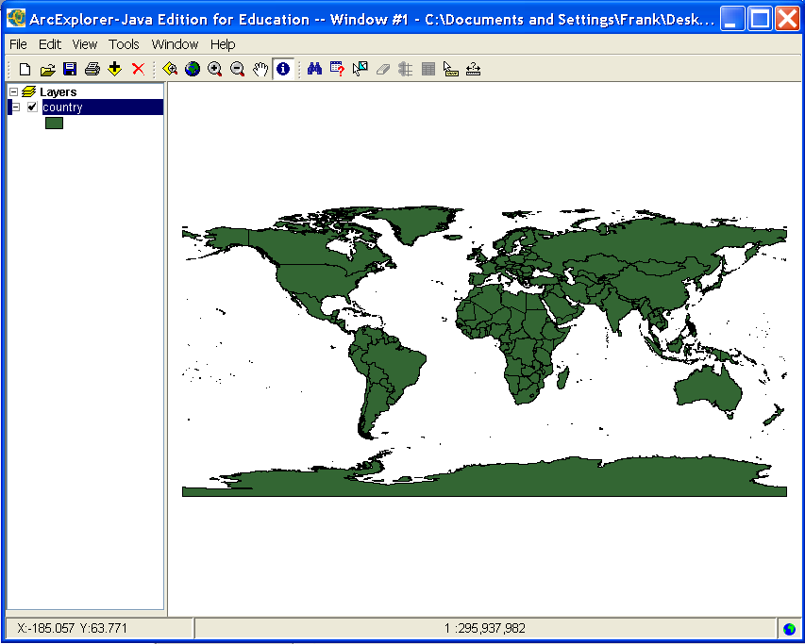
ArcExplorer with country Layer Active

LAYERS & GEOREFERENCING
Part of the power of a GIS application is its ability to add multiple layers of data to the same map. You can add stuff like a countries layer, a layer of schools, a layer of rivers, a layer of parks, and even a layer of information like how many people live in every area (populations).Once the layers have been added to the GIS map, you can turn on and off layers and change how they are displayed. You can also use the information from all of the layers together because the same location in all of the layers represents the same location in real life. This is called georeferencing---the locations on your GIS map represent locations in the real world. For example, if you turned on a layer of schools and a layer of parks in a GIS map and your school is right next to a park in real life, it will also be right next to the park in the GIS map even though these things were on separate layers. Can you do that with a paper map? Not really---unless you want to draw everything on one map and then erase what you don’t like. With a GIS, you can do that in a second and it will look nice!

Adding the data table to your project:

We are going to add another layer of data onto your GIS map. This time we are going to use a list of world earthquakes. This huge list contains all of the earthquakes recorded during the years 2000. There were 46,741 earthquakes recorded in 2000. It shows the location of the earthquake, the date of the earthquake, the size of the earthquake, and how deep the earthquake’s focus was.

In order to plot this text data, you need to add a table containing that data to your project.

In the following steps, whenever necessary, use the Zoom to Full Extent button to zoom out to the entire world map. This allows you to see everything on the entire map after you have zoomed in or out.

- To add the data to your map, go to the View menu and choose Add Event Theme.

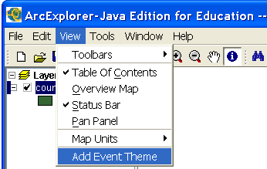
Add Event Theme (Layer)

- You will then see a dialog box which needs to be completed to tell the GIS about this huge list of data so it knows how to organize the information and display it for you.
  - First, choose the file on your local disk drive containing the list of earthquakes. This file is called, “quak2000.txt”. It should be in the “seismic” folder with the other stuff.
  - Specify the field containing the x-coordinates (left-to-right on the screen, usually longitude) “Lon” and the field containing the y-coordinates (up-and-down on the screen, usually latitude) “Lat.”
  - Select an Output Dir where you want the organized information to be saved. You may be told where you need to save this information. Otherwise, just save it in the seismic directory along with the rest of the files.
  - When you are finished entering all of this information, click .

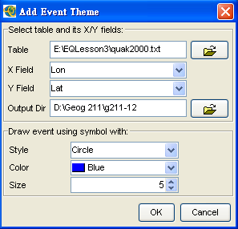
Adding Tabular Data to the GIS

The data should now be available in your map view, listed under Layers. This time the layer is called “quak2000.”

Remember to check the box to turn the layer on to see it.

You should now see several dots representing all of those earthquakes. Again, don’t worry if it displays the location of the earthquakes in a different color from the sample screen.

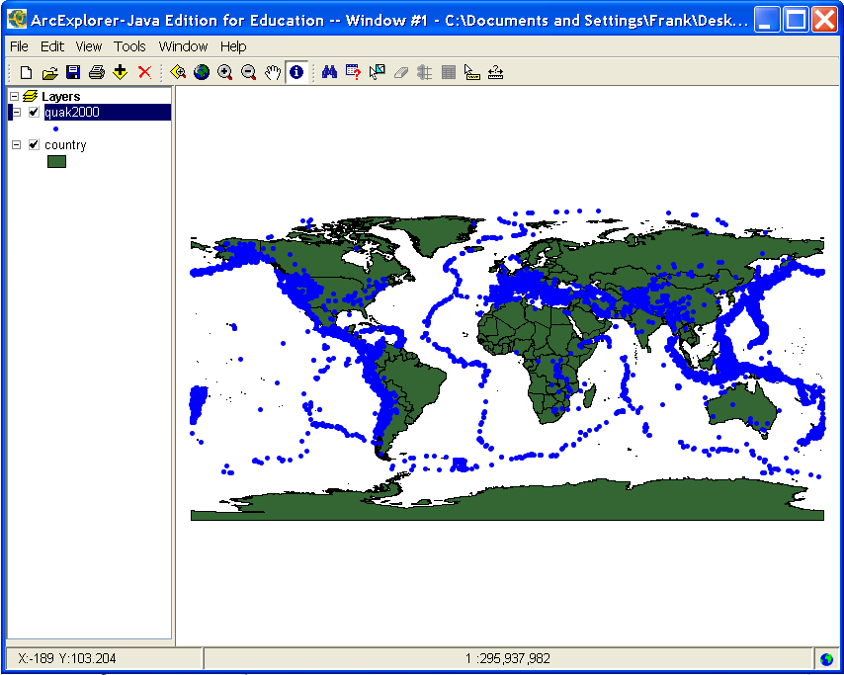
GIS Map with Locations of Earthquakes displayed on top of a Layer of World Countries

Do you notice anything interesting about the arrangement of the earthquake dots?

Do you live next to a lot of earthquakes?

Wow! Time is up for this time. I think all of you have some knowledge about what an earthquake is and where earthquakes are located.

Some of you may wonder about living in an area with a lot of earthquakes! Well, you may want to know how dangerous it is by investigating the magnitude (or “strength”) of an earthquake. That is the topic of the next section.

Section 2 – Richter Magnitude

Today we’ll introduce earthquake Richter magnitude. I believe almost everybody has heard of the Richter scale but only a few people know what it means.

Part 3 - How can I map the magnitude of the earthquakes?

Color Classification of a GIS Map
One of the most powerful tools you have for mapping your data is the ability to use colors to represent the data according to your classification. This requires careful thought on your part as you make choices in how to display the data in order for your map to be useful to other people. For this example, we will color code the earthquake data you added in the previous exercise.

Earthquakes magnitude:

Earthquakes magnitude is primarily measured on the Richter scale. It was invented by Charles F. Richter in 1934. The Richter magnitude is calculated from the amplitude (or height) of the largest seismic wave released by an earthquake, no matter what type of wave was the strongest.

Richter Magnitude Scale
Magnitude | Number of earthquakes  per year globally | Typical intensity  at epicenter
>8.0 | 0.1 - 0.2 | XII
7.4 - 8.0 | 4 | XI
7.0 - 7.3 | 15 | X
6.2 - 6.9 | 100 | VIII - IX
5.5 - 6.1 | 500 | VII
4.9 - 5.4 | 1,400 | VI
4.3 - 4.8 | 4,800 | IV - V
3.5 – 4.2 | 30,000 | II - III
2.0 – 3.4 | 800,000 | I - II
Table of Richter Magnitude Scale
Source: http://www.em.gov.bc.ca/Mining/Geolsurv/Surficial/quake/eq2.htm

- First, right click on the “Quak2000.txt” layer and choose Properties from the drop down menu.

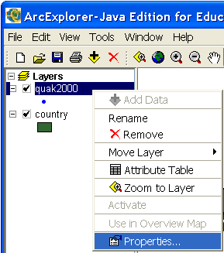
Choosing Layer Properties

- Choose the Symbols tab.
- Select Graduated Symbols from the Draw features using option menu and Mag (Magnitude) from the Field option menu.
- When you are finished, click .

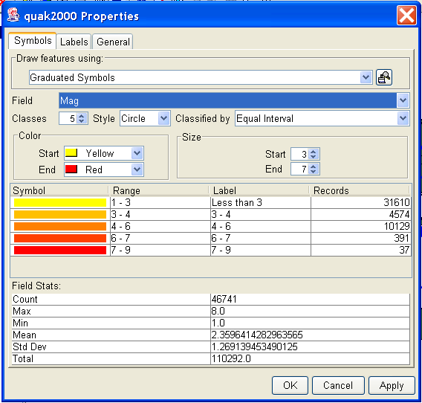
Classifying the Layer Data

You will choose to use graduated colors based on the magnitude of each individual earthquake. Lighter colors will show earthquakes with a lower magnitude while darker colors will show earthquakes with a higher magnitude. This way, instead of just a bunch of dots with the same color, you will also be able to tell how strong the earthquakes are on your GIS map.

Near the middle part of the dialog box, notice the Color choice. The color let you select the shades of color used for graduated symbols. In many situations, a particular color scheme is appropriate. For example, blue would be a good choice to show cold weather on weather maps while green might be useful for vegetation maps.

Try a different color by clicking on the Start and End option menus to choose your own preferred colors. Be sure to click to see the changes. When you are satisfied with the color, close the Properties dialog box by clicking on the button.

This map now shows the location of earthquakes in 2000, with the darker colors representing the quakes with greater magnitudes:

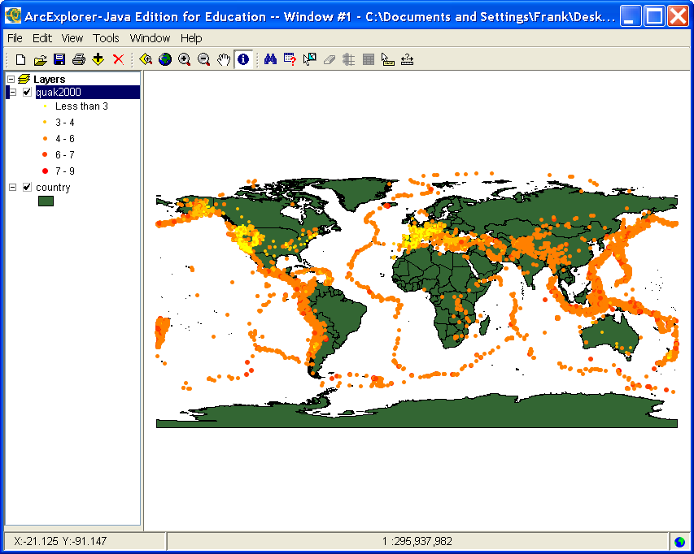
GIS Map Showing Location, Number, and Color-Classified Magnitude of Earthquakes

Notice that the lighter colors (representing lower-magnitude quakes) tend to be clustered around the western part of the United States and in Europe. Much of the science of seismology and plate tectonics involves noticing and investigating spatial patterns like this. Your GIS map made these observations possible. See how powerful of a tool GIS can be!

Now, we’ll use the ArcExplorer to investigate the locations of the “smaller” quakes.

- First, we need to “thin out” the quake data set to show only the smaller quakes. We are sort of trying to ignore the rest of them.

Note: To show only part of a layer, first make sure it is the “active layer” (the “active layer” appears “raised up” in the list of layers on the left of your ArcExplorer window). Make sure the “quak2000” layer is “active” by clicking on the layer name once.

- Select the Query Builder tool from the Tool Bar.

We will use the Query Builder to display only those quakes with a magnitude of between 3.5 and 4.2. That is because in the Richter Magnitude Scale in the table above, magnitudes of 3.5-4.2 represent the typical intensity at an epicenter II – III.

- In the Query Builder dialog box, double click on the field [Mag].
- Click once on the Greater Than Or Equal To button .
- Type in the number 3.5.
- Click in the Query Builder.
- Double click on the field [Mag].
- Click once on the Less Than Or Equal To button .
- Type in the number 4.2.
- Click to execute your selection.
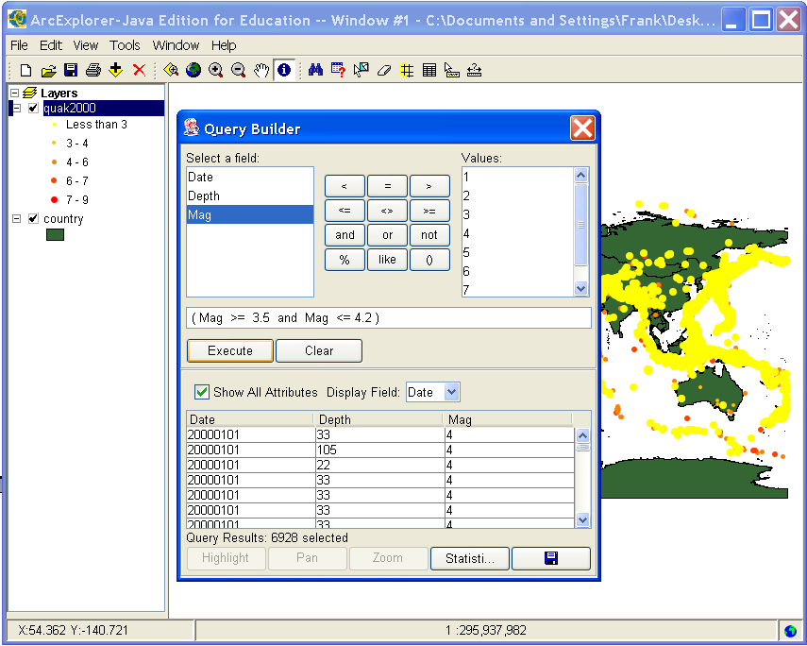
Query Builder Used to Sub-Select Data

Your map now shows only the locations of recorded earthquakes with a magnitude of between 3.5 and 4.2. All of the other data are ignored for now and not selected.

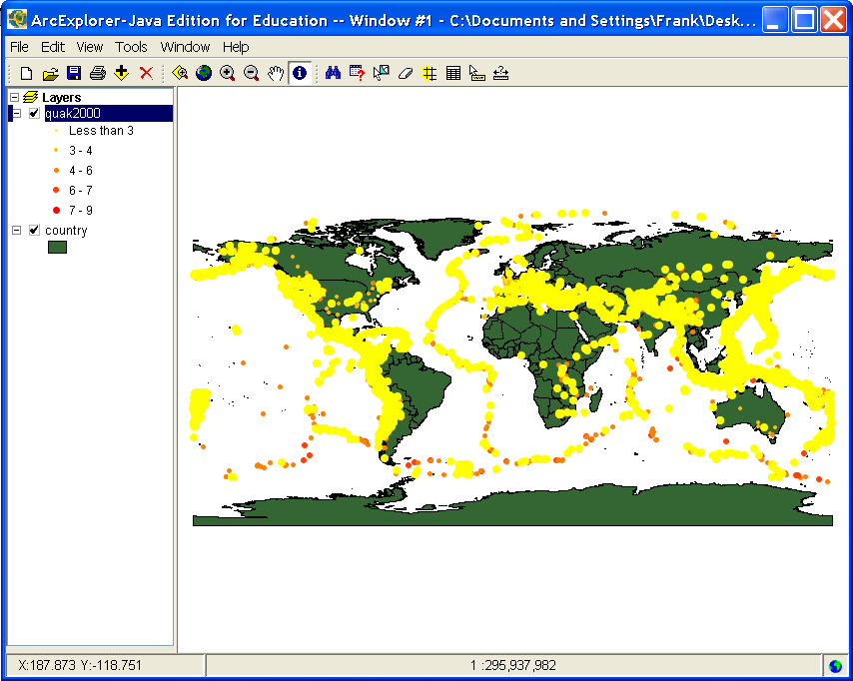
GIS Map Showing Results of a Sub-Selection Query

It might be interesting to zoom in on an area using the Zoom In or Zoom Out tools.

Go ahead and try.

Remember, you can return to the “Full Extent” of the entire world map by clicking on the Zoom to Full Extent button . This allows you to see everything on the entire map after you have zoomed in or out.

Do you recognize the area shown in the following map?

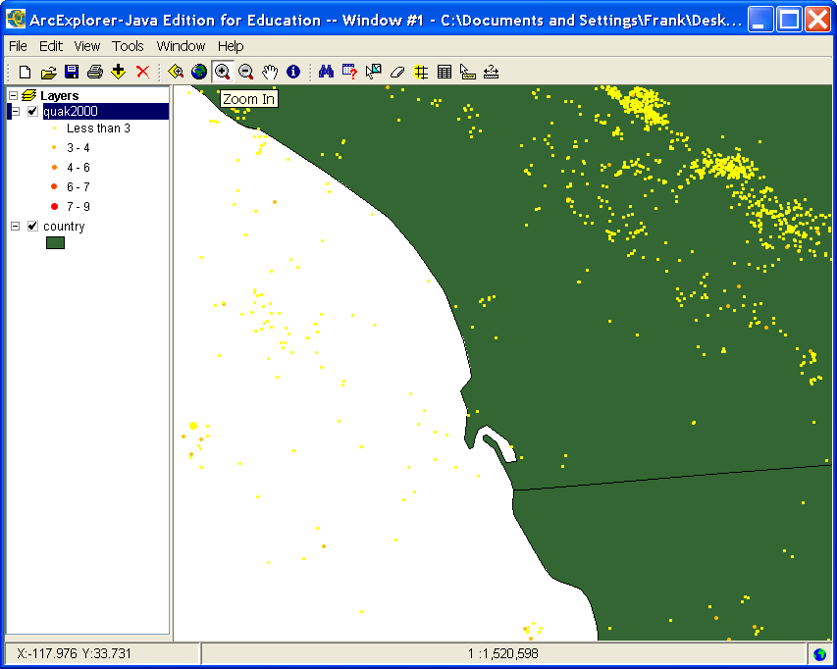
Zoomed in Display of GIS Map Showing Individual Earthquakes

Woops! Looks like we ran out of time again. I need to say goodbye here.

Next time, if you watch TV or listen to the radio with you family or friends and hear something about earthquakes, you can explain earthquake magnitude and the Richter scale to them. They will probably be so impressed after hearing your explanation that they will call you Dr. Earthquake.

Section 3 – Earthquake Location

Hello! It’s nice to see you again. Today is the highlight of our Earthquake program. Everybody is watching our TV program carefully so pay attention. The TV production company is very impressed with your work and wants a map to display on the 7 O’clock News when they talk about that earthquake that everybody felt this morning.

Part 4 – Why are earthquakes located where they are?

Geologists currently believe that the Earth’s surface is covered with a number of tectonic plates that are constantly moving (V-E-R-Y slowly). Think of these tectonic plates like the shell of an egg if the whole egg represented the earth.

If different disconnected parts of the earth’s crust are moving around all over the place, imagine what would happen when these plates come in contact with each other. At the plate edges, they might get pushed up or down or sideways when they come into contact with another tectonic plate. That is where and why many– although not all– earthquakes occur!

Earthquakes causes:

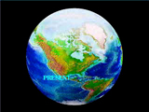
The majority of earthquakes are caused from the forces of plate tectonic activity. When the tectonic plates shift, they release energy and that results earthquakes.

If you are online, view this animation of plate tectonic activity: http://www2.nature.nps.gov/geology/usgsnps/animate/pltecan.html

Now we are going to investigate using your GIS map.

To see how the earthquakes and plates are related to each other, you’ll need to add a map layer that shows the plate boundaries.

- To do this, click the Add Data icon to add the “plate_In.shp” layer.

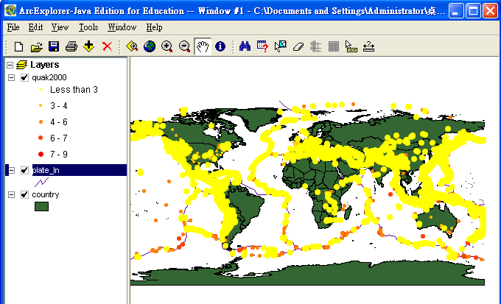
Adding the Plate Boundary Layer to the GIS Map

The lines you just added show the plate boundaries. What do you notice about the boundaries and the location of many of the earthquakes?

If the lines of the plate tectonic boundaries are hard to see, use the layer properties to change the way each map layer appears.

- Right click the ”plate_In” layer and choose properties.
- Click Style, Color and Size option menus to select various line styles, colors, and sizes.
- When you want to see a change, click the Apply button to see the line change.
- Continue to make changes until you are satisfied. Click Ok when you are satisfied with your change.

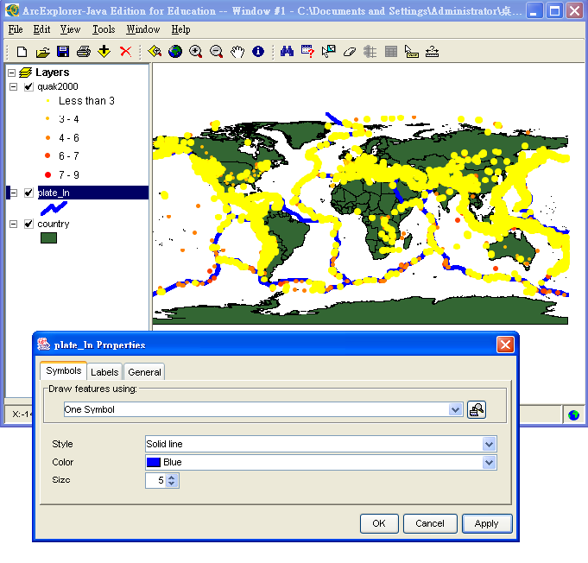
Applying Different Styles, Colors, and Sizes to a Line Symbol

Part 5 – Saving and Printing Your Work

ArcExplorer lets you save your project for a later time. You can also print a hard copy of your map. This will be useful if you want to show other people an image from the GIS map that you created.

The hard copy printout is what you will be providing the production company for the 7 O’clock news program when they talk about the earthquake this morning.

- Saving a project.
To save a project, click “File,” then “Save” or “Save As.” If you choose “Save As,” be sure to choose a directory location to save your project file and an appropriate project name that you will remember for next time.

- Opening a saved project.
Go through all of the steps to start ArcExplorer. Click “File” then “Open.” From here, browse to the location where your project file is saved and select it to open it.

- Printing a project.
Make sure there is a printer available for you to print on. Click “File” then “Print.” Follow the instructions in your computer system’s printer dialog box for a nice hard copy image from your GIS map.

It’s time to say goodbye again. Today is the final episode of our program and you did an incredible job with the Earthquake Chasers television program as well as providing a map for the 7 O’clock news! It was a hit and you helped teach a lot of people about earthquakes, seismology, and plate tectonics. You also did an amazing job with your introduction to GIS technology. Now, managers from other television stations are trying to take you away from us because they want to learn about GIS technology!!! But, don’t worry we have other journeys to make together Traveling Around the Earth.

Part 6 - Quizzes

Q1: A earthquake focus that is 50 km deep is considered to be a “deep” earthquake.
a. True.
b. False.

Q2: How do “seismic waves” occur?
a. Caused by the explosion of a powerful bomb.
b. Caused by the vibrations of rock and earth movements at plate boundaries.
c. Caused by Tsunami waves.

Q3: When referring to earthquakes, what is a “fault?”
a. It is caused by two parts of the earth’s crust moving against each other over a long period of time.
b. A crater in the earth’s crust caused by a previous earthquake.
c. A huge meteorite that crashed into the ground.

Q4: What’s the “Richter Magnitude Scale”?
a. A calculation of the amplitude of the largest seismic wave released by an earthquake.
b. A calculation of the strongest type of seismic wave.
c. A calculation of the destruction caused by an earthquake.

Q5: What scale is used to measure earthquakes?
a. Epicenter.
b. Richter Scale.
c. Fault Scale.

Q6: What is the center of an earthquake as measured from the ground surface called?
a. Epicenter
b. Focus
c. Shake Center

Q7: What do scientists believe causes the most earthquakes?
a. Plates rubbing together
b. Meteorites hitting Earth
c. Built-up lava

(Q6 and Q7 Source: http://news.bbc.co.uk/cbbcnews/hi/quiz/newsid_1897000/1897352.stm)

Q8: Going up one whole unit on the Richter scale represents
a. a 10-fold increase in energy release
b. a 30-fold increase in energy release
c. a 10-fold increase in damage done by the quake

(Source: http://www.oswego.edu/~gabel/q1eq.html)

Q9: Which country is located along a plate boundary?
a. Brazil
b. United States of America
c. Australia

Q10: The point on the Earth directly above the hypocenter of a quake is called?
a. Plate boundary
b. Epicenter
c. Focus

Q11: What Richter magnitude of quakes is recorded most often around the world every year?
a. 2.0-3.4
b. 3.5-4.2
c. >8.0

Q12: Please write down the relationship between earthquakes and plate boundaries.

Q13: Please write down the difference between a focus and an epicenter.

Until Next Time…

Quiz Answers:

1. b
2. b
3. a
4. a
5. b
6. a
7. a
8. c
9. b
10. b
11. a

12.
Geologists currently believe that the Earth's surface is covered with
a number of tectonic plates that are constantly moving (very
slowly). The majority of earthquakes result from the interaction of forces stemming from plate tectonic activity. When a tectonic plate moves or shifts, it releases energy and result in earthquakes.

13.
The focus is the location within the earth where underground rock moves
and sends out earthquake waves. Earthquake foci occur at a range of depths.

The epicenter is the point at the ground level directly above the focus.

(Page Intentionally Left Blank)

