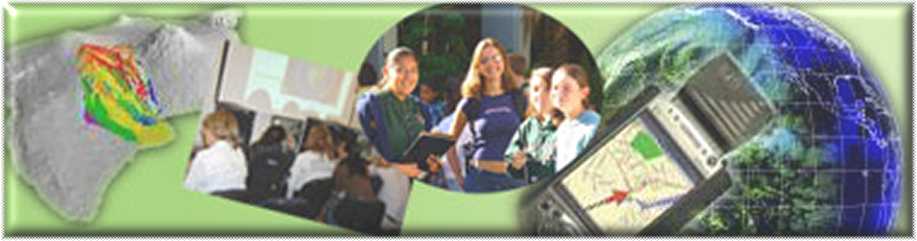

GIS Career Awareness Learning Module # 2
Version 2 - Revision 1 - 4 APR 2007

How Can GIS Help Us? --- GIS Applications in Various Fields

- Estimated Time: 1.5 hours
- Learning Goal: This module will introduce various GIS applications and illustrate their usefulness in different specialty areas such as political science (election campaign fundraising), criminal justice (crime mapping and tracking), business and marketing (real estate sales and pricing), and environmental science/ecology (environmental monitoring & management).
- Platforms: PC, Mac, or UNIX.
- Software Tools Required: Web browser with high-speed Internet access.

Note: This Web-based GIS learning module was developed with support from a National Science Foundation – Advanced Technological Education Program Research Grant (NSF-ATE DUE # 0401990): “A Scalable Skills Certification Program in Geographic Information Systems (GIS).” ( http://geoinfo.sdsu.edu/hightech )

ANSWER ALL QUESTIONS ON THE SEPARATE ANSWER SHEET

Section 1 – Political Science - Election Campaign Fundraising.

Part I.- FundRace Money Map

GIS can be used in many useful applications. One of the most interesting applications is for election campaign fundraising. Different political parties and election candidates can use GIS to strategize and analyze their political campaigns, voter landscapes, and fundraising. The following GIS application for the 2004 U.S. Presidential election is a notable example:

To begin, launch your Web Browser (with a live connection to the Internet). Navigate to http://www.fundrace.org and then click on the link named, Money Map. A map of the United States will appear illustrating the campaign fundraising percentages by city for the major political parties of the 2004 federal election. In the case of this first national map, campaign fundraising advantages are illustrated by color for each U.S. first 3-digit ZIP code area. The red shading indicates areas which made a higher percentage of contributions to the Republican Party as compared to contributions to the Democrats. The blue areas indicate areas which made a higher percentage of contributions to the Democrats. Brightness represents the strength of each party’s fund raising at the given location while white indicates a virtual tie. At the top of the page, select the link for National Maps. A new map of the United States will appear with the ability to select other maps illustrating the fund raising amounts and advantages of some individual candidates and their political parties during the 2004 Presidential election. Quickly observe the map legend, and notice that the brightness of colors signifies higher relative values while the lighter colors signify intermediate values.

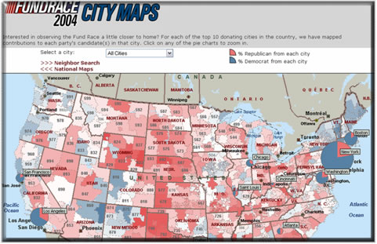
Figure 1: FundRace Democrat vs. Republican National Money Map

Choose the name of an individual Presidential candidate you would like to research from the drop-down menu named, Select a Candidate. Change the Zoom level to 3 Digit ZIP Code.

A-1: Candidate Chosen

A-2: Which geographic regions contributed most to this candidate?

Now, change the Zoom level to State.

A-3: Did the geographic regions change or stay the same? If there was a change what happened?

A-4: Which states gave the most contributions to your chosen candidate?

Choose another candidate from the Select a Candidate menu. Change the Zoom Level to 3 Digit ZIP Code. Compare the result with your first candidate.

A-5: Second Candidate Chosen

A-6: Did the geographic regions that support this candidate change or stay the same as compared to the first candidate?

A-7: Now, change the Zoom level to State. Which states gave the most contributions to your second chosen candidate?

Now, change the Zoom level to County and quickly compare the individual candidates in the Select a Candidate menu.

A-8: Based on the information on the map, which candidate was given the most money in the county where you reside?

Now click on the City Maps link and use the Select a City drop-down menu to select the Los Angeles (Hollywood).

A-9: Can you see any kind of spatial pattern between the Democratic and Republican Parties fund raising in this area?

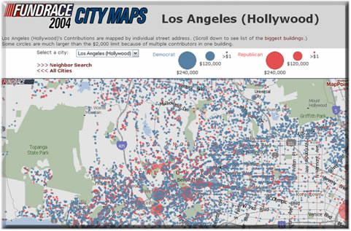
Figure 2: FundRace Los Angeles (Hollywood) Money Map

A-10: What was the spatial pattern of the fund raising of Democrats vs. Republicans at the State level? (Please compare the West, East, and the Middle of U.S.)

A-11: What was the spatial pattern of the fundraising of Democrats vs. Republicans at the County level for the state of California?

A-12: In San Diego County, did the Democrats or Republicans raise more money for the 2004 Presidential election?

A-13: In the Hollywood area of Los Angeles, did the Democrats or Republicans raise more money for the 2004 Presidential election?

A-14: If you are currently campaigning to become the President of the U.S., how would you use the information in these maps to your advantage and why?
Section 2 – Criminal Justice - Crime Mapping and Tracking

Part I. – City of San Diego Crime Map

The second GIS application example can be used to study and visualize reported criminal incidents and the locations were they occurred. This is an example of a “Crime Map.” A Web-based mapping tool was developed for the Automated Regional Justice Information System (ARJIS), a computer network utilized by 50 local, state and federal agencies in the San Diego region.

To begin, launch your Web Browser (with a live connection to the Internet). Navigate to http://www.arjis.org scroll down the screen, and then click on the link named, Crime Maps. A new Web page will pop up (If you are using Microsoft Internet Explorer as your Web browser and you receive a message indicating that the pop-up was blocked, hold down the <Control> key and click on the Crime Maps link to bypass the Pop-Up Blocker.)

On the Crime Maps Disclaimer page which pops up, click on the Accept button to continue. Now, on the next page, click on the Go to Mapping button. The Regional Crime Maps Web interface should appear.

Under Jurisdiction, click on San Diego (The “plus sign” next to San Diego will list or the communities within San Diego however, you want to select every community within San Diego so just click on San Diego.)
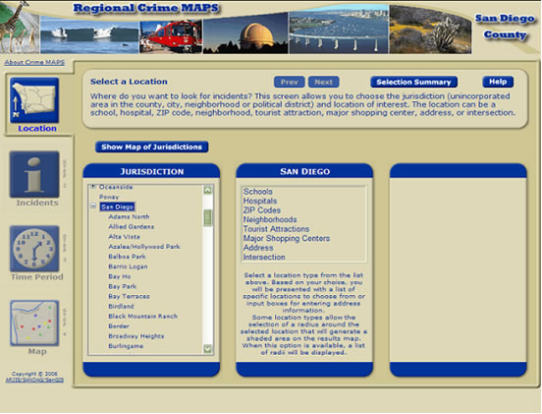
Figure 3: San Diego County Regional Crime Map Interface

A column named San Diego will appear. In this column, choose Address and a third column will appear. In the third column, enter your home or high school street address (if you live or go to school in the City of San Diego). If you don’t reside in the City of San Diego, type 5500 Campanile Dr. (the street address of San Diego State University) and click on Verify Address. If multiple addresses appear, choose any one that is closest to your actual address. After verifying the address, choose 1 mile from the pull-down menu under “Radius for shaded area around selected location.” This is known as a “buffer area” and will display all of the incidents within a one-mile radius. After setting the buffer area, click the Next button toward the center-top of the browser window. A column of Incident Types should appear.

Under Incident Types, choose all types of Crimes by checking off all of the criminal incident types under the Crimes folder. You can either select each incident individually or you can select all of them under the folder by clicking on the folder icon next to Crimes. Again, for this exercise, select all types of Crime. If you are curious, the right column lists the definitions of these incident types. When finished selecting, click the Next button toward the center-top of the browser window. Controls to select the incident time period should appear.

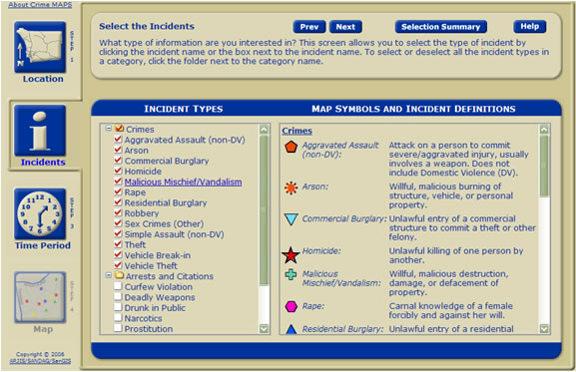
Figure 4: Selecting Incident Types

You can look up the incidents that have been stored in the system by selecting a range of dates, days of the week, and time range. For now, leave the Date Range and Time Range and Days of Week as is. It is automatically set for the last month.

Under Date Range on the left column, the top calendar is used to set the start date. The bottom calendar is used to set the stop date. The right column, Time Range and Days of Week, can be used to select specific days of the week and time of day. Again, leave everything as is and click the Next button toward the center-top of the browser window.

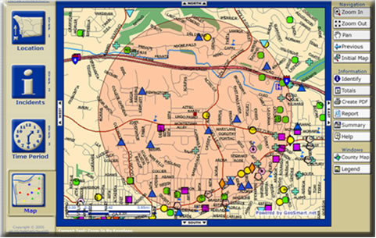
Figure 5: Example Generated Crime Map

A map should appear shortly displaying the immediate area around the address you selected. There may or may not be any incidents recorded around the location for the given time period. Incidents are denoted by icons on the map. In the Example Crime Map image above this paragraph, you can see several icons including green plus signs (vandalism), yellow dots (theft), and blue triangles (residential burglary). If you don’t see any incidents, you may want to choose a different location by clicking on the Location button on the top-left of the map and resetting the location with the previous steps. You can also use the Zoom Out and Zoom In controls on the right side of the map to change the map areas displayed. If you still don’t see any incidents, you may also want to expand the date range to cover several months instead of just the default single month in the Time Period menu. After changing any of the settings, you can redisplay the map by selecting the Map button on the lower-left corner.

Now, you can get more information about an incident by selecting the Identify button on the right side of the map, and clicking on any incident icon.

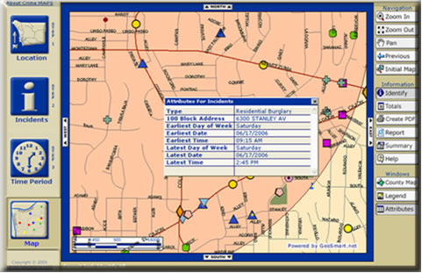
Figure 6: Identifying a Specific Incident

You can change the Location, types of Incidents, and Time Period by clicking on the respective buttons on the left side of the map. After changing your selection, click on Map button to redisplay your map. This system covers all areas in San Diego County. You can look up any street address, city and zip code within San Diego County. Please create crime maps with different combinations of Location, types of Incidents, and Time Period settings.

Part- II. Please answer the following questions on the separate answer sheet:

B-1: Based on the Crimes that you mapped, what types of incidents are most frequent around the area you selected?

Go to the Incidents menu by selecting the Incidents button (the big “i” button on the left of the map). Now unselect all of the Crime types and now select all of the Traffic-related incident types. After doing so, redisplay your map by clicking on the Map button on the bottom-left of the browser window.

B-2: Based on the new information that is displayed, what types of Traffic-related incidents are most common on your redisplayed map?

Go back to the Incidents menu by selecting the Incidents button (the big “i” button on the left of the map). Now unselect all of the Traffic-related incident types and now select all of the Arrests and Citation incident types. After doing so, redisplay your map by clicking on the Map button on the bottom-left of the browser window.

B-3: Based on the new information that is displayed, what types of Arrests and Citation incidents are most common on your redisplayed map?

B-4: If you were the mayor of the City of San Diego, how could you use this system to improve the safety of San Diego visitors and residents and why?
Section 3 – Business and Marketing - Real Estate Sales and Pricing

Part I. – Real Estate Housing Costs with Zillow.com

This example will introduce GIS applications in private industry, business, and commerce. Many companies have been utilized GIS for promoting their businesses and to increase their profits. They do this by conducting market analysis, and new store and distribution center site-selection studies. GIS can combine information about the cost of land, the cost of local taxes, the local laws and regulations (zoning), the distance to the sales locations (or retail outlets), and the types of customers within the local area (demographic analysis). Using all of this information and more, decision makers can make better business management choices.

The following example introduces a unique GIS application in the Real Estate business specialty area. This application estimates home values based on recent sales in the area of equivalent homes in the area.

To begin, launch your Web Browser (with a live connection to the Internet) and navigate to http://www.zillow.com .

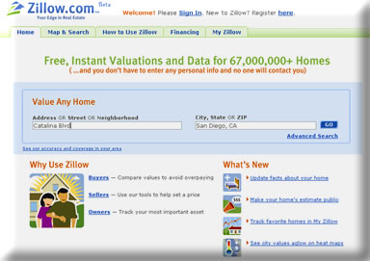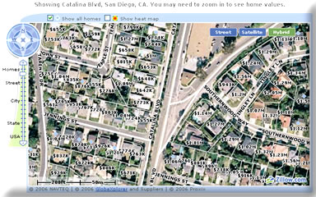
Figure 7: Address Input Example

Next, type in the street address of a house. If you don’t have the entire street address, it is also okay to just type the street name without the address number. Then, type in the city where that address is located followed by a comma, and either the state abbreviation or zip code.

As an example (given in the figure above), type in Catalina Blvd in the Address OR Street OR Neighborhood text field and San Diego, CA in the City, State OR ZIP text field.

A map should appear showing the area around the address you typed along with residences and home prices. You can navigate around the map once it is displayed. The compass on the top-left can be used to move the map a certain direction. There is also a zoom out and zoom in control under the compass on the top-left side of the map (It is labeled, Homes, Street, City, State, USA.) This will allow you to be show the map up close or far away. Depending on how far you zoom in our out (setting the map scale), you can change the level of detail. If you move the zoom in and zoom out control down, the map will display more streets. If you move the control up, the map will display fewer streets but, with more detail. Try several different views to see which one you prefer however; make sure the estimated home prices are visible. Note that the home prices are displayed in 100,000’s. For example $400K means $400,000.

Part II – Please answer the following questions on the separate answer sheet:

After selected an area, click on a home and determine its estimated value.

C-1: What is the street name of your selected home?

C-2: What is the estimated value of your selected home?

C-3: What is the estimated value of the neighboring property to the east of your selected home?

C-4: What is the estimated value of the neighboring property to the west of your selected home?

C-5: Is there any difference in the estimated values between the three properties (original selected home, one to the east, and one to the west)?

Again, click on the first home which you selected to get a pop-up window with more information. In addition to estimated value, the address, the number of bedrooms, the number of bath rooms, and the square footage of the house may be displayed. Get more information for the two neighboring houses as well.

C-6: Is the property that you selected larger or smaller than the other two neighboring houses and does this difference seem to affect the housing costs?

C-7: If you wanted to buy a home in San Diego, how could you use this Website to help you to select the house?

C-8: If you wanted to sell a home in San Diego, how could you use this Website to help you to select the house?
Section 4 – Environmental Science/Ecology - Environmental Monitoring & Management.

Part I – San Diego Watershed Common Ground Website

This section will introduce GIS applications in environmental science and ecology with specific examples for environmental monitoring and management tasks. Many federal agencies, such as the U. S. Geological Survey (USGS) and the Environmental Protection Agency (EPA), and local governments have been using GIS to manage their watersheds, water supplies, wildlife, wetlands. The following example will introduce a research project developed through the collaboration of the SDSU Geography Department, the City of San Diego, a private environmental consulting company, and San Diego Coastkeeper (a non-profit environmental advocacy group).

To begin, launch your Web Browser (with a live connection to the Internet) and navigate to http://www.sdbay.sdsu.edu .

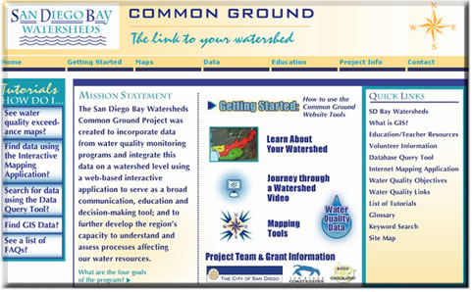
Figure 8: San Diego Bay Watersheds: Common Ground Home Page

After the Web page opens, click on the link, Journey through a Watershed Video. Watch the 4-minute multimedia video (You will need to have a multimedia video player on your computer such as Microsoft’s Windows Media Player, RealPlayer, or another multimedia video player that plays back the .WMV media format). (This video was developed with Google Earth Pro and a video editing application (Video Studio 9). After watching the video answer the following questions:

D-1: Where did the pollutants come from?

D-2: Where did the pollutants end up?

D-3: What can you do to help keep San Diego Bay clean?

Now close the multimedia video player window and switch back to the Website home page (http://www.sdbay.sdsu.edu ). On the right side of the window, there are several Web links listed under Quick Links. Select the What is GIS? link and spend five minutes reading he Webpage content.

Please write down TWO possible GIS Career positions based on what you know and what you read on the separate answer sheet:

D-4:

D-5:

Now select the Maps pull-down menu at the topic of the Web page, then select Interactive form the list.

Next, a disclaimer page will appear. Scroll down to the bottom of the Maps Disclaimer page, and click on the Agree button to proceed to the Interactive Map. (If you are using Microsoft Internet Explorer as your Web browser and you receive a message indicating that the pop-up was blocked, hold down the <Control> key and click on the Agree button to bypass the Pop-Up Blocker.)

A new map window should have popped up. On the right side of the window, you will see a list of layers which organize water quality data around the San Diego region. Click and place a check mark in the square “check box” next to the Pueblo Watershed in the Layers list to display it in the map. The map will update with your chosen information. Also, select the circular “radio button” of the same layer---the Pueblo Watershed. This will make the layer “active” and will allow you to explore the Pueblo Watershed data interactively on the map.

You should now see water quality monitoring sites on the map. They are highlighted with bright pink circular markers.

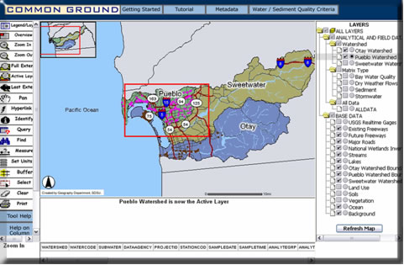
Figure 9: Zooming In to Water Quality Monitoring Sites

On the left side of the map, click the Zoom In button to activate the Zoom In control. Next click and drag a rectangular box around the area with the pink water quality monitoring sites (See figure above.).

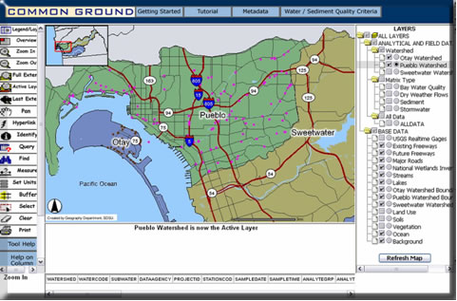
Figure 10: Zoomed In to Water Quality Monitoring Sites

After you have successfully zoomed in to the area where most of the water quality monitoring sites are located (See figure above.), click on the Identify tool located on the left side of the map to activate it. Now, select one of the Pink water quality monitoring points on the map. If successful, the system will check the database of the water quality monitoring station located at your selected site and display the information in a table below the map. Use the scroll bar below the data to briefly examine the data and feel free to check the data at other water quality monitoring sites (the pink dots).

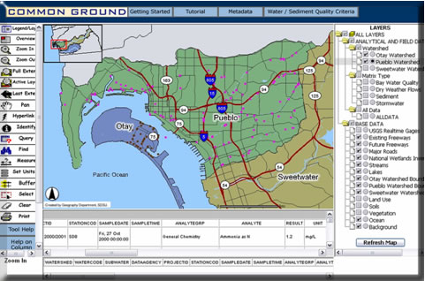
Figure 11: Displaying Water Quality Monitoring Data

Please answer the following questions:

D-6: The word “Analyte” describes the substance that is being analyzed. In this application, the analytes are the substances measured in water. In your database query result of water quality data, what is the first ANALYTE listed?

D-7: For this analyte, what is its corresponding RESULT value and UNIT?

D-8: What do the RESULT value and UNIT represent?

D-9: How can you use this system to monitor the water quality in your neighborhood?
Section 5 – Additional GIS Web Applications.

The next step is to visit ONE GIS application website (from the following table or other places) and provide a short summary of the Website’s purpose and its major GIS./Mapping functions.

Website | Description
http://map.sdsu.edu/fireweb | San Diego 2003 Wildfire Mapping
http://geoinfo.sdsu.edu/campusmap/ | San Diego State University Campus Map
http://maps.google.com/ | Google Maps
http://www.mapquest.com/ | MapQuest

E-1: Please write down your selected Website on the separate answer sheet:

E-2: Please write down a short summary (100 words) of your selected Website’s purpose and its major GIS./Mapping functions on the separate answer sheet:

Section 6 – Written Assignment

Now that you have seen five GIS applications examples in five different fields, we would like you to answer some questions with the idea that you will be putting them all together in a 250-word paragraph (approximately one typed page) by including the following information.

F-1: In your paragraph, please highlight five different applications of GIS. Can you think of ONE additional new application area that was not mentioned in this learning exercise? Please mention it if you can think of one.

F-2: In your paragraph, please discuss which application you liked the best and tell us WHY? Do you think that this GIS application can help people? How can it help people?

F-3: In your paragraph, please tell us if it was difficult or easy to access the Web GIS maps using your Web browser. Why was it easy or difficult?

Student Survey

This learning module was developed specifically for you---the students---in order to expose you to GIS and related geospatial technologies.

GIS and related geospatial technologies, similar to what you worked with in this learning module, are major components of one of the most important new industries for career growth. Businesses, organizations, and governments are increasingly seeking skilled talent in this industry.

Now, to benefit other students and the authors of this learning module, we would greatly appreciate your input. Please take time to answer these questions as openly and honestly as possible. They will not affect your grade or score. You can either provide your feedback to your teacher/educator along with the learning module answers on the separate answer sheet or you can email your responses using the mail form available at http://geoinfo.sdsu.edu/hightech/contactUs.htm.

Thank you for helping us improve our modules!

S-1: What did you like best about this learning module? Why?

S-2: What did you like least about this learning module? Why?

S-3: Was there anything that was really hard to understand or difficult to complete? What was it? Why?

S-4: Is there anything in this learning module that we can add, exclude, or change to make it better? What is it? Why?

STUDENTS MAY STOP HERE!
------------------------------------------------------------------------

